**OCR GCE A**

**COMPUTER SCIENCE PROJECT**

Contents

1. Analysis 4

1.1 Problem identification 4

1.2 Stakeholders 4

1.3 How can problem be solved by computational methods. 4

1.4 Research 6

1.4.1 Interview with stakeholder 6

1.4.1.1 Review of Interview 6

1.4.2 Research into Duolingo and Squarespace 6

1.4.2.1 How features affect Language-learning in Duolingo. 11

1.4.2.2 Features that will be used. 12

1.4.2.3 Features that will not be added. 12

1.5 Hardware and Software requirements 12

1.6 Success Criteria 13

2. Design 15

2.1 Systems Diagram 15

2.1.1 Module explanation 15

2.2 Useability Features 16

2.3 Databases 20

2.3.1 Database tables 20

2.4 Key variables 21

2.5 Algorithms 22

2.6 Test Data 26

3. Developing the Coded Solution 28

3.1 Iteration One 28

3.2 Iteration Two 28

3.3 Iteration Three 33

3.4 Iteration Four 39

3.5 Iteration Five 44

3.6 Iteration Six 47

3.7 Iteration Seven 52

3.8 Iteration Eight 54

4. Evaluation 59

4.1 Testing Data 59

4.2 Does the solution match the Success Criteria? 107

4.3 Maintenance 109

4.3.1 Limitations 110

5. Project Appendixes 110

5.1 Complete Code Listing 110

6. Bibliography 123

# 1. Analysis

## 1.1 Problem identification

My project will be a website similar to the language learning app “Duolingo” but specifically targeted to those who wish to learn Japanese. The website will prioritise learning and identifying hiragana and katakana characters. Hiragana and Katakana are the two main writing scripts in the Japanese language. Katakana is used for “borrowed words” and sounds; borrowed words are words which have come from and/or are similar to the same words in other languages. Hiragana is used for all Japanese words. I believe these writing scripts are the foundations of Japanese. Therefore, to improve one’s proficiency in Japanese, it is important to prioritise learning these at first. I may also add options to practice Vocabulary and Grammar.

The website requires: a system that allows the user to log in so they can save their progress; a start page where the user can select what tasks they want to do; a score to see how many questions the user got right in a task; something indicating the user’s proficiency/level in Japanese; message outputted if the user got many questions right; a list of all the questions that were done incorrectly/shows the number of questions they got wrong.

## 1.2 Stakeholders

The interface of the website will be much more sophisticated and minimalistic than Duolingo’s. The website will mostly be used on laptops and PCs. The target audience will be Japanese teachers and students aged 13 up, due to the more sophisticated interface.

I have selected my Japanese teacher as my main stakeholder. We mostly use a textbook during lessons, but it can be boring and tiring to learn katakana and hiragana from. Therefore, I thought that creating a website for practicing identification of hiragana and katakana characters will speed up the learning process. Other stakeholders will include students aged 13 and up.

## 1.3 How can problem be solved by computational methods.

|  |  |
| --- | --- |
| **Computational Method** | **Justification** |
| Thinking Abstractly | Abstraction will be useful for this project as it removes unnecessary details thus only keeping the necessary ones. I will adopt a similar format to Duolingo for tasks.   * Numbers indicating which question the user is on or a progress bar. |
| Thinking Ahead | Thinking Ahead will be ideal for this project as it allows me to plan ahead and give structure to my problem.   * I plan to use React Typescript and Visual Studio Code as my IDE to develop the website. * I also plan to use a database to store data I intend to show on the website e.g., images of Katakana and Hiragana characters. * The website can be used using a mouse. * Messages will be outputted when the user gets something correct. * The user’s level will be shown as they continue to do tasks |
| Thinking Procedurally | Thinking Procedurally will be good for this project as it will also give the problem structure. It will also allow me to break down the problem and work on it more easily. I can use functions in my code so I can reuse them, if necessary, which also allows my code to be less messy.  Start page can be decomposed into:   * Place where user can log in.   Menu can be decomposed into:   * Buttons/links for tasks such as katakana, hiragana practice etc. * Something showing the user’s level/proficiency in Japanese at the top. * Rank beside each task, how good the user is at each task. * Option/settings button at the top |
| Thinking Logically | Thinking Logically will be good for this project as it will allow me to identify points where decisions need to be made:   * When the user gets something correct, this is taken into account and their overall proficiency will increase. Their score for the individual task will also go up. * If they get something wrong, their overall proficiency will stay the same. Their score for the individual tasks will decrease. If they keep struggling with the same topic, this topic will hopefully be recommended for them to work on. |
| Thinking Concurrently | Thinking concurrently will be good for this project as it will allow me to think about what tasks can be completed at the same time, increasing efficiency:   * When the user gets something right, the score will update, and a message is outputted. * As the user progresses through a task, the question number they are on will change. * The question will change to the next question after a user has completed it. |

## 1.4 Research

### 1.4.1 Interview with stakeholder

**Interview Questions**

1. What sort of Language Learning do you want to see?
2. Do you think sound effects would be ideal?
3. Should the user be shown their overall proficiency/level in Japanese as they progress through tasks?
4. What sort of visuals would you like?
5. What features make a language learning website/app useful?

**Stakeholder’s answers**

1. Matching Japanese characters to the Romanised letters.
2. It would be ideal to have sound effects or messages when the user gets something right/wrong.
3. Their level should be shown on the start page/menu screen to find suitable practice for their proficiency.
4. There could be animations when the user gets something right or wrong.
5. Having a grading system will be useful, and a menu.

#### 1.4.1.1 Review of Interview

To get an idea of initial requirements, I conducted this interview with my stakeholder.

We concluded that visuals and sound effects/messages will help motivate the user to carry on with their learning and also give them a sense of accomplishment. It also makes language learning more interactive, enjoyable and with the visuals it will be pleasing to look at.

For the language learning itself, just like Duolingo there were different ways on how to approach the learning that were proposed. However, the stakeholder emphasised matching Japanese vocabulary to English/Romanised sounds is much more than the other approaches to language learning.

### 1.4.2 Research into Duolingo and Squarespace

**Inspiration for Japanese Language Website**

Duolingo is an application in which users can pick a language out of many to learn. They practice vocabulary, grammar, pronunciation, and listening skills. It uses game-like methods to teach and encourages consistent learning from the user.

The language-learning is split into stages/levels. For example, at first the user could work on learning the languages alphabet. Other stages will include themes of food, holidays, school etc. Within these stages the user will learn vocabulary through matching, for example, English words to the Japanese translated words, writing a sentence by listening to it, pronouncing the words you hear, learning grammar through writing sentences etc.

As you complete all the levels in a stage, you earn crowns which show your progress in the language. You also earn gems as you progress through the language which encourages the user to keep going.

There is also a leader board which shows your standing compared to other learners in the language you are learning.

Main features of Duolingo:

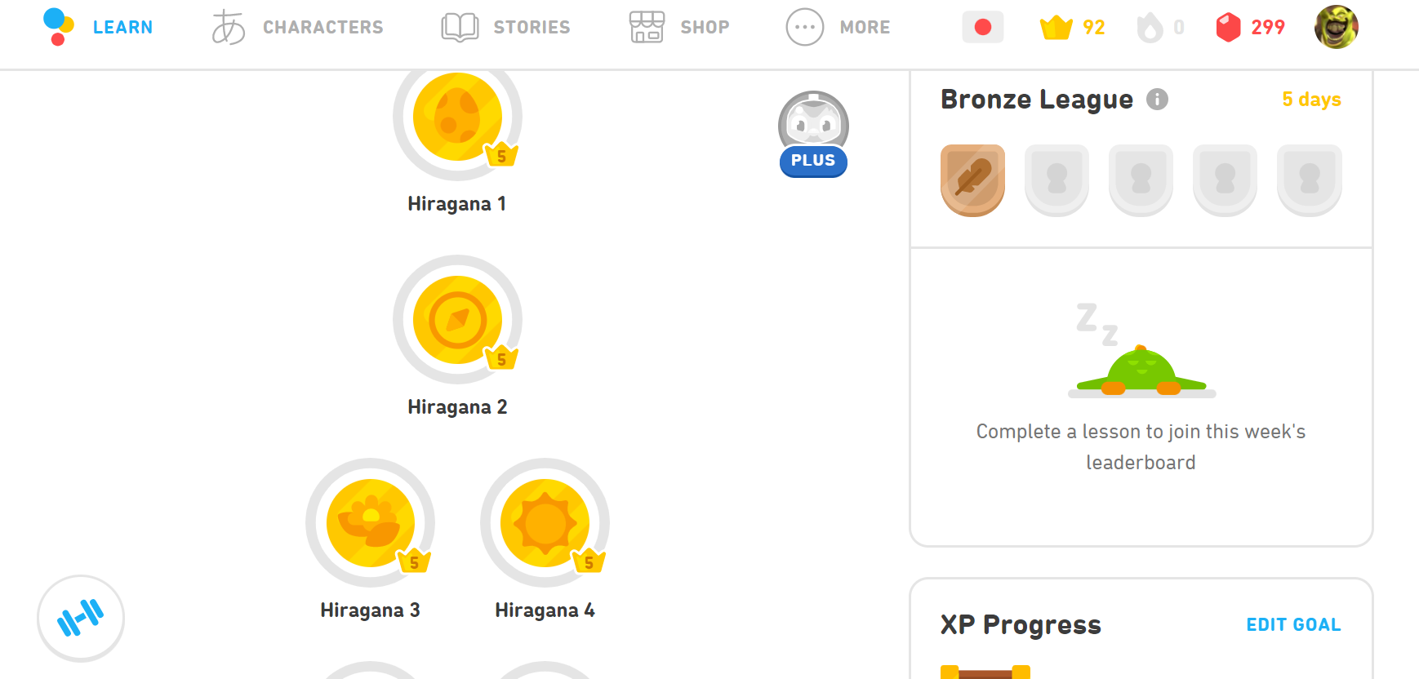

Crowns given as user proceeds through the stages in each theme.

Themes/practice shown on start page.

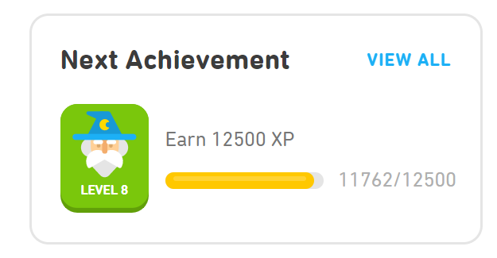

Option to view all different levels.

Level and experience shown when scroll down the start page.

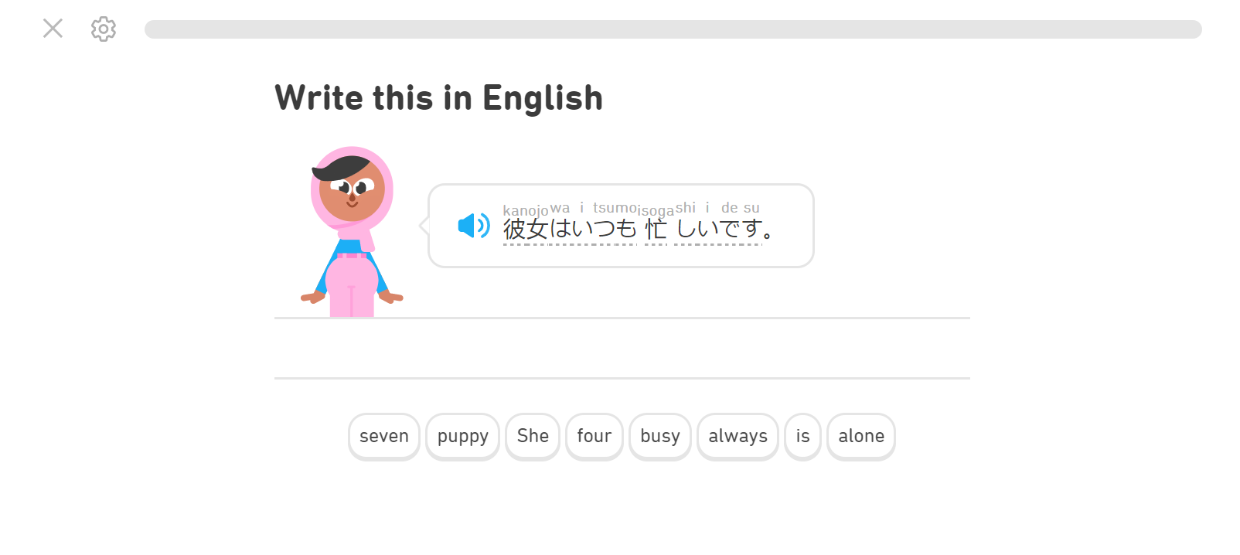

Japanese to English Translation Task

Progress Bar to show how far user is through the task.

When you click one of the themes as shown above, it makes the user do different tasks to learn the language.

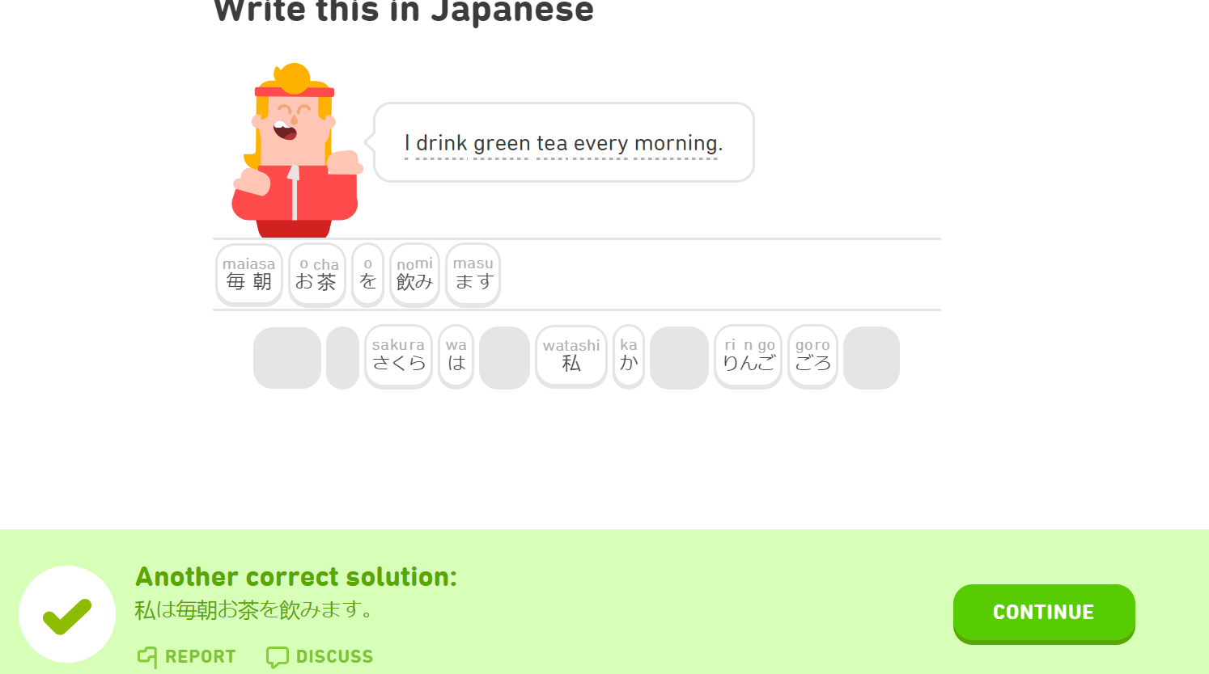

Green colour and checkmark shown when user completes task correctly, a sound is also played.

Character animation shown when user correctly completes the task

English to Japanese Translation Task

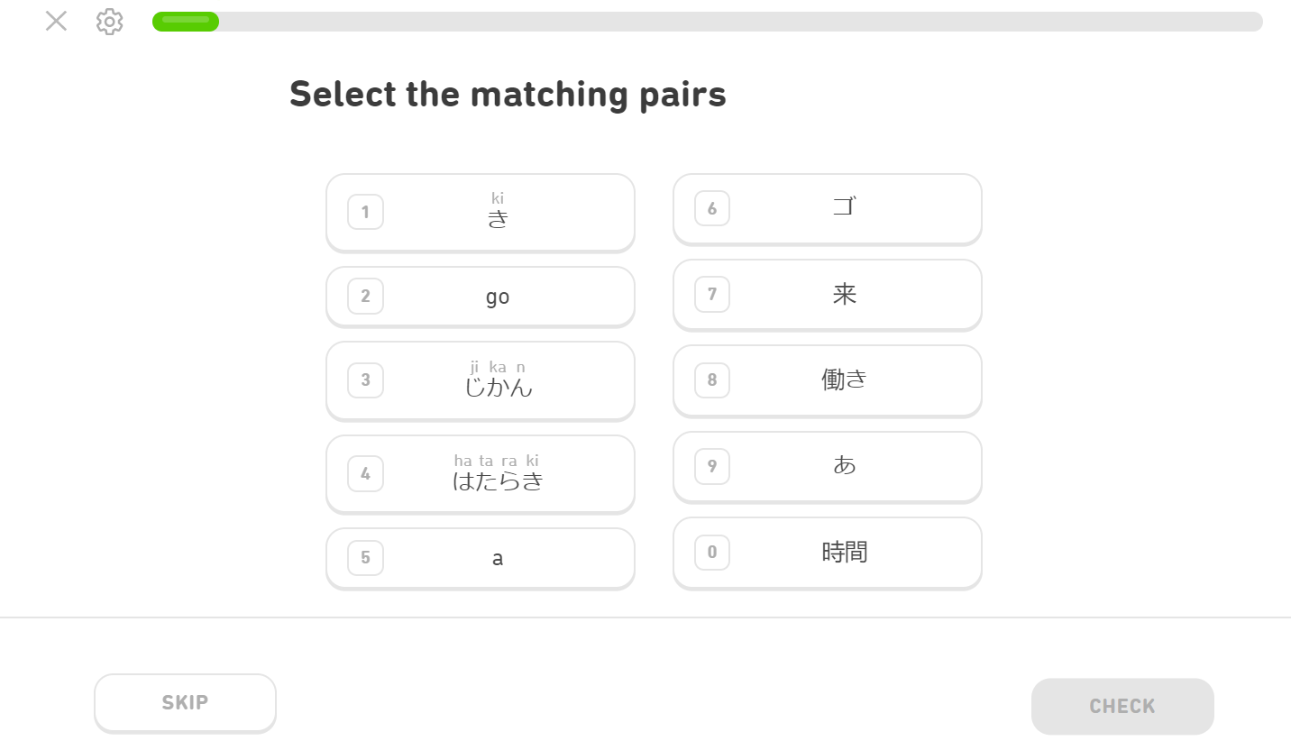

Matching Kanji(Chinese characters) to Hiragana(Japanese writing script)

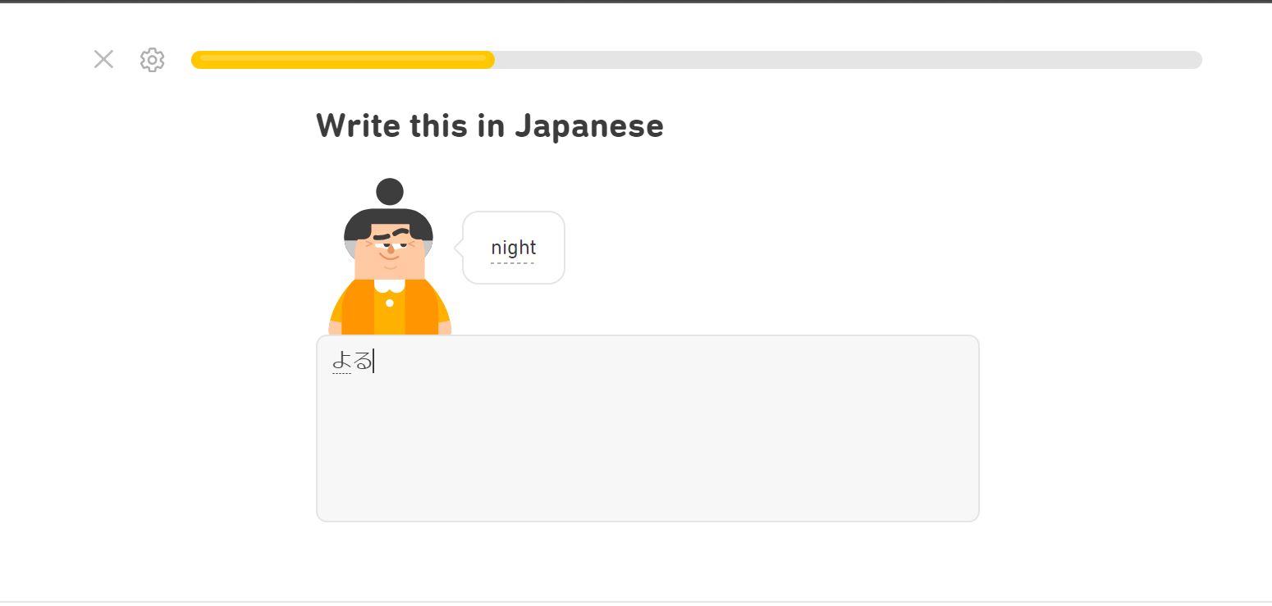

Progress bar turns from green to yellow when user gets multiple questions correct in a row.

Translating vocabulary

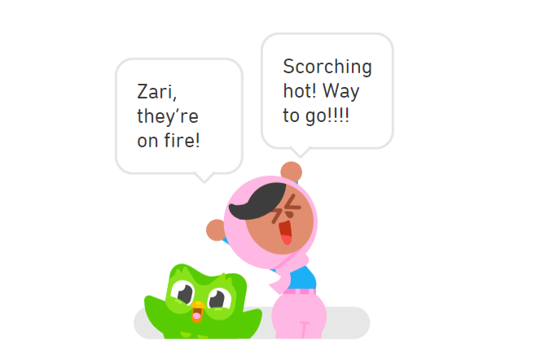

Animation shown after user continues streak, encourages user to keep going.

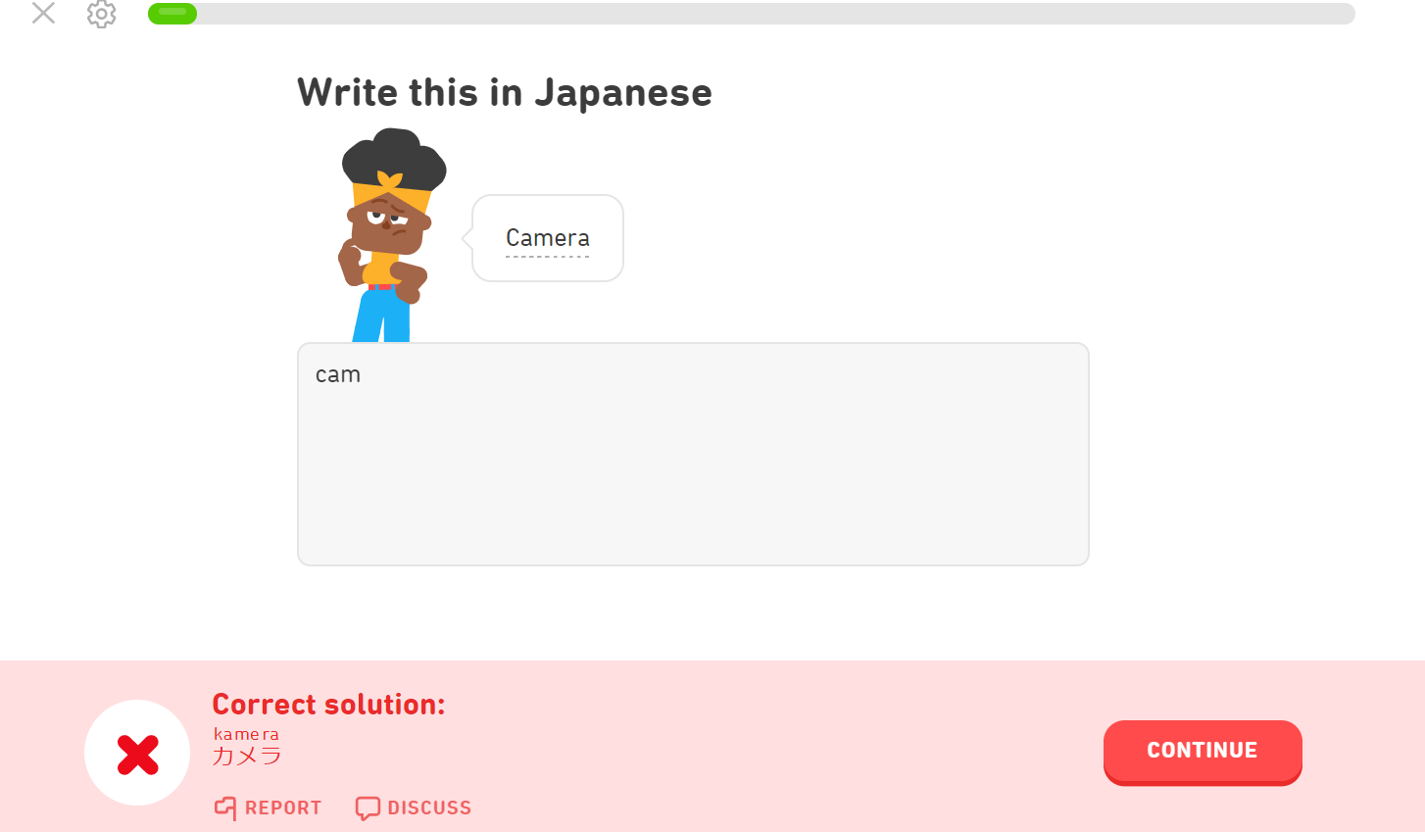

Red box with red cross appears when user gets something wrong, sound effect also played.

Correct answer shown.

Character animation show when user gets something wrong.

**Inspiration for Interface: Squarespace**

I took inspiration for the interface of the website from various templates on Squarespace. Squarespace is a website building service which allows users to use pre-built templates to make webpages.

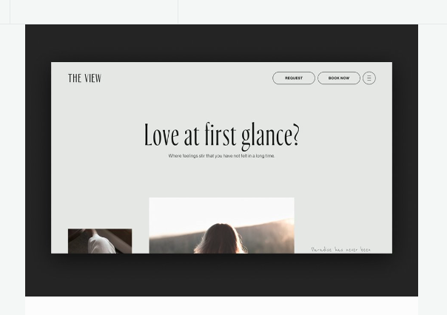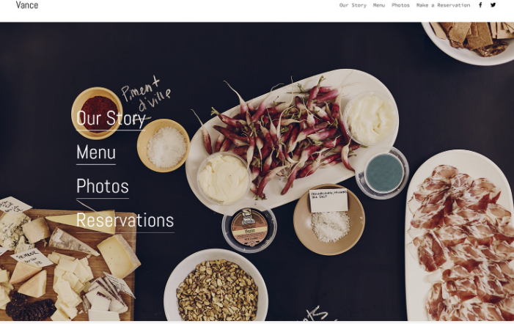

The grey colour scheme is very minimal and looks sophisticated.

I liked the look of the lines underlining different options.



#### 1.4.2.1 How features affect Language-learning in Duolingo.

**Menu/Start Page**

Allows user to view their progress within each theme and their progress in general. Motivates user when they see their progress as they will want to improve.

**Visuals/animations**

Makes language-learning less “boring”, and more visually appealing. Animations shown also encourage user to keep going. For examples, green checkmarks and boxes shown when user does something correct.

**Sound**

Complements visuals as when the user gets something corrects a sound is played.

#### 1.4.2.2 Features that will be used.

* Log-in and sign-up page
* My website will be similar to Duolingo, but I will add/remove certain features.
* I will add an overall proficiency in the language by taking an average of the user’s level in each area. This is because my stakeholder wanted a good grading system. This will be shown on the start-page with an option to practice hiragana and Katakana.
* Duolingo does not show the number of questions the user got right or wrong after a task (or this feature is only available for premium users) so I will add this feature in mine. This will allow the user to know their strong and weak points.
* The interface will be much more minimalistic and monochromatic with a simple font. This will allow easier navigation of the website. Furthermore, I feel like it will have a more sophisticated look than Duolingo which is ideal for my age range.
* I will have a progress bar/numbered questions within the tasks so the user can track how far they are within a task. I will also add a score at the end with something indicating how many questions the user got right or wrong. This will show the user what specific type of questions they need to work on.
* Each task will have 5-10 questions. This makes it easier to give the user a set score, and to work out their proficiency.

#### 1.4.2.3 Features that will not be added.

* I will avoid having the many different types of themes that are present within Duolingo. For example, there are themes of Travel, Routines, Time, Travel 2, Routines 2, Time 2 etc. A lot of these themes could have been combined into one with various different levels. If I created the same number of themes, I would have to implement all the questions within them. This will be too time-consuming as I have a limited amount of time to create this.
* In terms of language-learning tasks I will avoid having listening tasks. I think adding more types of questions will be difficult to create within the time limit.
* I will avoid having the characters and character animations that are present in Duolingo. It will take too much time designing and creating them. It also does not fit with my idea for a minimalistic interface.
* I will avoid having too many different types of language-learning such as answering questions, translating many sentences as I am prioritising the identification of Hiragana and Katakana characters.

## 1.5 Hardware and Software requirements

**Hardware**

|  |  |
| --- | --- |
| Hardware | Reason |
| Monitor | To display visuals |
| Mouse/Touchpad | User can interact with website using this |
| Speakers/Headphones | User can hear sounds emitted |
| 4 GB of RAM | Most low-end pcs hold 4GB of RAM, most people will be able to use the website without much problem. |

**Software**

|  |  |
| --- | --- |
| Software | Reason |
| Chrome/ any web-browser | Typescript compiles to Javascript which means all browsers can be used to use the website. |

## 1.6 Success Criteria

|  |  |  |  |  |
| --- | --- | --- | --- | --- |
| Requirement No. | Requirement | Importance | Justification | Reference |
| 1. | Log-in Page | High | Allows user to save progress | Duolingo feature |
| 2. | Start-Page | High | Allows user to choose what they would like to learn, view their levels and progress etc. | Duolingo feature and Interview |
| 3. | Score shown after user completes a task | High | User can see what they are excelling and lacking in. | Interview |
| 4. | User’s proficiency in each area of the language shown on the start-page | High | User can see what areas they are excelling and lacking in. | Interview |
| 5. | Overall proficiency displayed on start-page by taking an average of the proficiencies of each area | High | Motivates user to better their proficiency | Interview |
| 6. | Ten questions per task | Medium-High, this number could be changed | User can see a set score after completing a task. Allows for easy scoring of the user’s proficiency of the language | Research |
| 7. | Animation played after user answers question correctly or incorrectly | Low – can be difficult to implement, and not a necessary feature | Motivates user, visually appealing | Duolingo feature |
| 8. | Sound played when user gets a question correct or incorrect | Low – can be difficult to implement and is not a necessary feature | Motivates user, more interactive | Duolingo feature |
| 8. | User has option to practice mistakes after a task | High | Allows user to practice what they need help in | Duolingo feature |
| 9. | Minimalistic Monochrome Interface | High | Allows user to navigate website more easily. | Research into Squarespace |
| 10. | Question Format split into: Identifying hiragana and katakana characters, vocabulary and grammar | High | Allows range of ways to learn the language. | Interview |
| 11. | Progress Bar within each task indicating how far user is along task. | Medium – can be replaced with something showing the question number the user is on | User can see how long is left of a task. | Duolingo feature |

# 2. Design

## 2.1 Systems Diagram

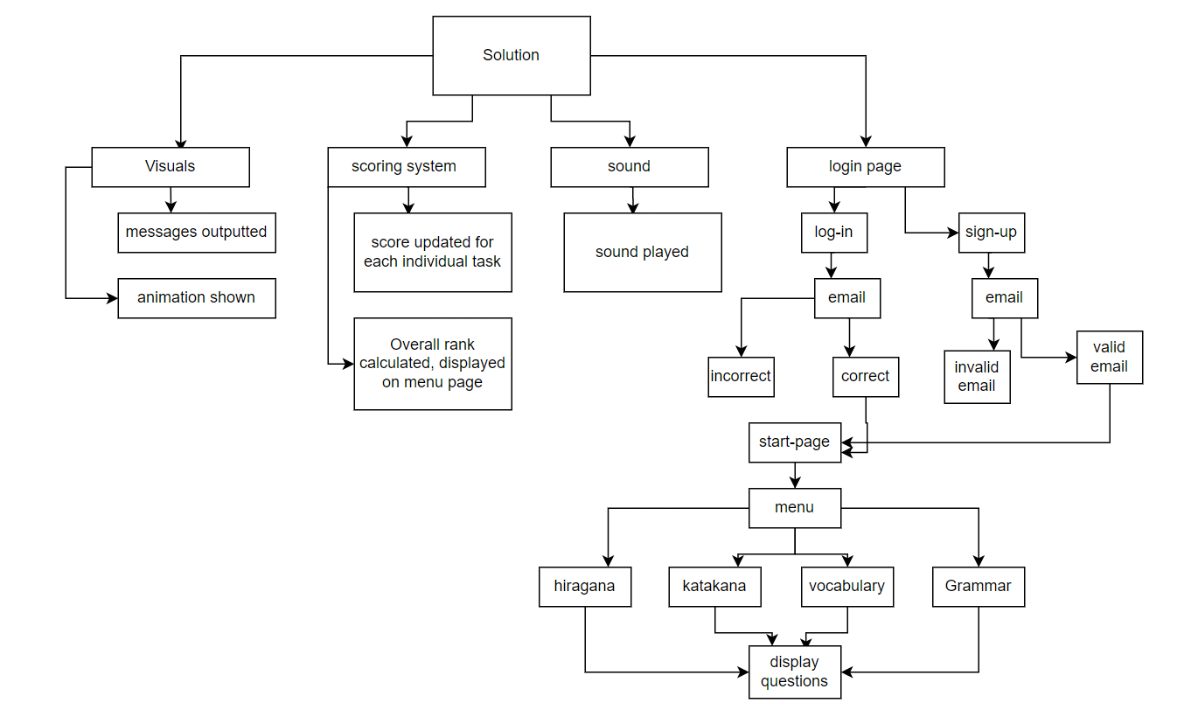

**Reasons for a top-down approach**

I decided to go with a top-down approach as it separates the code into different modules and into different parts which allows it to be understood better. This is beneficial as it will give my program some structure and I can efficiently work towards a solution.

### 2.1.1 Module explanation

**Visuals**

**Messages outputted:**

When the user enters an incorrect or correct answer an appropriate message is outputted

**Animation shown:**

When the user enters an incorrect or correct answer an appropriate, simple, animation is displayed.

**Scoring System**

**Score updated for each individual task:**

Each task will have a number of questions, the score for each task is set to 0. It will increment when the user gets the question correct.

**Overall Rank calculated and displayed:**

An average of the scores from each task the user completed is taken and displayed on the menu page.

**Log-in and Sign-up**

**Log-in:**

When the user enters the correct email, they will be directed to the start page of the website. Otherwise, an appropriate message is outputted.

**Sign-up:**

When the user enters a valid email, they will be directed to the start page. Otherwise, an appropriate message is outputted.

**Start-Page:**

**Menu:**

When this link/button is clicked, user is directed to the menu page.

**Menu:**

**Hiragana:**

When the user clicks this link/button on the menu Page, a task with questions is displayed.

**Katakana:**

When the user clicks this link/button on the menu Page, a task with questions is displayed.

**Vocabulary:**

When the user clicks this link/button on the menu Page, a task with questions is displayed.

**Grammar:**

When the user clicks this link/button on the menu Page, a task with questions is displayed.

## 2.2 Useability Features

Design for pages created on Canva (graphic design platform used to create visual content)

**Log-in Page:**

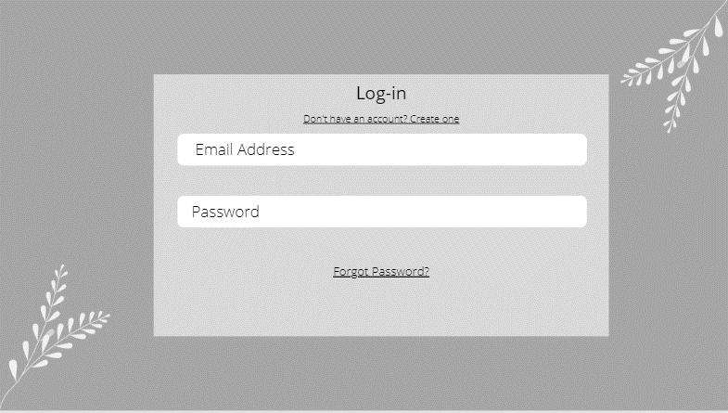

When the user clicks this link, they will be redirected to the Sign-up page.

This screen shows the log-in page for the website, which will allow the user to save their progress within the language. Input boxes which allow the user to enter their details. If the user’s email address is recognised and the password is correct, they will be directed to the Start page of the website. Minimalistic Interface ensures easy navigation.

**Sign-up Page:**

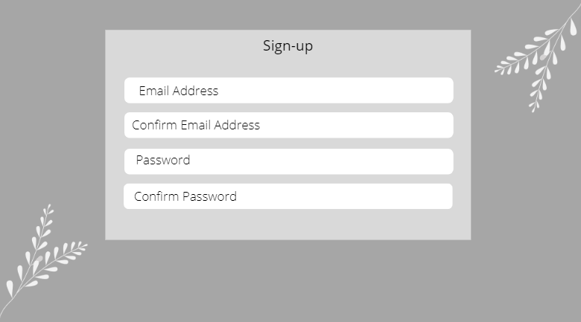

The user will be asked to enter a valid email address and confirm it. Input boxes to allow them to do so. The password will be between 8-15 characters and the user will be asked to confirm it. If the email address in invalid or the password is invalid, the page will reload and show a message. If they are both valid, the user will be directed to the Start Page.

**Start-Page/Menu-page:**

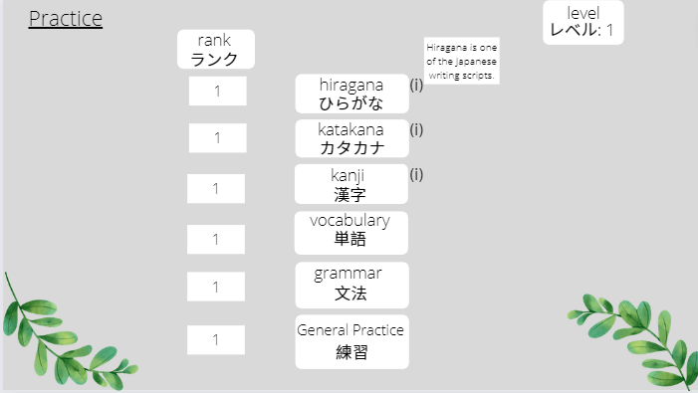

The user can click these buttons and be navigated to the respective pages wherein they can practice these areas of the language.

The rank within each area of the language is shown at the top of the screen indicating to the user their strengths and weaknesses.

Users who are encountering the language for the first time will not know the meaning/what Hiragana, Katakana and Kanji are. This “button”, when clicked, gives the definition of what they are.

The level is shown at the top of the screen indicating to the user their overall proficiency in the language.

**Language Task Pages:**

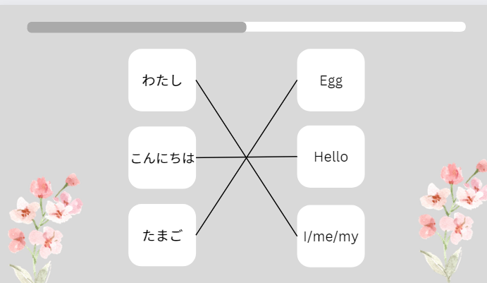

User can use lines to connect the correct meaning to the Japanese.

Progress Bar shows the user how far through the task they are.

User asked to match the vocabulary. If incorrect, an animation/image is shown, a sound is played, and the correct answer will be shown. If correct, an animation/image is shown, a sound is played, and the users score for the task will go up. The progress bar allows easy tracking of what question the user is on.

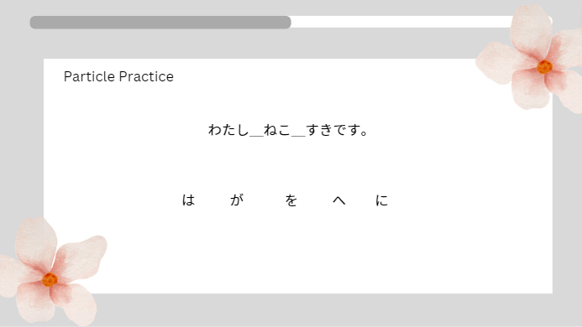

The user can drag particles to the correct place in the sentence.

**End of Task Page:**

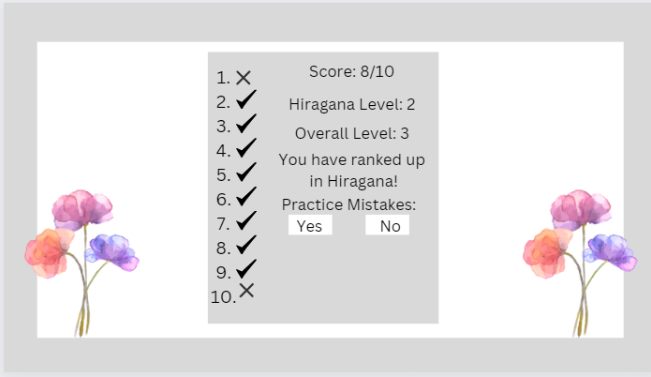

User presses these buttons to either practice the mistakes or not

Questions the user got incorrect are shown clearly.

User is shown their score in the centre of the screen as their attention will be drawn their first.

After a whole task has been finished, the user is shown their score for this task and is given an option to practice their mistakes. Levels are displayed depending on whether the user opted to practice a specific part of the language or decided to practice it overall.

## 2.3 Databases

I decided to use a database to store the users’ details (email etc.) and the language questions I intend to ask the user. I chose a database instead of an external file because databases can handle a higher volume of data, hold various types of data and values can be easily searched for using queries.

### 2.3.1 Database tables

I intend to create 3-4 tables within my database which will store the user’s log-in details, the questions I intend to ask the user and potentially their score/rank.

**User table**

User(UserID, Email, Rank)

UserID is the primary key in this table. A primary key is a unique identifier in a table within a database. The user’s email will be stored within the database.

The user’s rank or proficiency in the language will be stored and updated after the user completes a task.

**Questions Table: Hiragana**

Hiragana(QuestionID, characterURL, answer)

QuestionID is the primary key within this table.

The characterURL field refers to the URL of the image of the Hiragana character I wish to show to the user.

The answer field is where the answer to the identification of the character show on screen will be held.

**Questions Table: Katakana**

Katakana(QuestionID, characterURL, answer)

QuestionID is the primary key within this table.

Here, characterURL refers to the URL of the image of the Katakana character I wish to show to the user.

The answer field is where the answer to the identification of the character show on screen will be held.

**Database Diagram**

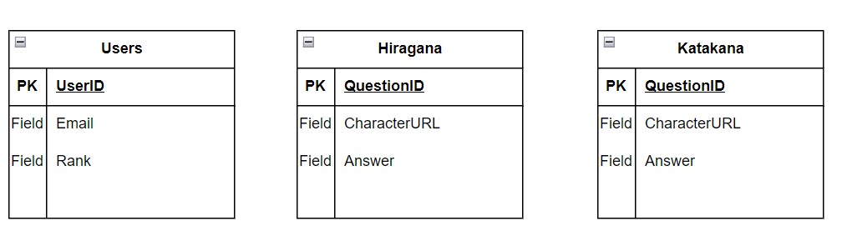

## 2.4 Key variables

|  |  |  |  |  |
| --- | --- | --- | --- | --- |
| Variable | Data type | Global/Local | Validation | Page |
| Hiraganascore | Integer | Global | No | Language Task Page: Hiragana |
| Katakanascore | Integer | Global | No | Language Task Page: Katakana |
| Progressbarscore | Integer | Global | No | Language Task Page: Hiragana, Katakana |
| Incorrectcount | Integer | Local | No | Language Task Page: Hiragana, Katakana |
| Rank | Integer | Local | No | Language Task Page: Menu Page |
| email | String | Local | Yes (must have an @ symbol) | Login Page, Sign-up Page |

## 2.5 Algorithms

**Sign-up/Log-in**

This page will load first when the website is run, the user will use their email to sign up/log-in. If an incorrect email is entered, nothing will happen except for an adequate message being displayed. Otherwise, the user is directed to the “Start-page” mentioned in the systems diagram.

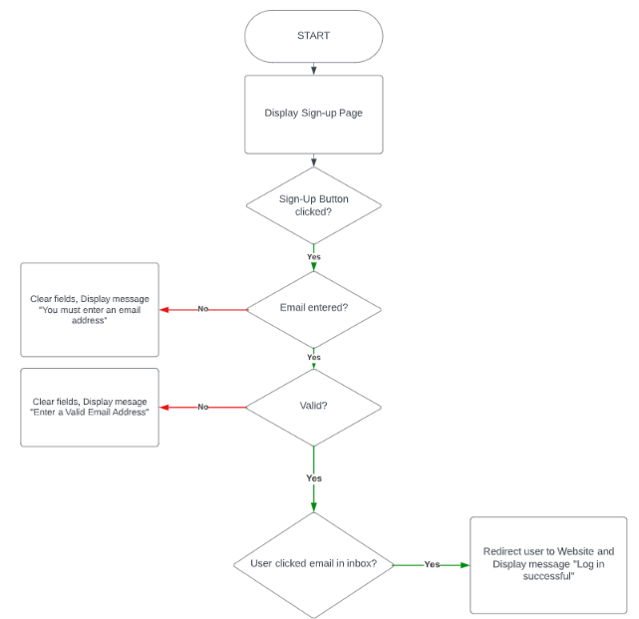

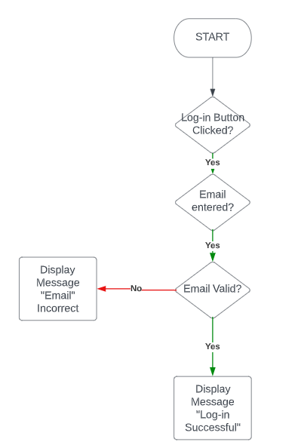

**Start-page**

Once the user has logged in, this page is displayed. Right now, I am not sure if the start-page and the menu-page mentioned in the systems diagram will be two separate pages. If the user presses a link to practice Hiragana/Katakana etc. they will be redirected to a page wherein they will be able to do a language task. If they click an “information” button they will be shown what, for example, Hiragana and Katakana are.

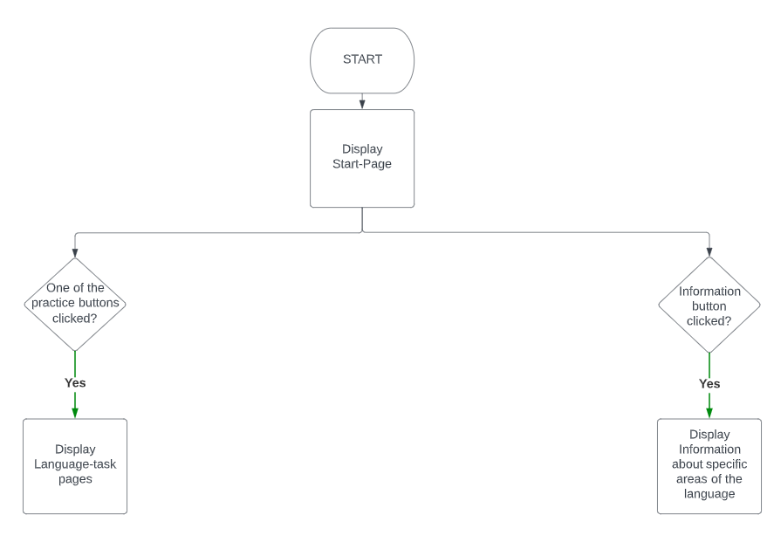

**Language-task**

As of now, I am unsure whether this task will be implemented in the final solution. If the user matches all the words correctly, their score will increase, a sound is played, and an animation is displayed. Otherwise, the score will decrease, a sound is played, an animation is displayed, and a correct answer is displayed.

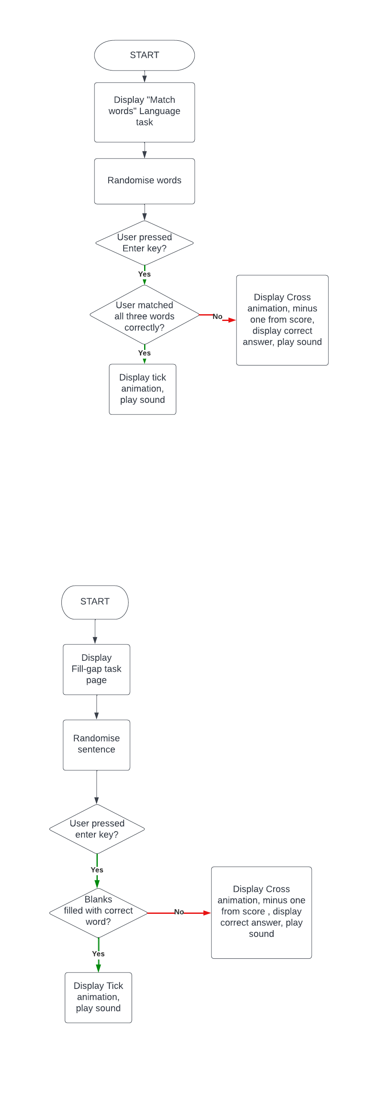

Score increments.

As of now, I am unsure whether this task will be implemented in the final solution. If the user fills the blanks with the correct word/character their score will increase, a sound is played, and an animation is displayed. Otherwise, the score will decrease, a sound is played, an animation is displayed, and a correct answer is displayed.



Score increments.

If the user correctly enters the phonetic reading of the sound of the character into the input box, their score increments, a sound is played, and an animation is displayed. Otherwise, the score decreases, a correct answer is displayed, and a sound is played.

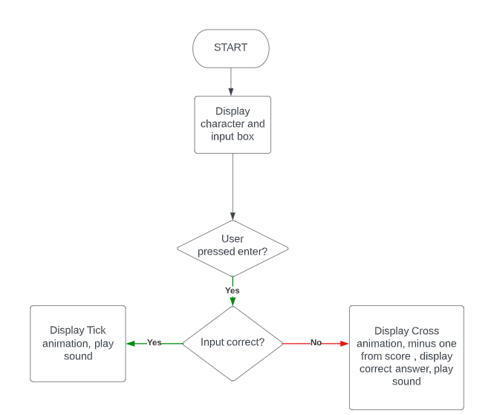

Score increments.

## 2.6 Test Data

**Log-in**

|  |  |
| --- | --- |
| Test Data | Type |
| [something@example.com](mailto:something@example.com) | Valid |
| Helloworld | Invalid |
| 1111 | Invalid |
| something@example | Valid |

**Sign-up**

|  |  |
| --- | --- |
| Test Data | Type |
| [something@example.com](mailto:something@example.com) | Valid |
| Helloworld | Invalid |
| 1111 | Invalid |
| something@example | Valid |

**Clicking Links to Pages**

|  |  |
| --- | --- |
| Test data | Type |
| Clicking on the Link | Valid – directed to the page |
| Clicking away from the Link | Invalid |

**Clicking the Information button**

|  |  |
| --- | --- |
| Test data | Type |
| Clicking on the button | Valid – text displayed informing the user what Hiragana/Katakana |
| Clicking away from the button | Invalid |

**Hiragana task page**

**For this test I am going to use the hiragana character ka as what will be shown to the user in each of these test cases.**

|  |  |
| --- | --- |
| Test data | Type |
| KA | Valid – Correct, score increments |
| ka | Valid – Correct, score increments |
| kA | Valid – Correct, score increments |
| Ka | Valid – Correct, score increments |
| A | Invalid – Incorrect, score stays the same |
| a | Invalid – Incorrect, score stays the same |
| Kaaaaaaaaaaaaaaaaa | Invalid – Incorrect, score stays the same |
| 1 | Invalid – Incorrect, score stays the same |
| 12 | Invalid – Incorrect, score stays the same |
| !! | Invalid – Incorrect, score stays the same |
| % | Invalid – Incorrect, score stays the same |

**Katakana task page**

**For this test I am going to use the Katakana character ka as what will be shown to the user in each of these test cases.**

|  |  |
| --- | --- |
| Test data | Valid |
| KA | Valid – Correct, score increments |
| ka | Valid – Correct, score increments |
| Ka | Valid – Correct, score increments |
| kA | Valid – Correct, score increments |
| A | Invalid – Incorrect, score stays the same |
| a | Invalid – Incorrect, score stays the same |
| 12 | Invalid – Incorrect, score stays the same |
| !! | Invalid – Incorrect, score stays the same |
| % | Invalid – Incorrect, score stays the same |

# 3. Developing the Coded Solution

## 3.1 Iteration One

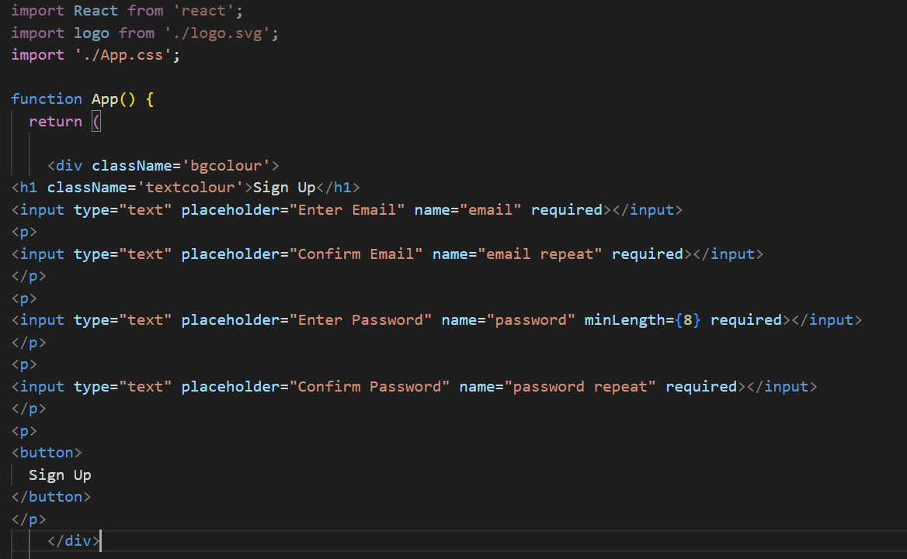**[1]**

Input boxes that allow user to enter an email and a password. *required* ensures that user must enter it to log in.

**What is the frontend?**

The frontend of a website refers mainly to the user-interface and what the user will be interacting with.



## 3.2 Iteration Two

**Trying out the backend/database:**

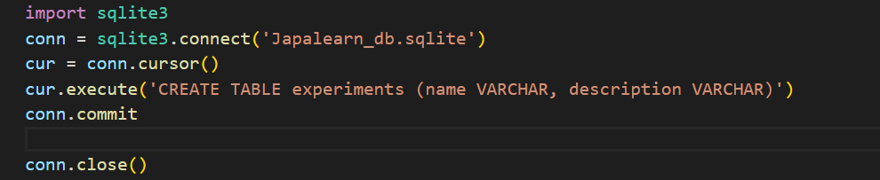

Connects to the database and should allow creation of tables through python. Unfortunately, this was not working. I was not able to create tables within my database.

**What is the backend?**

The backend of a website is what allows the website to operate. For example, the backend allows data from a database to be shown on the frontend when the user interacts with it.

**Trying to create a database to hold email and passwords.**

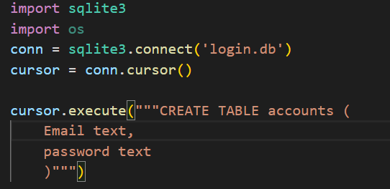

Again, connecting to the database (sqlite)and trying to create a table named accounts within it. This did not work either.

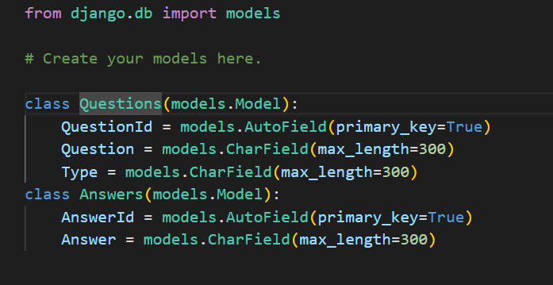**[2]**

Primary key: unique identifier

Classes will create the tables within our database. Within the classes, fields are named and one is set to the primary key

**I migrated the changes by typing a command into the command prompt so I can look at my tables within sqlite3.**

**Inserting into database (by migrating the changes):**

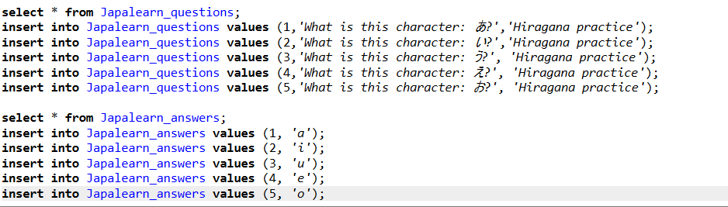

Inserting values into the empty fields in my database. Using same IDs in both tables so I can compare the answers to the question much better.

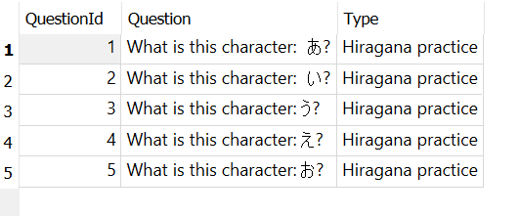

Values successfully inserted into the database.

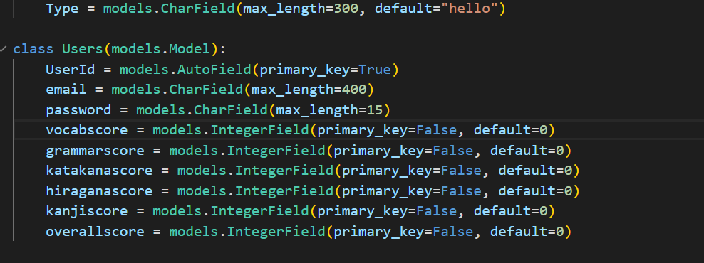

Creating a new table to store the user’s email, password, and their scores.



Removing the div so the whole page is grey instead of a division.

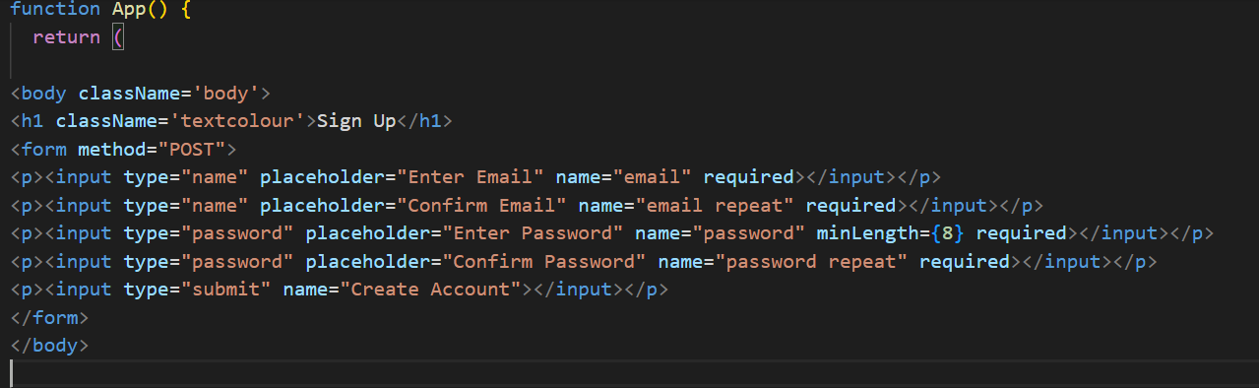

Starting to try pull in values from the database into the website using apis.

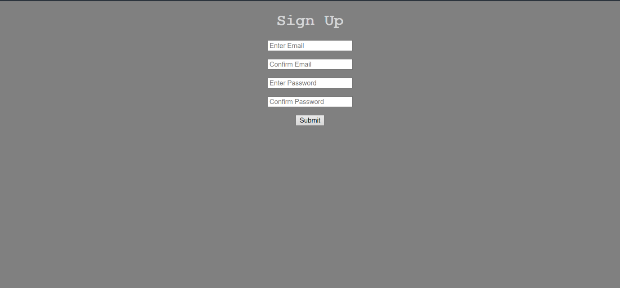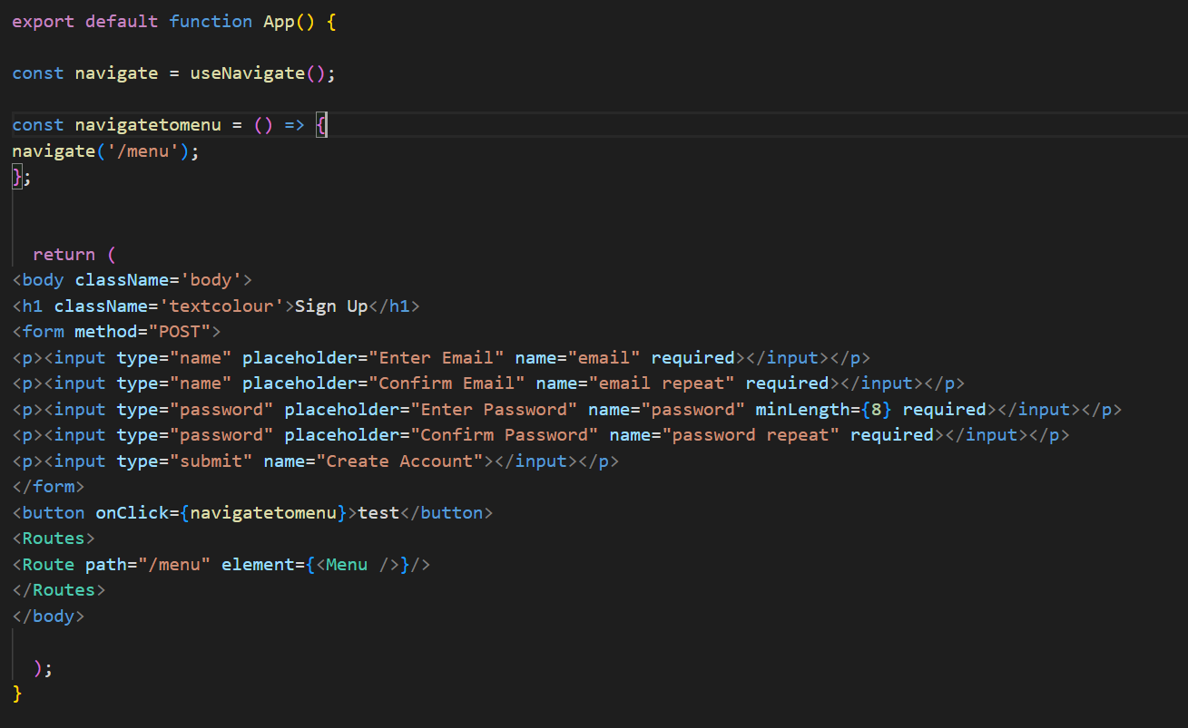**[3]**

When the user presses this button, they should go onto the next page. However, this code was not working, and I was left with a blank page and not the menu page I created.

Navigate function supposedly allows user to navigate to different pages on the website. Menu is another file I created within my program.



This was very difficult to do and time consuming, so I want to try something else using nextjs, nextauth in react typescript and using Planetscale database with Prisma.

This will hopefully allow for much easier authentication and when I eventually come to using the database to hold my questions, I will not have to use apis to show data on the frontend. [4]

## 3.3 Iteration Three

**Signing in through only email:**

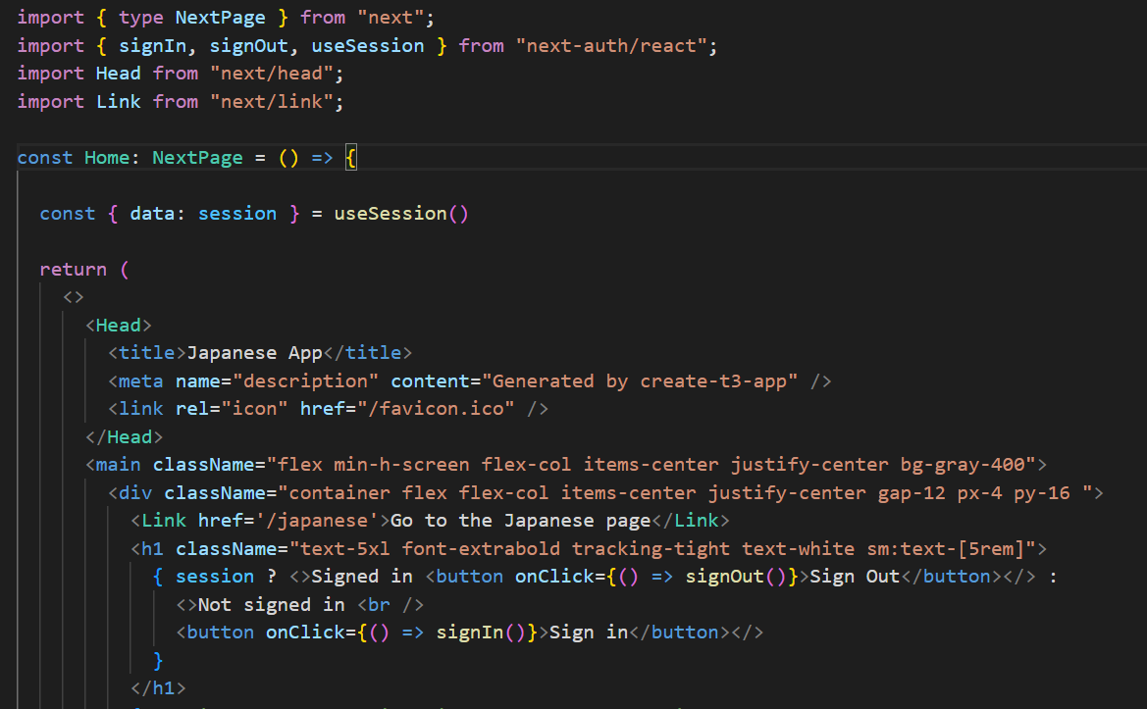

Importing from nextjs, next auth to allow easier authentication and travelling from one page to another.

When the user pressed the sign out button, the button text changes to not signed in. In turn, when the user presses the sign in button the text changes to signed in.

Pre-written code.

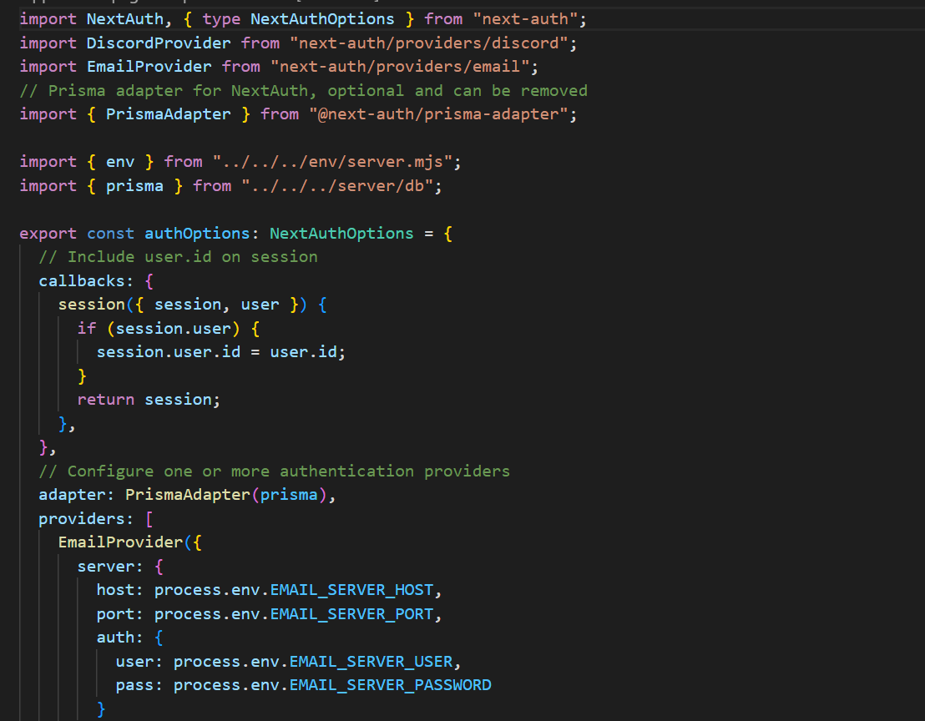

These imports allow us to set up authentication using the nextauth library on our website. This allows the user to be authenticated only through their email.

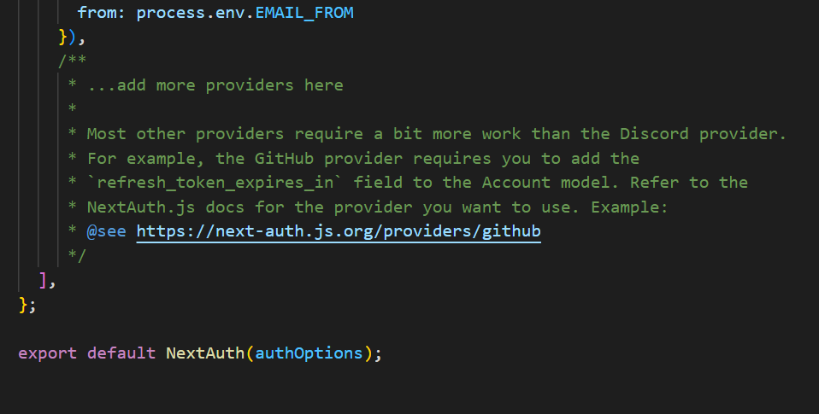**[5]**

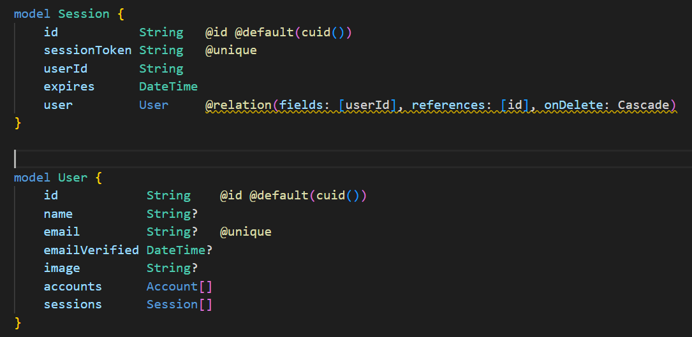

Pre-existing tables within the database. User’s email will be stored in the email field in the user table once they sign in with an email.



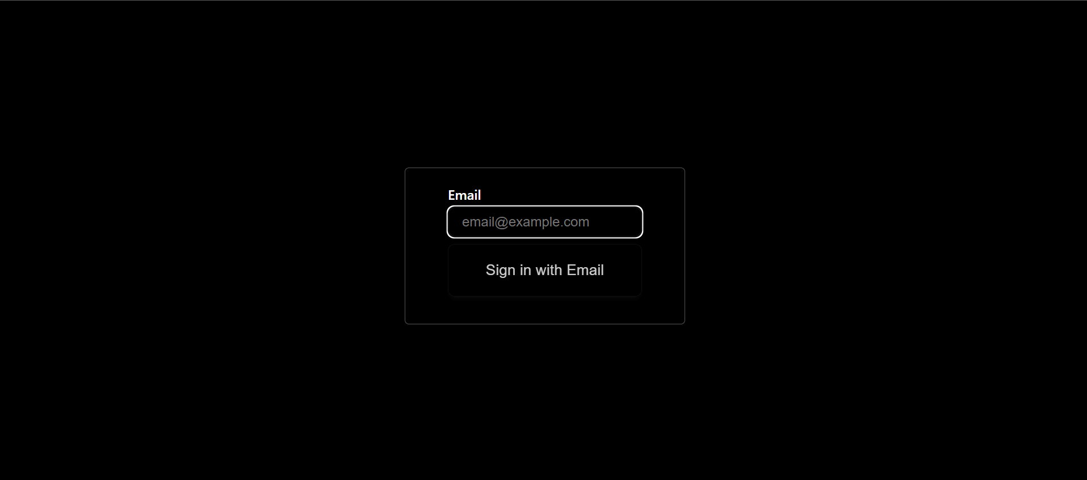

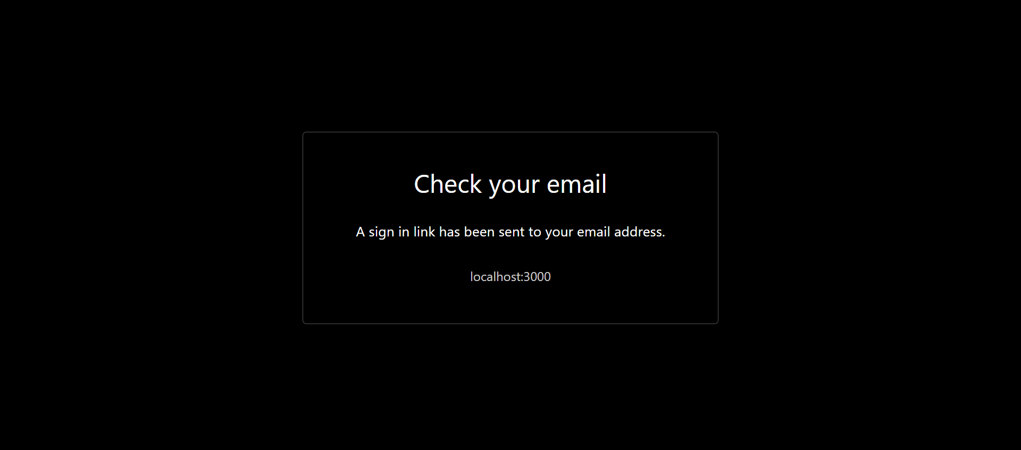

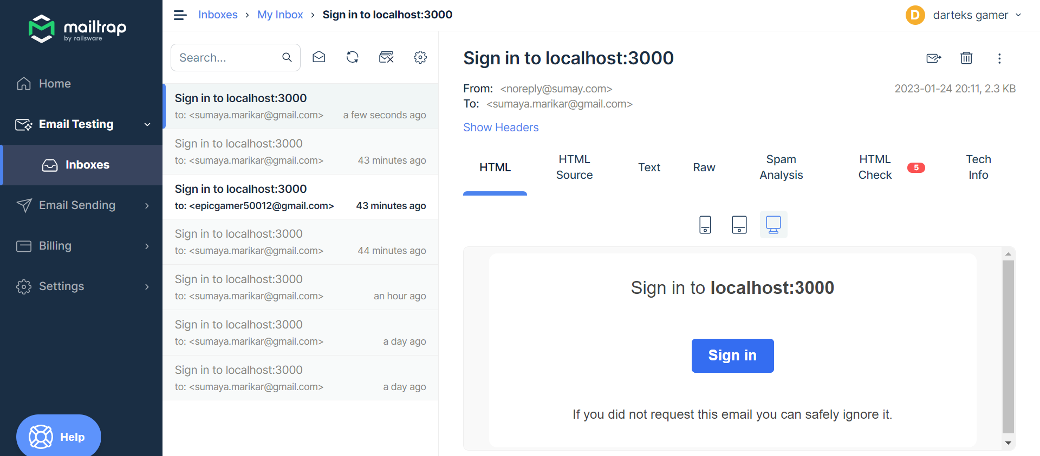

When user presses the link in their “email” it takes them to the website where they are now signed in.

Traps it in a mail server so it does not actually go to my email.



**Navigating to different pages within the program:**

Adds a link to the page which takes you to another page when it is clicked. /Japanese is another folder in my program



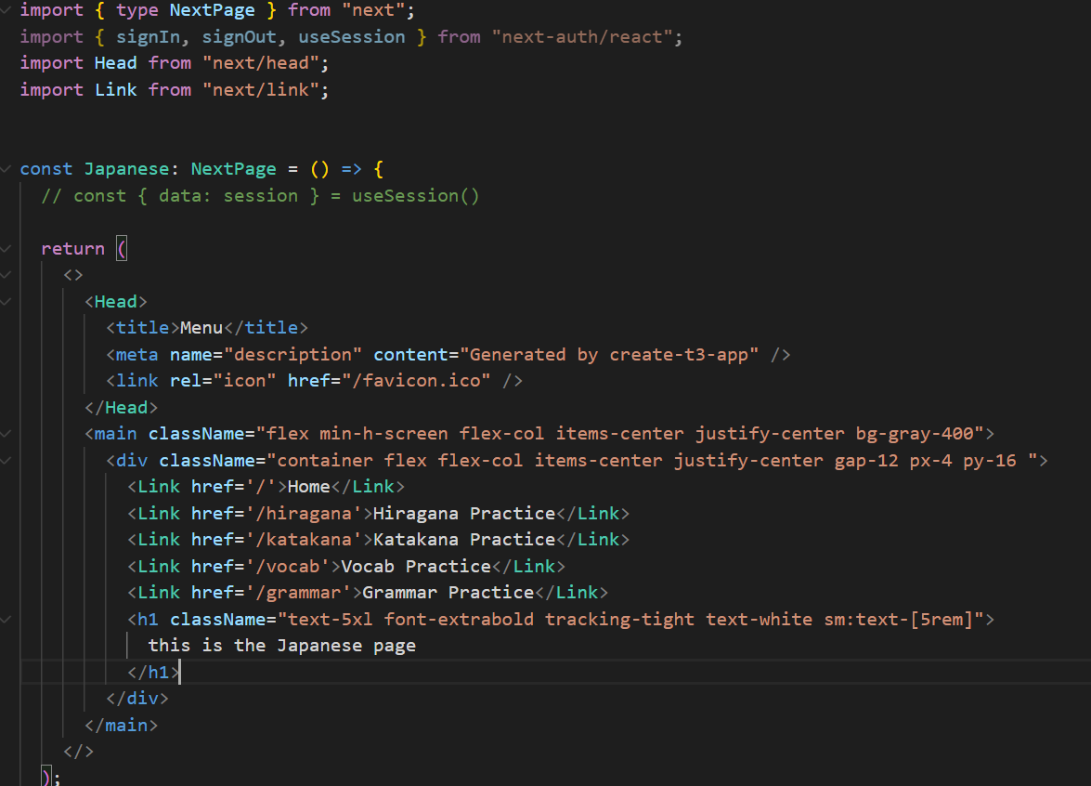

Added links for other pages.





These links allow the user to navigate back to the home and menu pages.

**Etc.**

## 3.4 Iteration Four

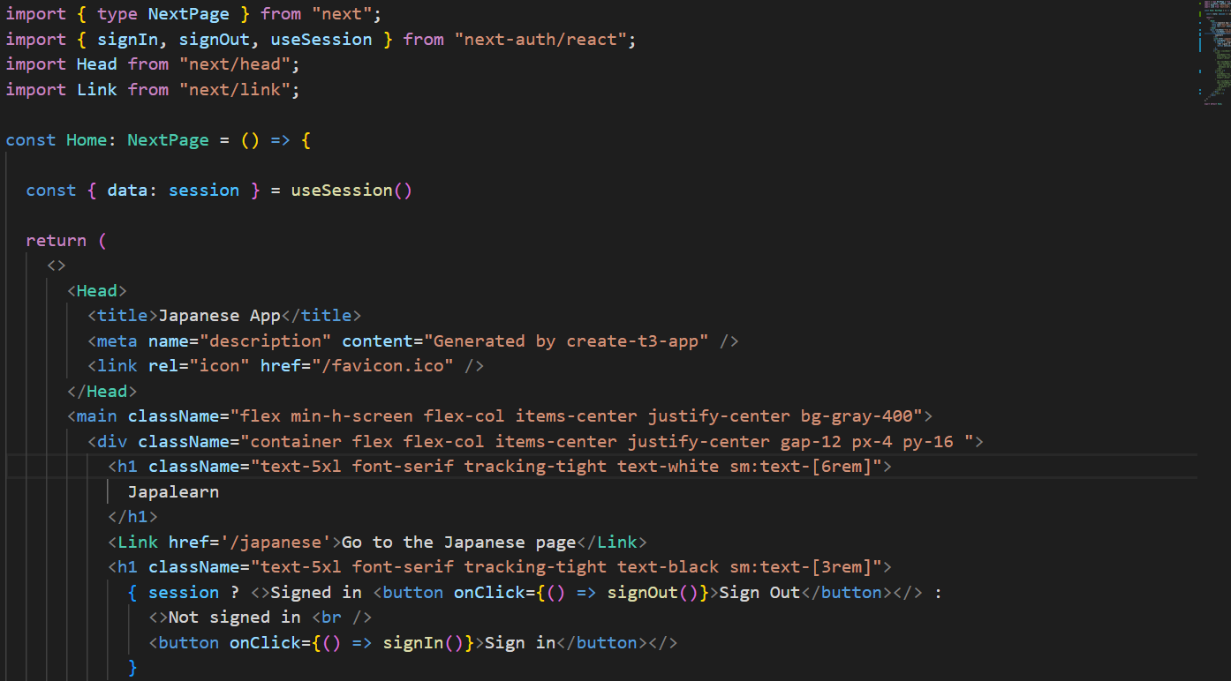

Some style changes, the class Names change the css name which allows changing of fonts and colours etc.



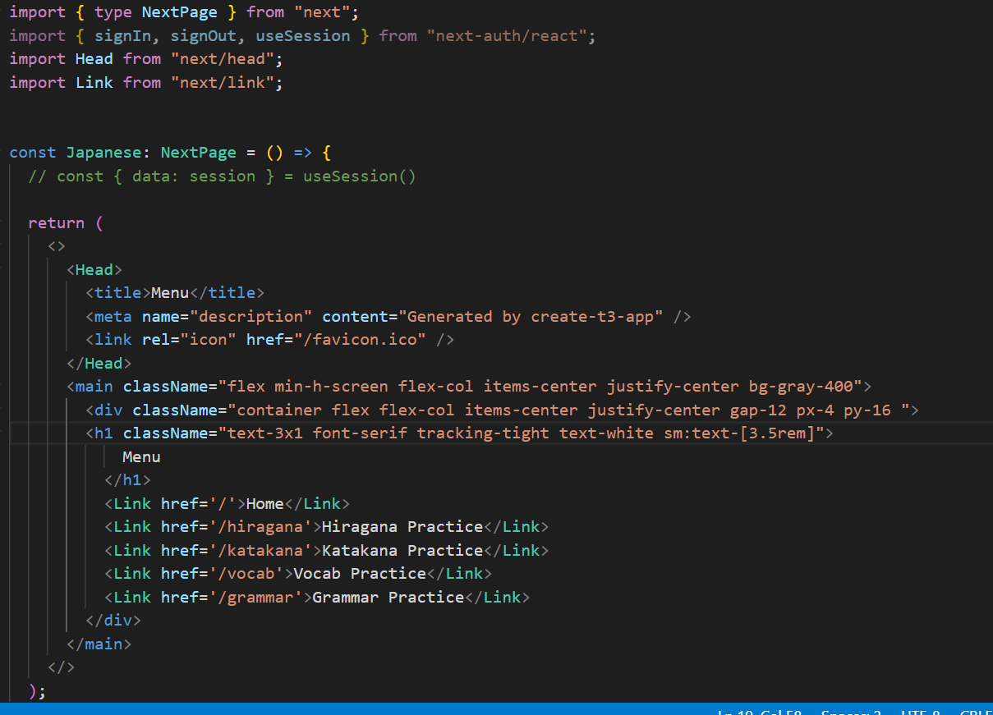

Some style changes again, the class Names change the css name which allows changing of fonts and colours etc.



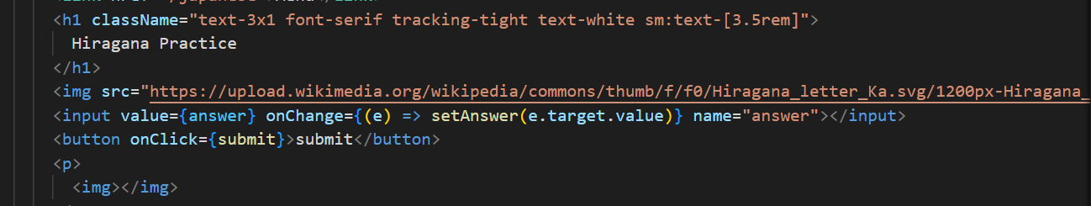

onChange: on when the user starts entering something. ( e ) means event.

Showing an image of a hiragana character to the user with an input box which allows them to enter which character they think it is.

**What is an event? [6]**

Events in react happen when the user interacts with the user interface through e.g., inputting something into a text box and or clicking a button. They are used to allow functions to run within React components (in this case a button when it is clicked).

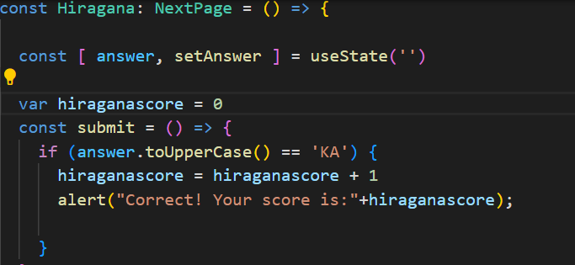

Variable hiraganascore initially set to 0 and increments when the user gets the answer correct.

The function which will show an alert box to the user if they correctly identify the character and also press the submit button.



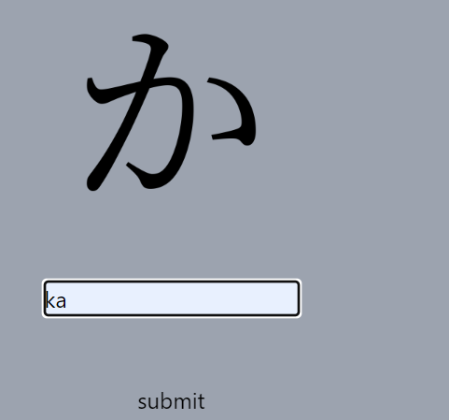

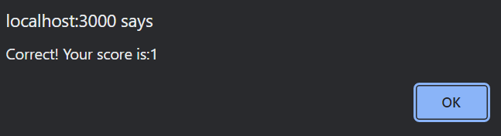

Score increments.

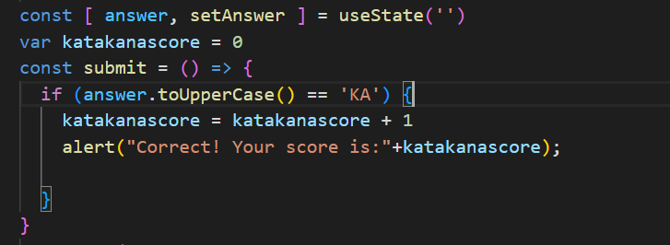

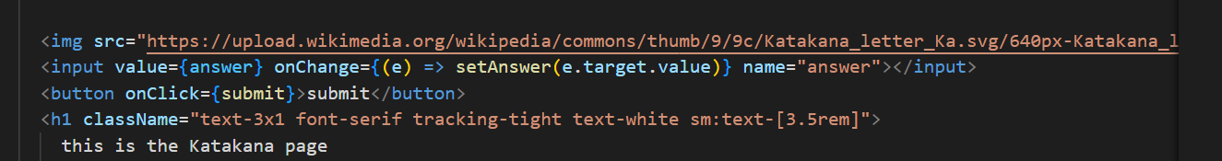

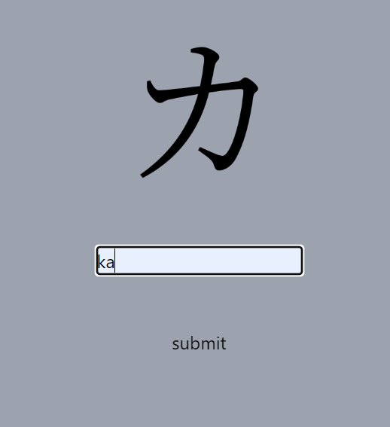

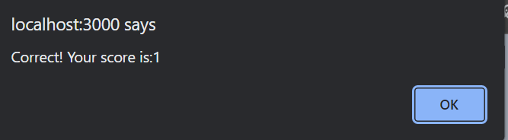

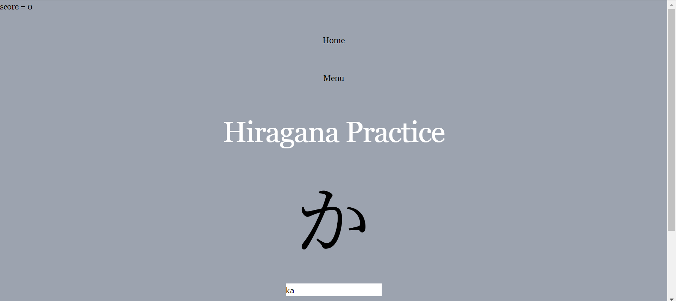

The score increments on the alert the website displays but not on the actual website.



I have currently hard-coded this bit of the solution. Although this works well, I would like to have minimum 5 questions. Hard coding all of those will be time-consuming. Thus, I intend to store all the image links of the characters I wish to test the user on in a database and pull them from there.

## 3.5 Iteration Five

**Score displayed on left top of page:**

Currently working on updating the score on the top left when the person answers the questions. For now, the score updates on the alert the website outputted but does not update on the top left. For this I intend to use react Context:

In react you can use context which allows sharing of data between different parts (e.g., folders, pages etc.) without passing it through each one. In other words, it can globalise a variable so it can be accessed from anywhere within the program.

**Context**

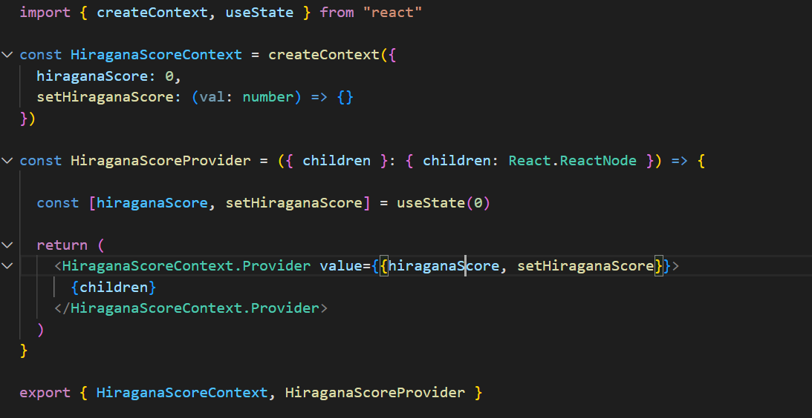

Importing createContext as it allows me to create context of which components of my program can read etc.

Importing useState which allows a component to have a state variable.

[7]

**What is state? [8]**

State, in react, allows you to store data within a component. As the user interacts with the UI (user interface), state can change dynamically. In this example, it stores the current value of the scores.

This allows Context to be used **anywhere** in the program.

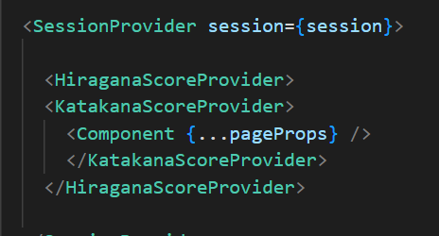

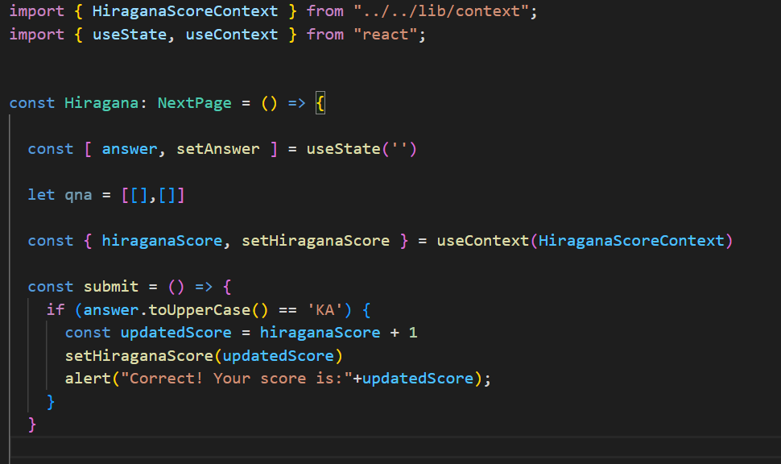

Importing my Contexts from the context page so it can be used in the main program.



The score will update in real time.



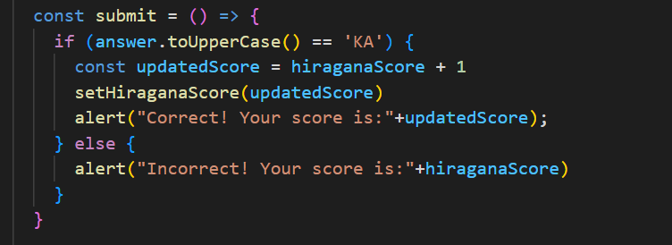

Adequate error message shown. Score will stay the same.

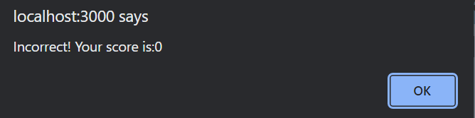

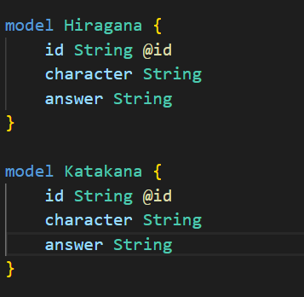

Setting up models which will be tables within my database.

[9]

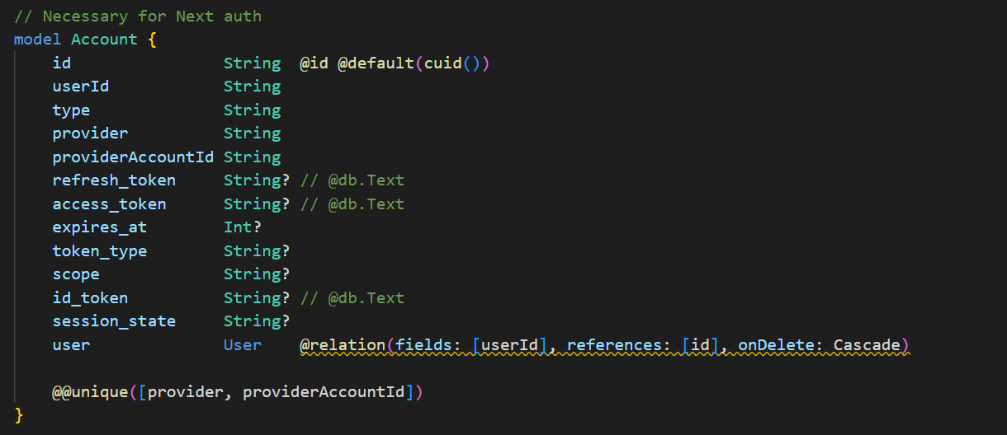

## 3.6 Iteration Six

After pushing the models to the database, I can query it now.

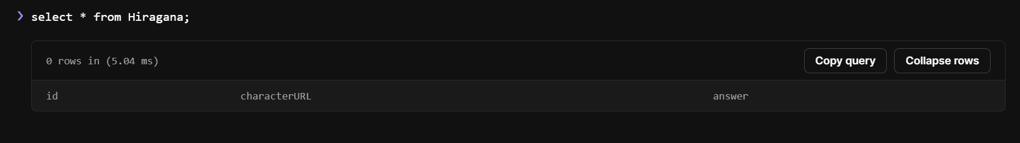

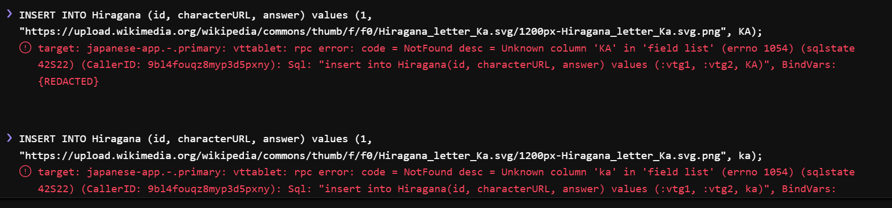

I tried inserting values into the database but unfortunately it was not working.



Fortunately, I only had to add speech marks for it to work.

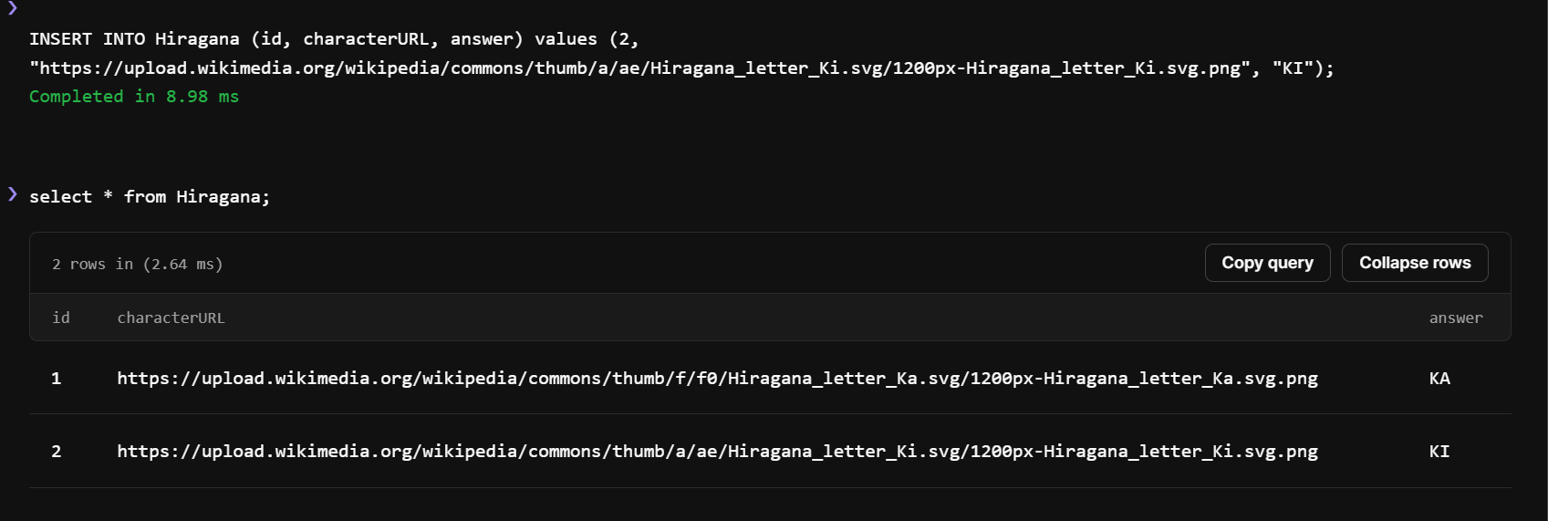

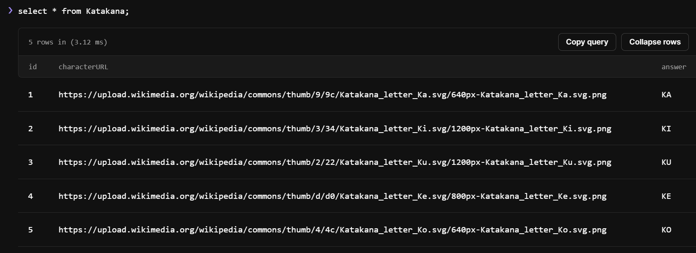

Inserted 5 values into the database, I intend to ask the user 5 questions in each section.

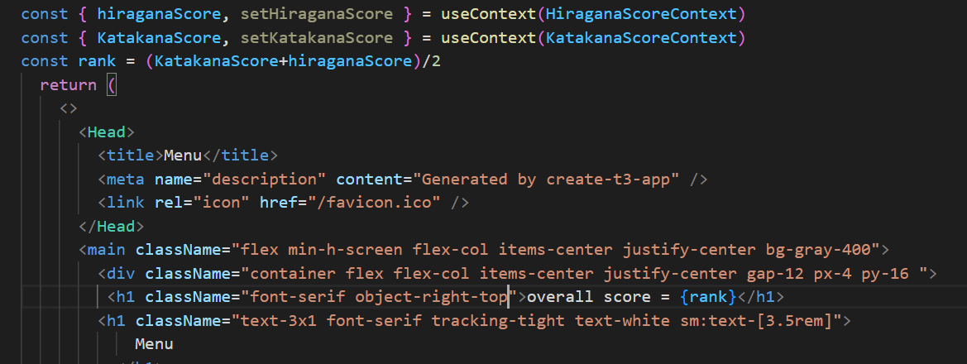

The user’s overall rank will be the average of their scores within Hiragana and Katakana

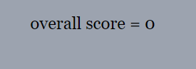

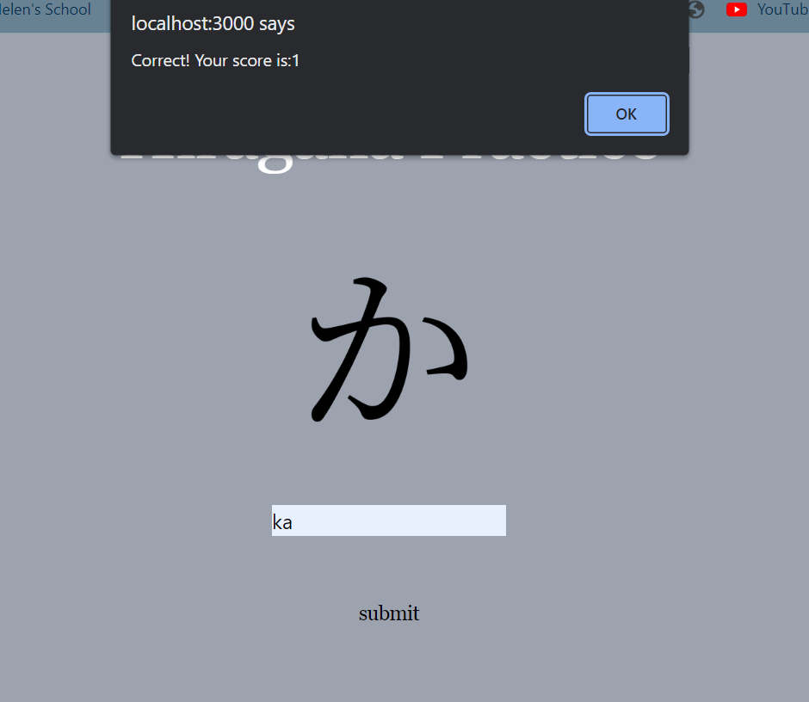

The user may enter the correct answer in both sections.

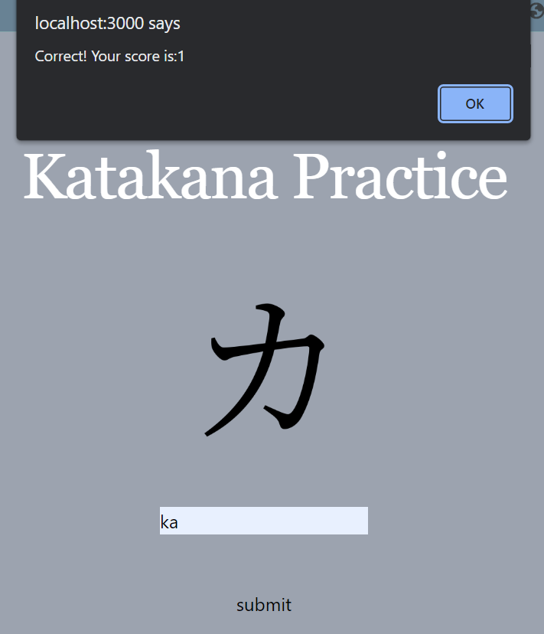



An average is taken and the overall score updates on the menu page!

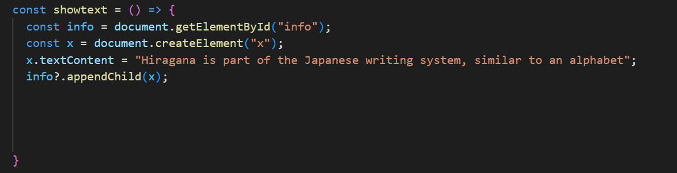[10]

When the “What is Hiragana” button is the text “Hiragana….alphabet” will show

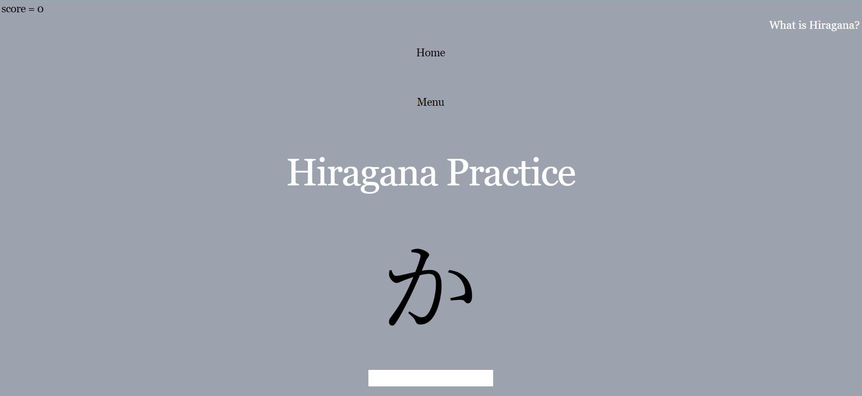

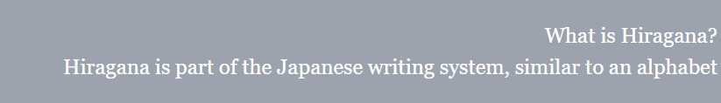

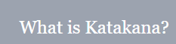

Same code for Katakana

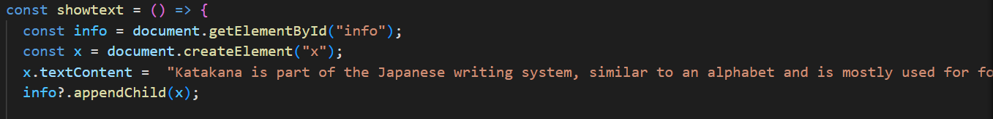





Same as above.

Unfortunately, this button does not toggle, so when clicked twice the text duplicates rather than going to the original text.

## 3.7 Iteration Seven

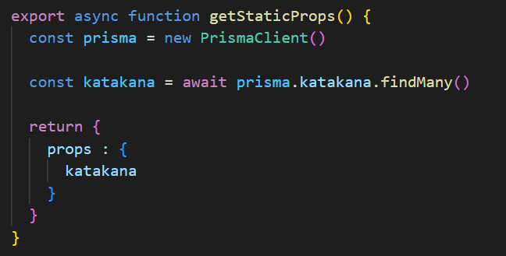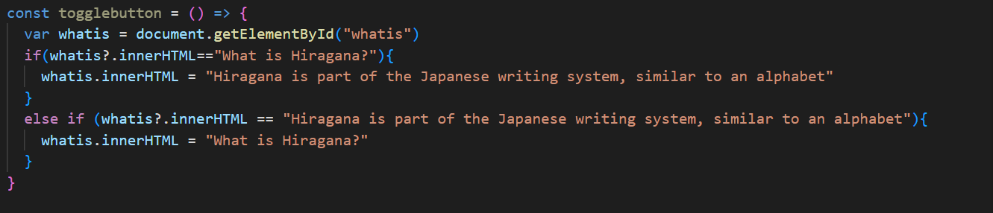

PrismaClient can be used to show data from a Planetscale database on the frontend of a website. Here I am retrieving data from my Katakana table within the database. Data is returned as an object with the property Katakana once it is retrieved from the database.

This code supposedly allows the button to toggle but Unfortunately it was not working the text just duplicated again when the button was pressed twice.

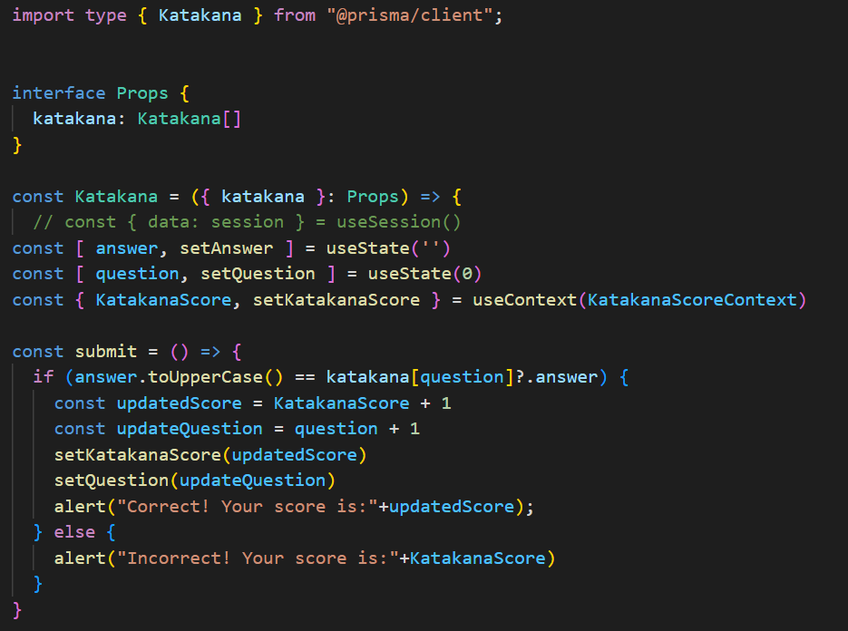

An interface defines a “blueprint” for an object. This ensures each function and component will receive the correct data.

After submitting the index increments and goes to the next image in the database.

Grabs the url from the database . characterURL is the field in which the link is stored in. Now all the images are stored in the database rather than directly in the code

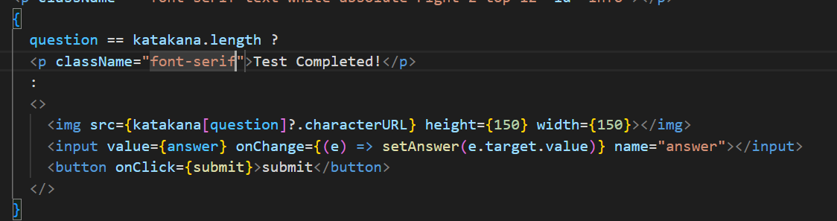

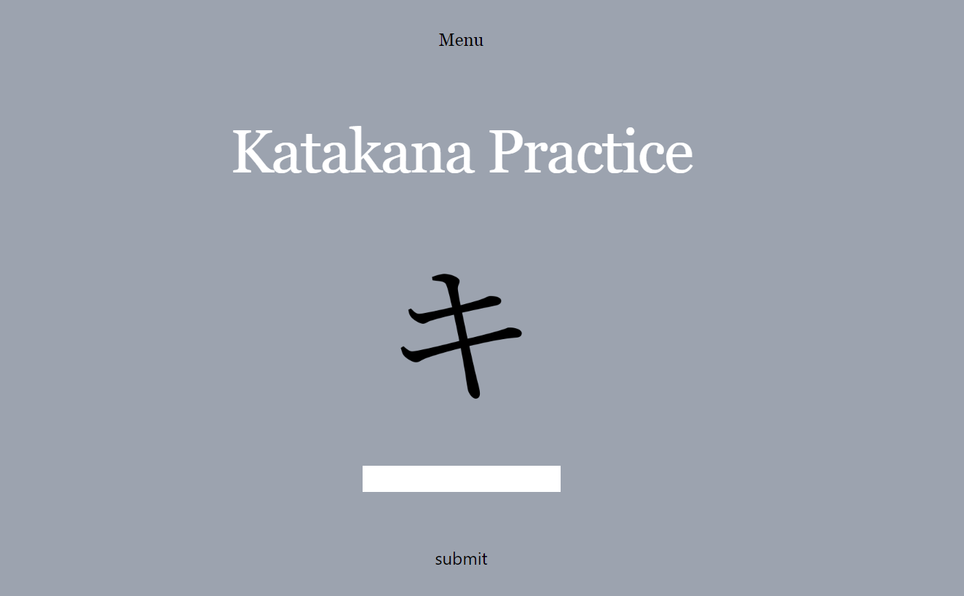

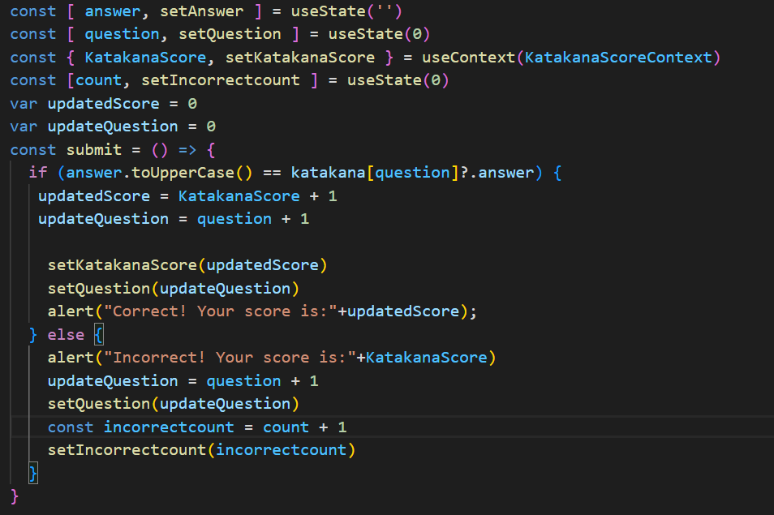

When the code reaches the end of the list/field in the database, the text in the submit “button” changes to “Test completed…..”

Count which counts how many questions the user got incorrect. State set to 0 initially.

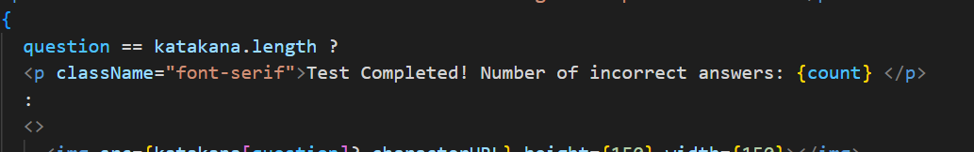

Thankfully I was able to store the image links in the database and show them on the frontend. However, I have not implemented a “progress bar” (or simply a number showing the user what question the are one) yet. I intend to do that in the next iteration.

## 3.8 Iteration Eight

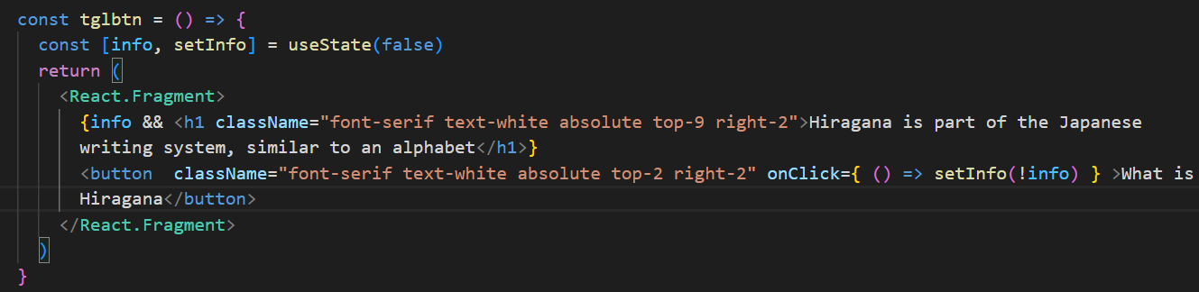

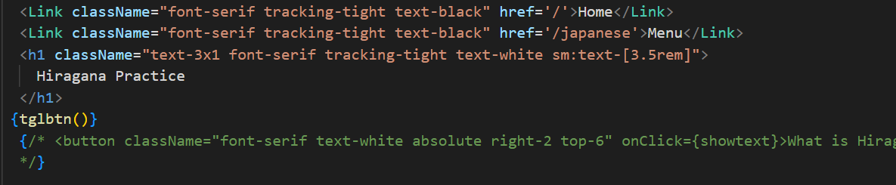

This code changes the text of a button when clicked. UseState is used to change the visibility of this. At first it is false, but when the function is called (on the click of the button), the visibility changes to the opposite state.

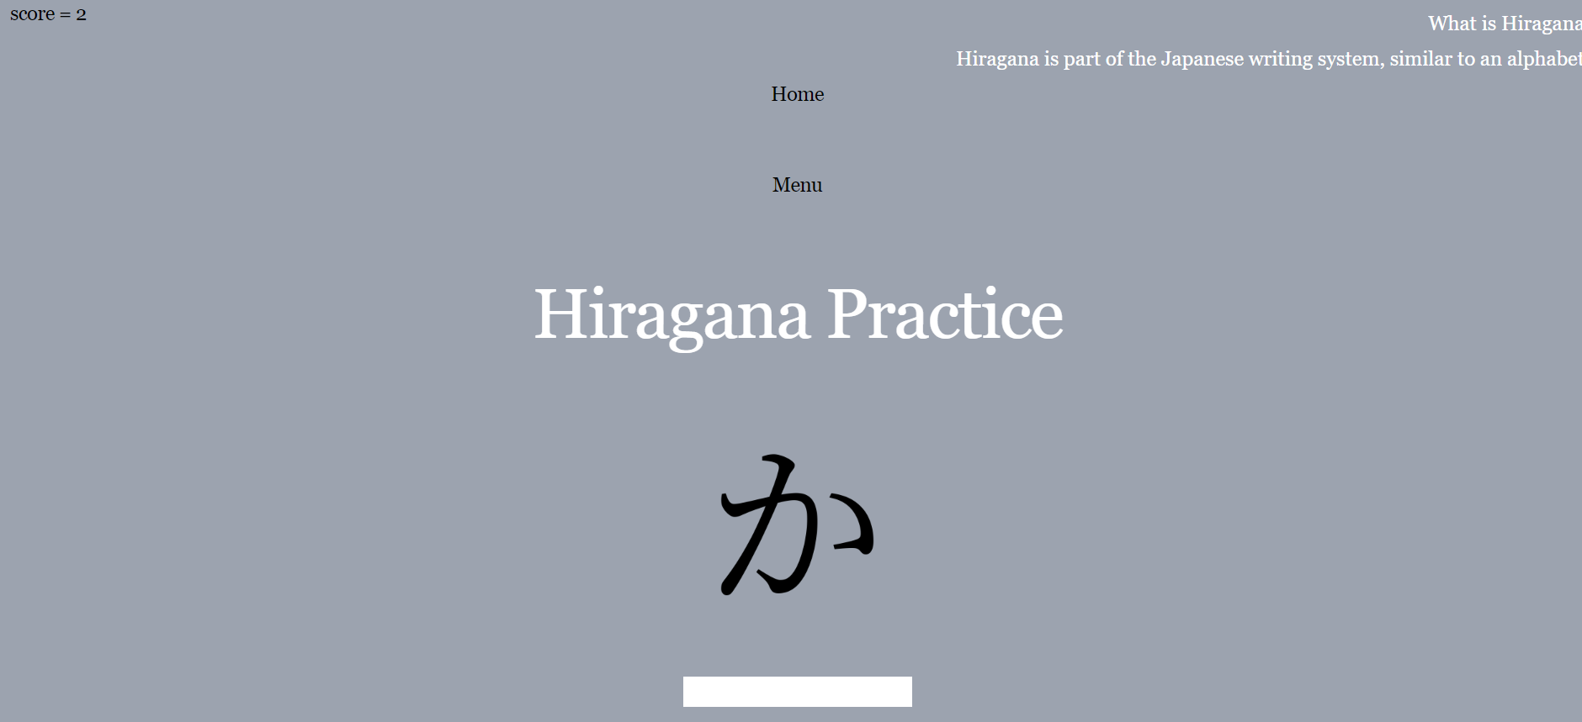

This button now toggles. Unlike the previous code, when this button is clicked twice, the code does not duplicate.

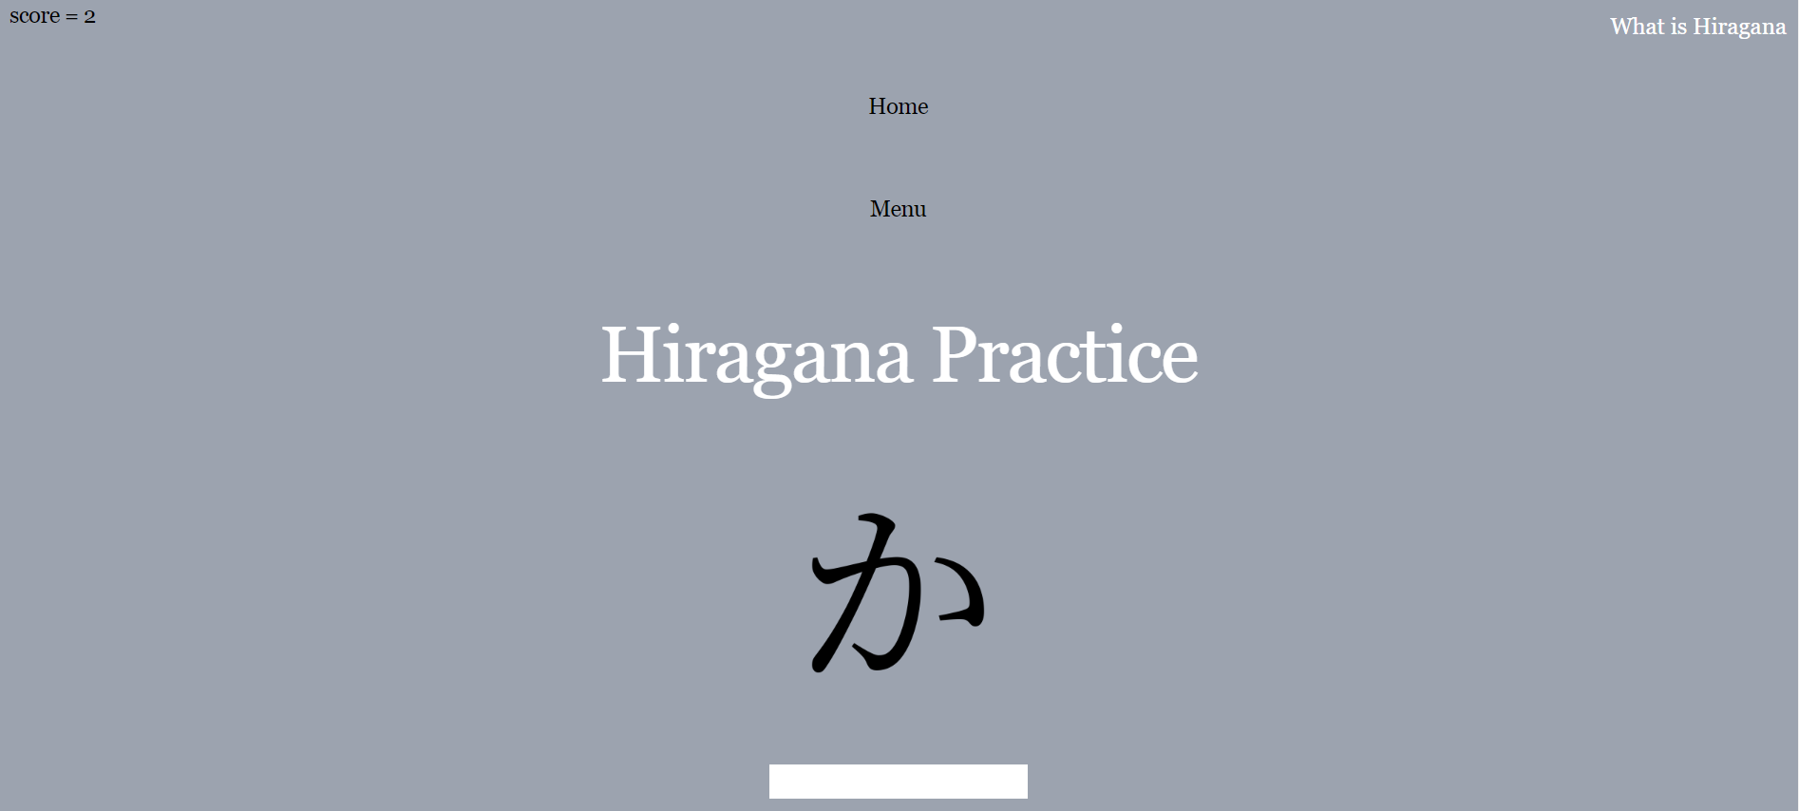

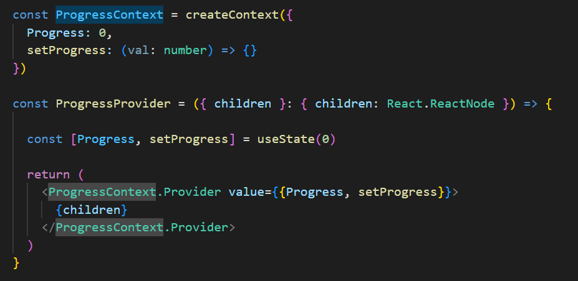

Setting up context for a “Progress Bar”. This will hopefully show the user which question they are on.

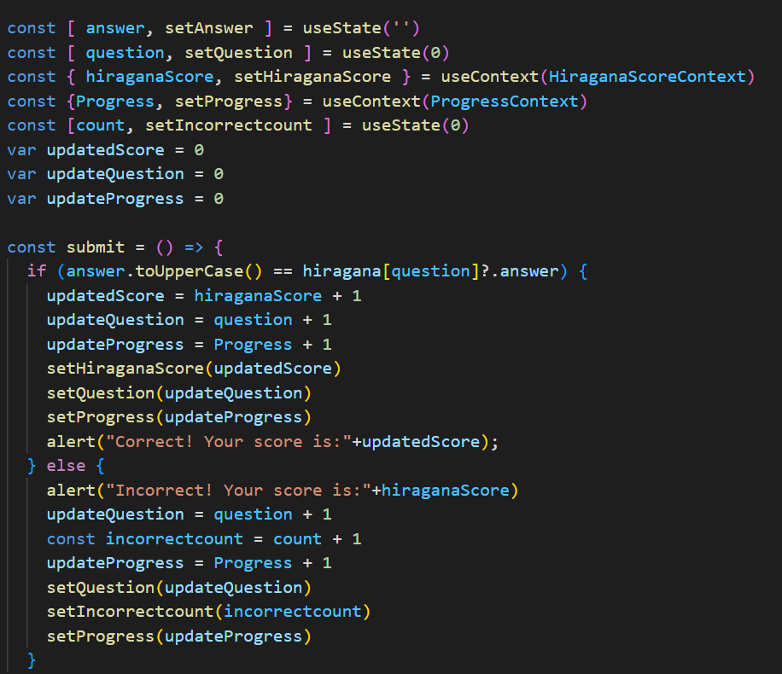

When the user completes a question, progress increments and shows the question the user is on.



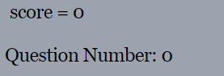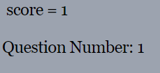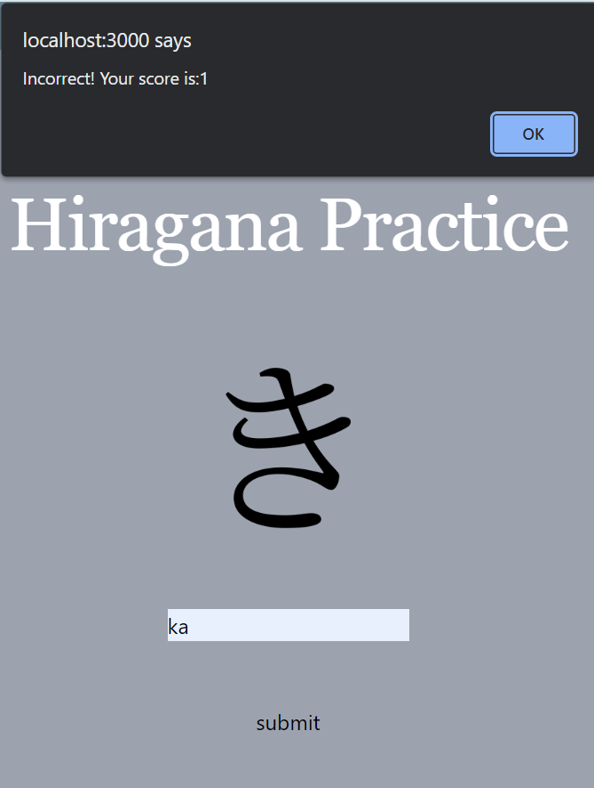

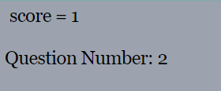

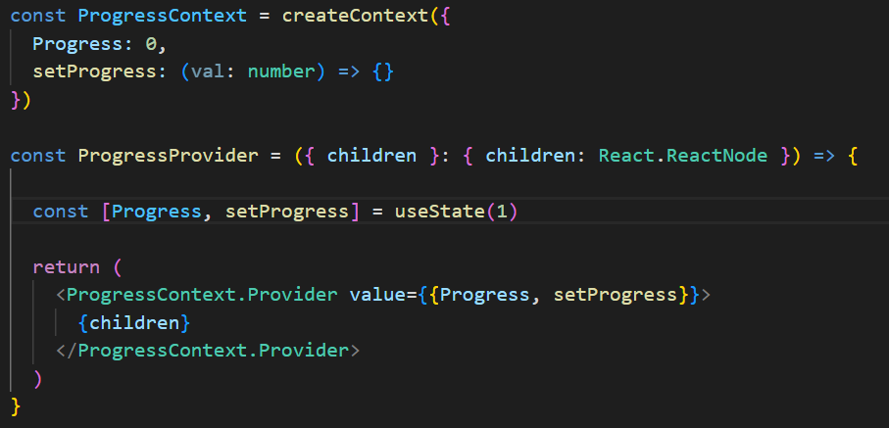

Set the initial state of Progress to 1 so it starts from Question Number: 1. It does not make sense to start from question 0.

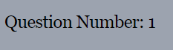



Added this image.





# 4. Evaluation

## 4.1 Testing Data

**Log-in**

|  |  |
| --- | --- |
| Test Data | Type |
| [something@example.com](mailto:something@example.com) | Valid – as expected |
| Helloworld | Invalid – as expected |
| 1111 | Invalid – as expected |
| something@example | Valid – as expected |

**Test case: something@example.com**

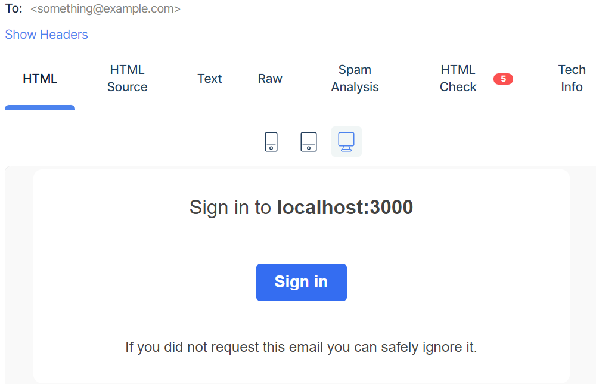

This test data is seen as valid and so an email is sent to their email address wherein when clicked, they will be directed to the website where they are now logged in



**Test case: Helloworld**

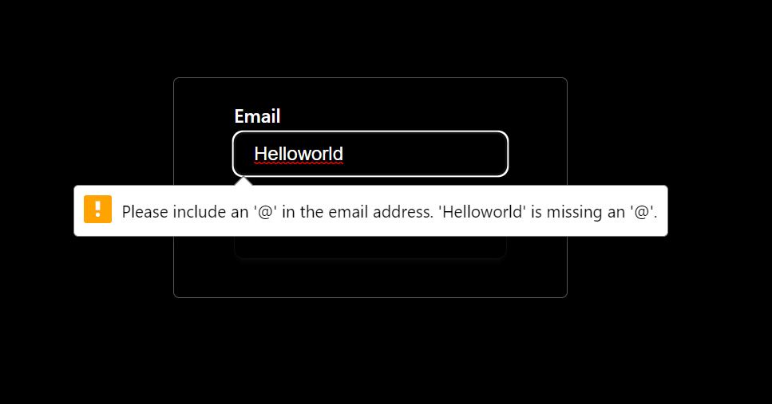

Invalid, appropriate message shown.

**Test case: 1111**

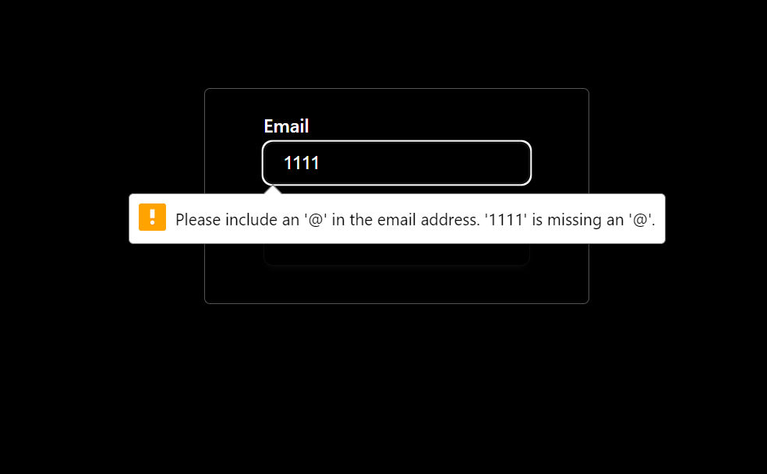

Invalid, appropriate message shown.

**Test case: something@example**

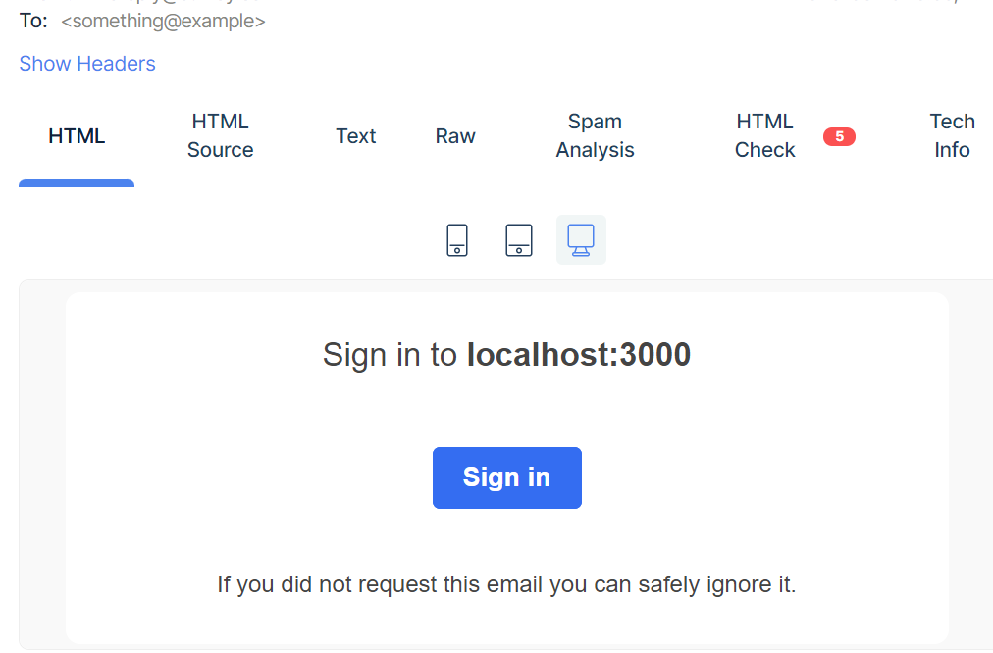

This test data is seen as valid and so an email is sent to their email address wherein when clicked, they will be directed to the website where they are now logged in.



**Sign-up**

|  |  |
| --- | --- |
| Test Data | Type |
| [something@example.com](mailto:something@example.com) | Valid |
| Helloworld | Invalid |
| 1111 | Invalid |
| something@example | Valid |

**Test case: something@example.com**



Because of the nature of this authentication, it works the same way as logging-in. And so, this is valid.



**Test case: Helloworld**



Invalid appropriate message shown.

**Test case: 1111**



Invalid appropriate message shown.

**Test case: something@example**



Because of the nature of this authentication, it works the same way as logging-in. And so, this is valid.



**Clicking Links to Pages**

|  |  |
| --- | --- |
| Test data | Type |
| Clicking on the Link | Valid – directed to the page – as expected |
| Clicking away from the Link | Invalid – as expected |

**Test case: Clicking on the Link**

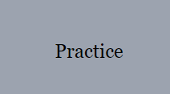

Clicking on the practice link on the “start-page” directs you to the menu-page.

Clicking on the practice links on the menu-page takes you to these pages.

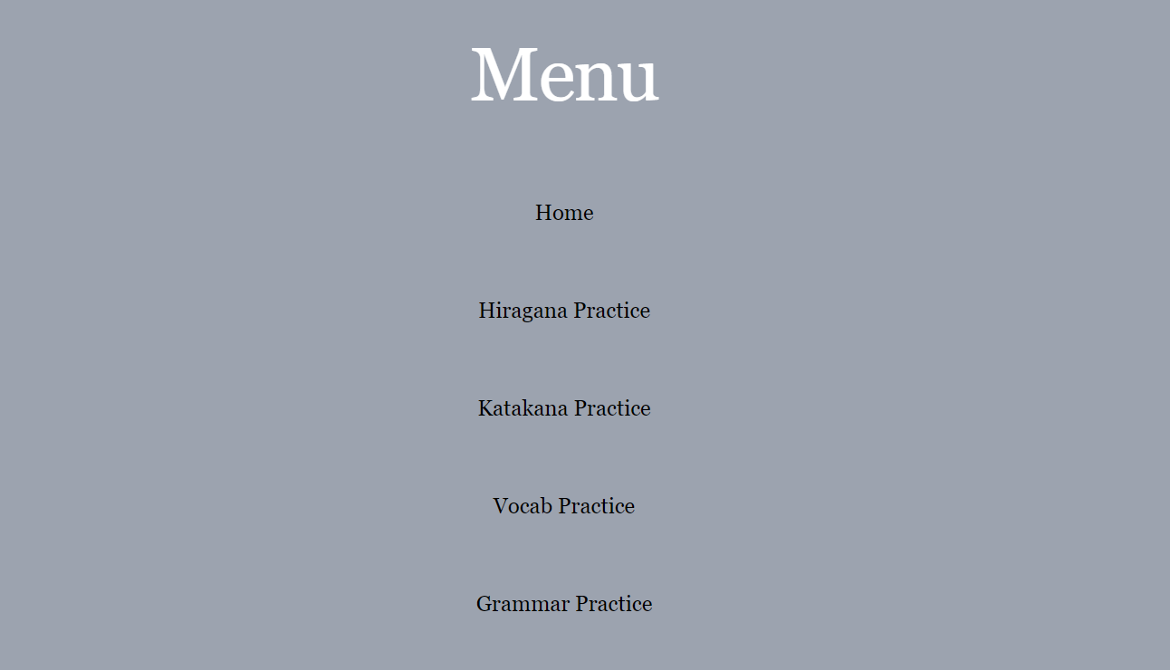



**Test case: Clicking away from the links**

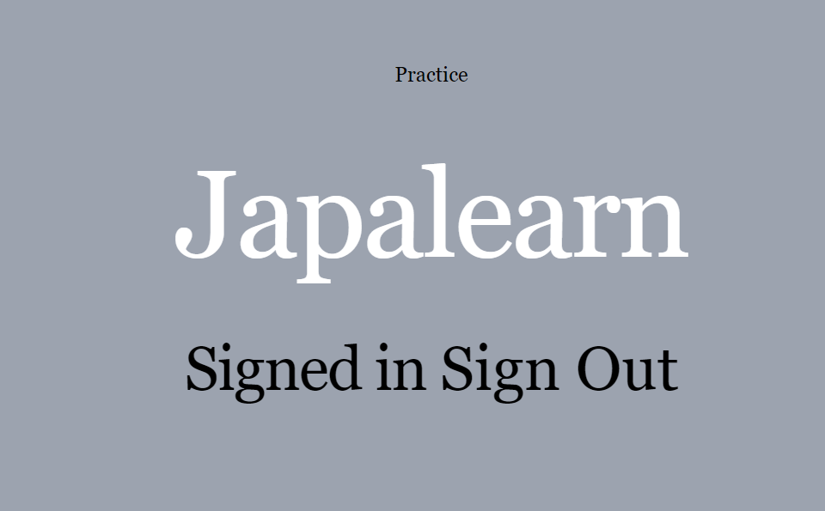

Clicking away from the links does not direct you anywhere.

**Clicking the Information button**

|  |  |
| --- | --- |
| Test data | Type |
| Clicking on the button | Valid – text displayed informing the user what Hiragana/Katakana |
| Clicking away from the button | Invalid |

**Test case: Clicking on the button**

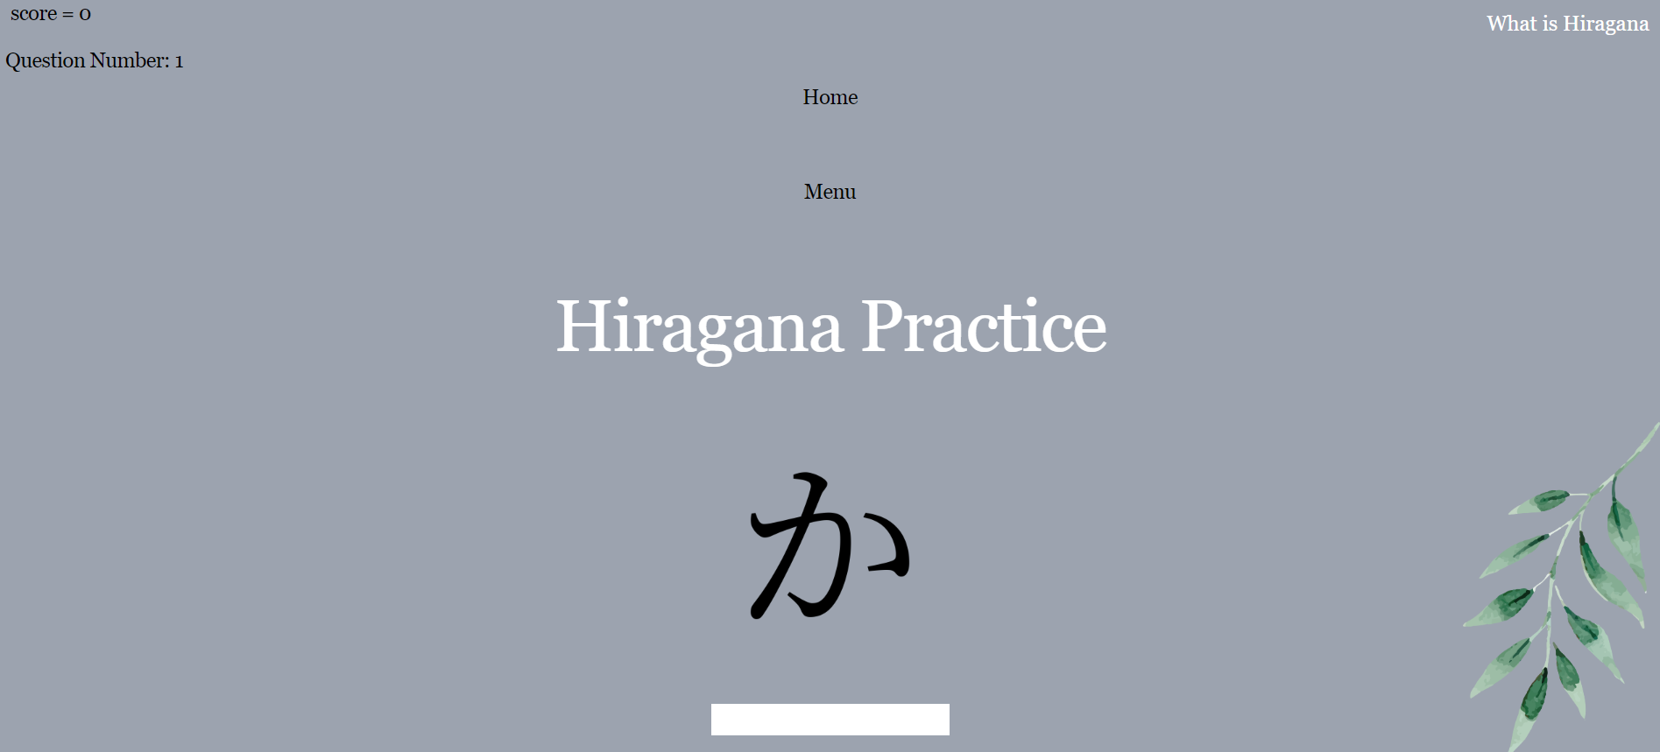

Clicking on the button shows the text.

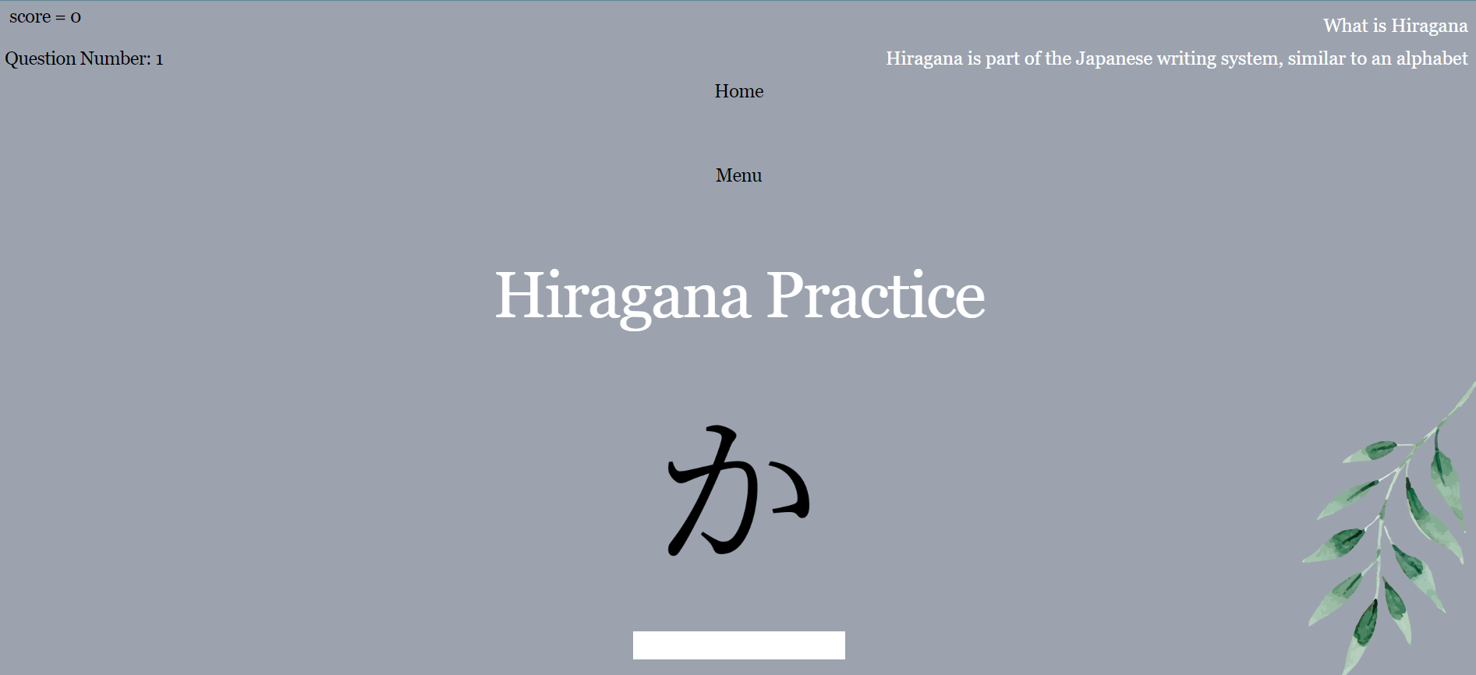

**Test case: Clicking away from the button**



Clicking away from the button does not show any text.

**Hiragana task page**

**For this test I am going to use the hiragana character ka as what will be shown to the user in each of these test cases.**

|  |  |
| --- | --- |
| Test data | Type |
| KA | Valid – Correct, score increments – as expected |
| ka | Valid – Correct, score increments – as expected |
| kA | Valid – Correct, score increments – as expected |
| Ka | Valid – Correct, score increments – as expected |
| A | Invalid – Incorrect, score stays the same – as expected |
| a | Invalid – Incorrect, score stays the same – as expected |
| 12 | Invalid – Incorrect, score stays the same – as expected |
| !! | Invalid – Incorrect, score stays the same – as expected |
| % | Invalid – Incorrect, score stays the same – as expected |

All test cases with the letters ka together worked as expected because the code changes the answers to uppercase which is what it is in the database.

**Test case: KA**

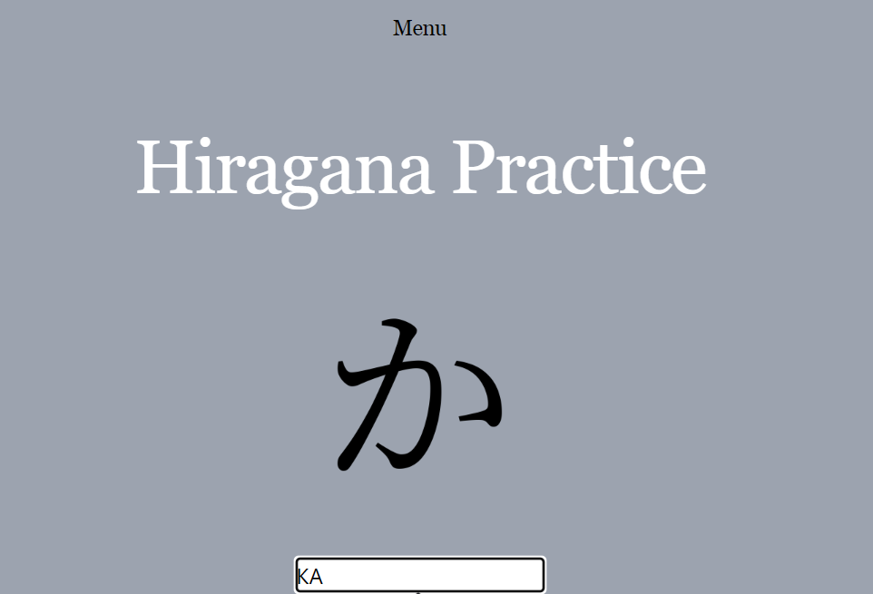

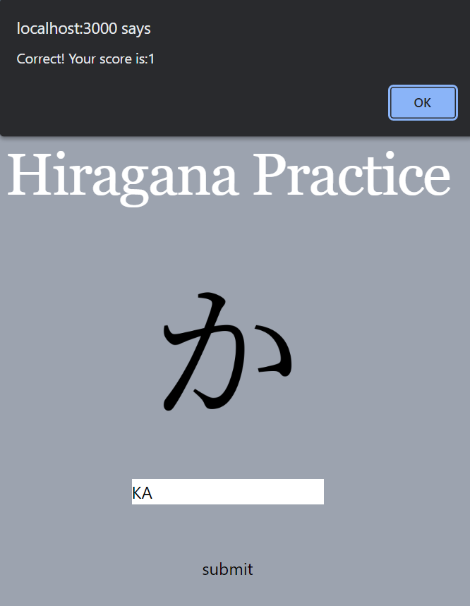

**Test case: ka**

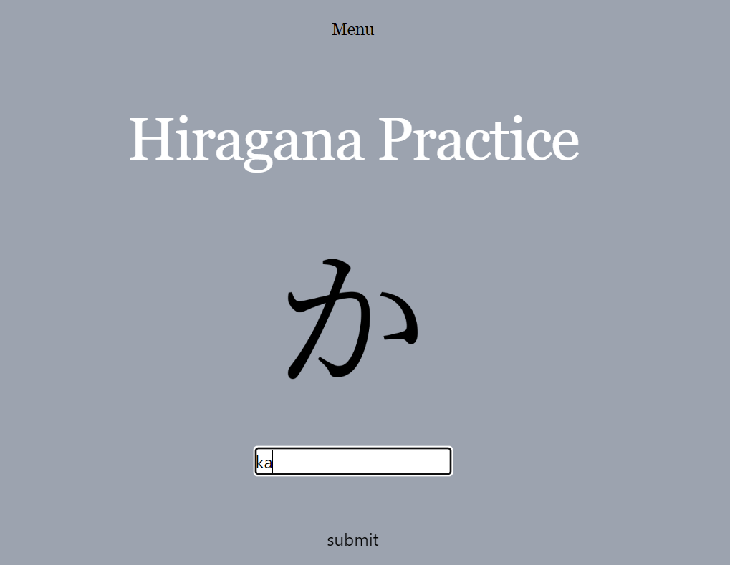

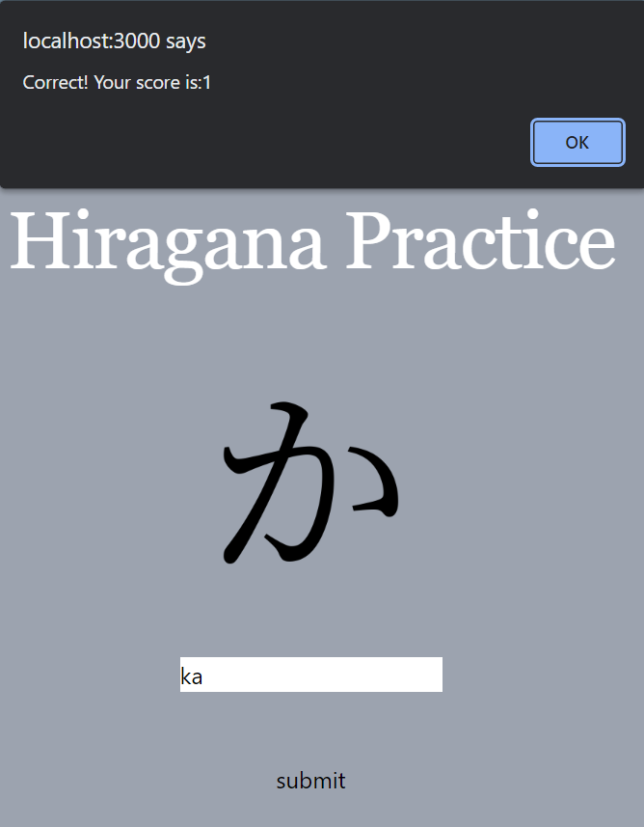

**Test case: kA**

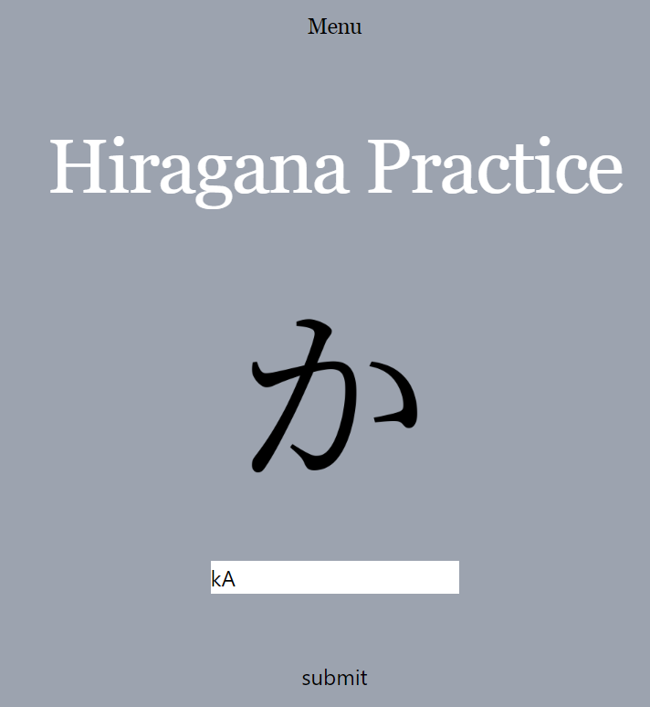

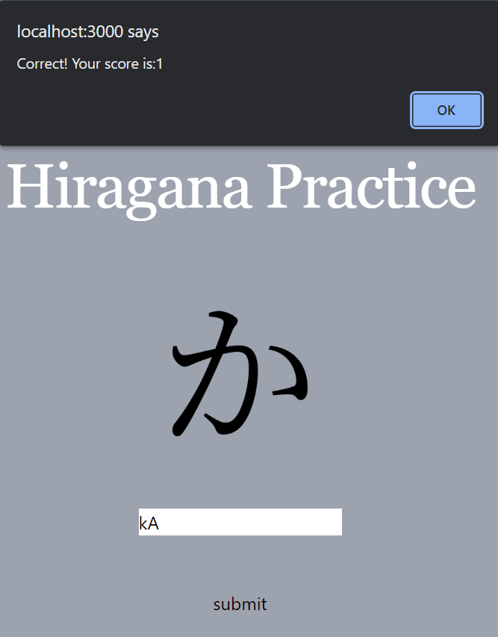

**Test case: Ka**

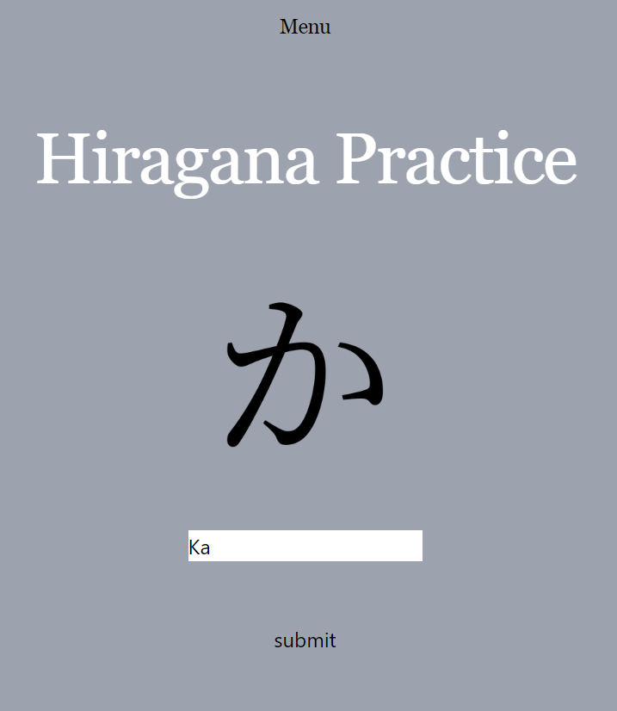

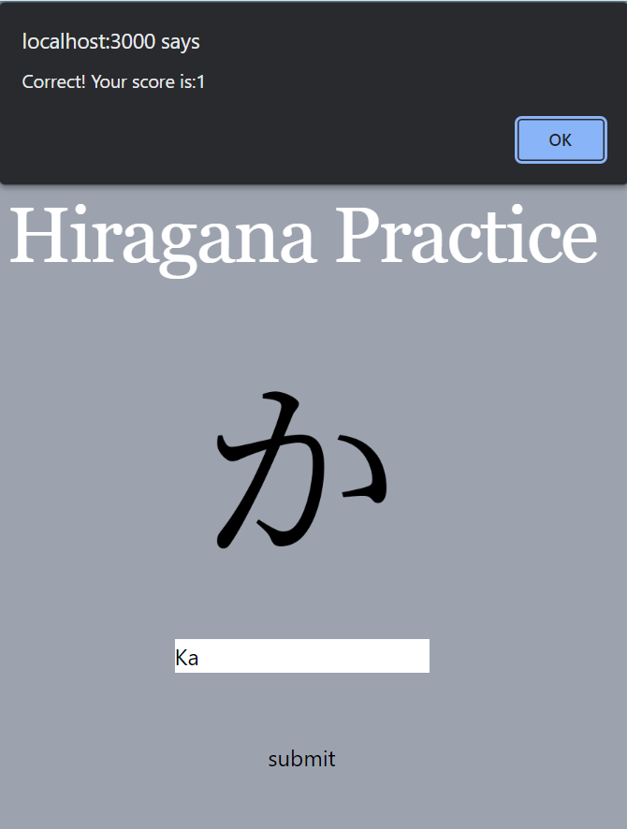

All test cases without ka together, did not work as that is not what is held in the database.

**Test case: A**

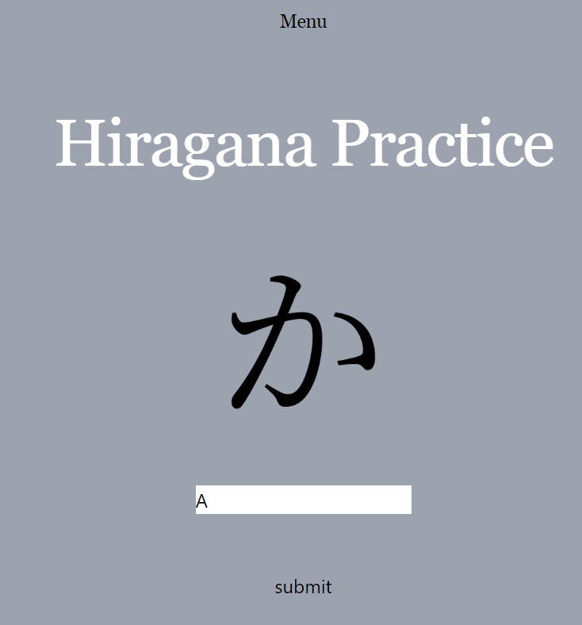

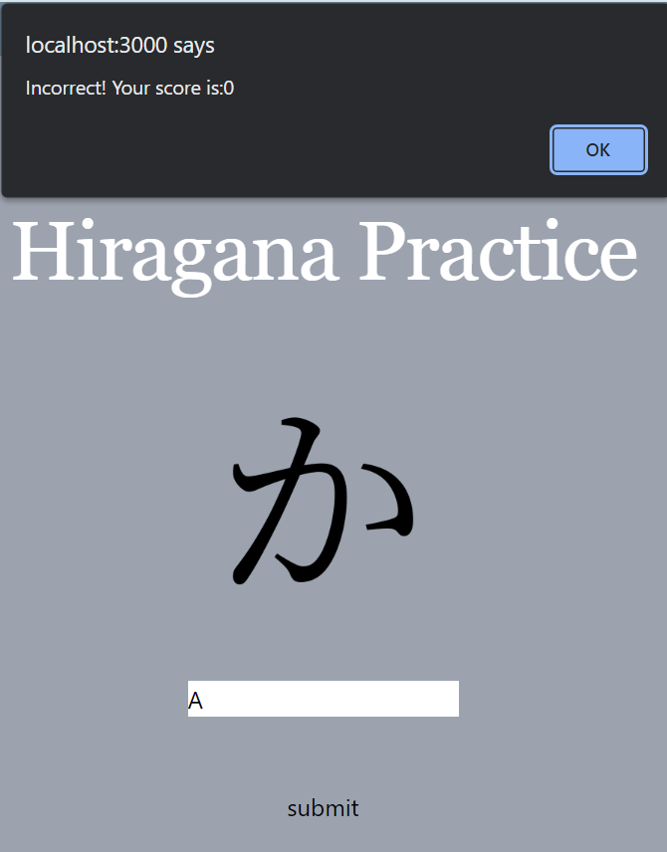

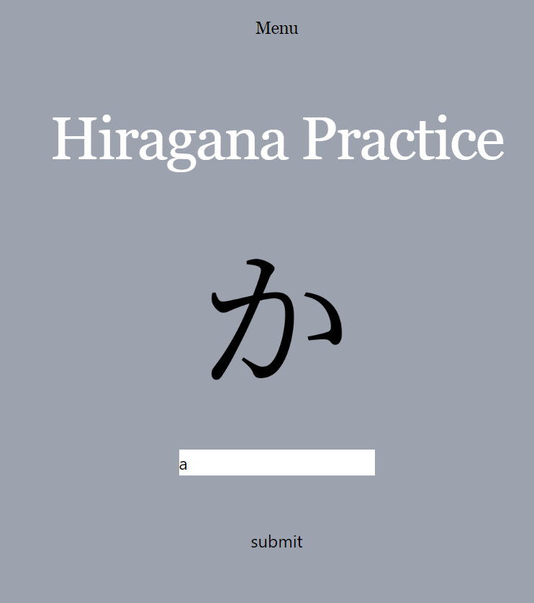

**Test case: a**

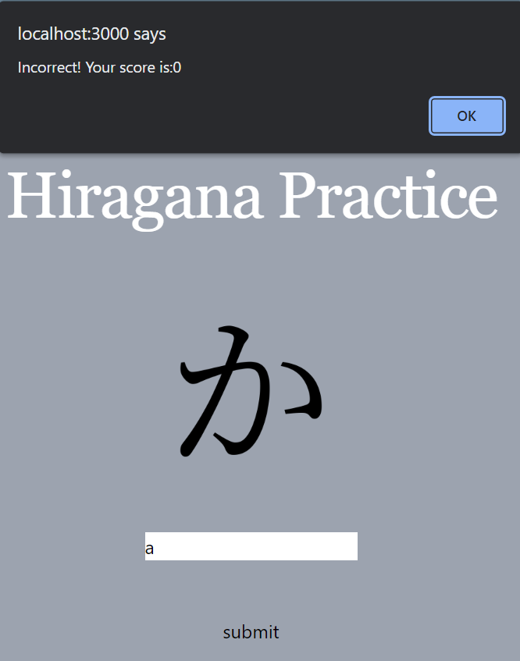

**Test case: 12**

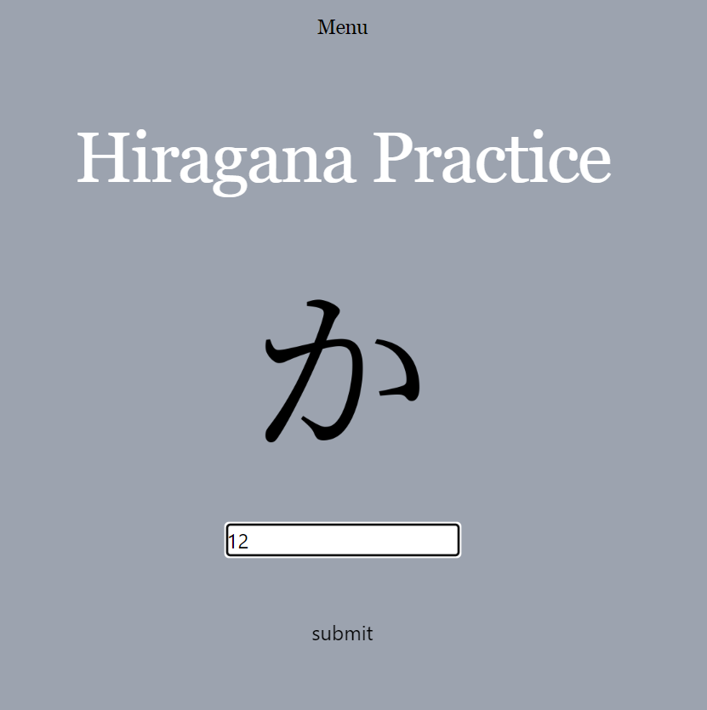

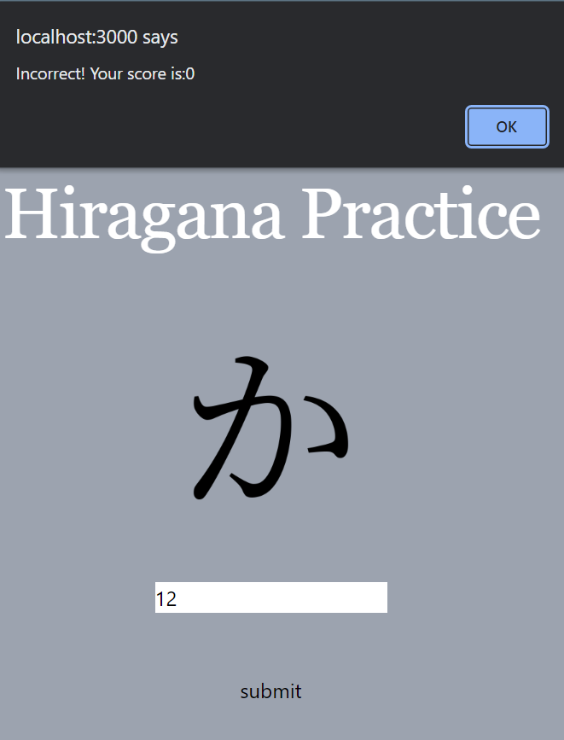

**Test case: !!**

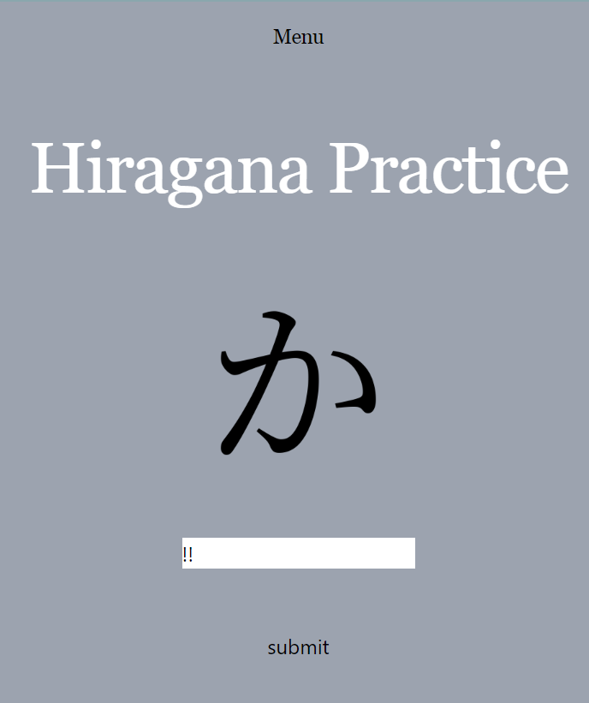

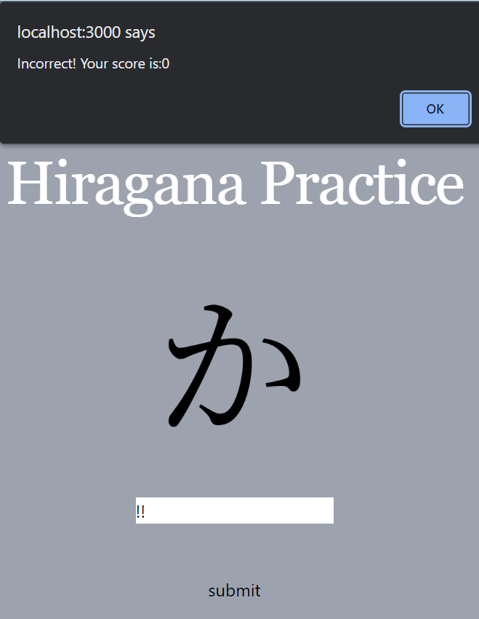

**Test case: %**

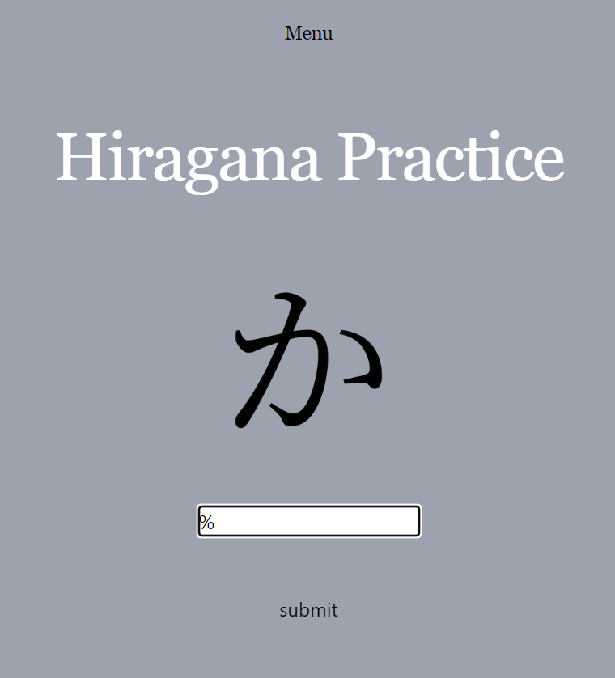

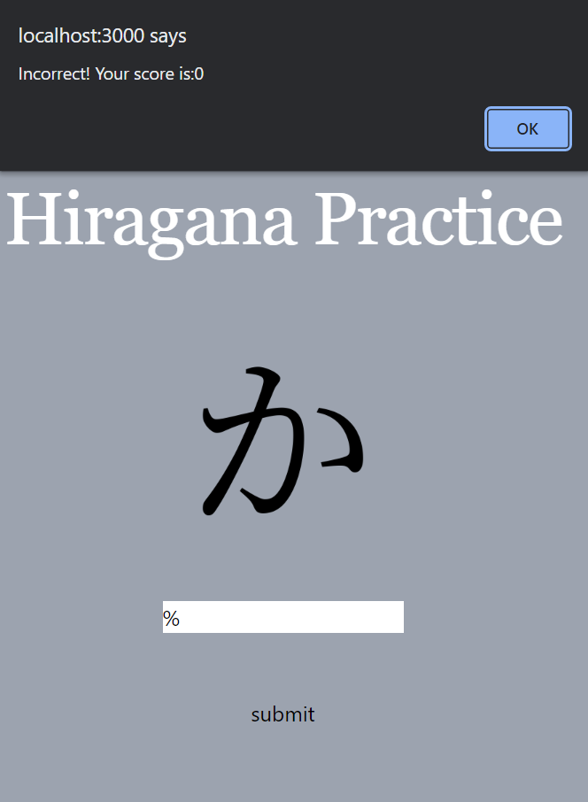

**Katakana task page**

**For this test I am going to use the Katakana character ka as what will be shown to the user in each of these test cases.**

|  |  |
| --- | --- |
| Test data | Valid |
| KA | Valid – Correct, score increments |
| ka | Valid – Correct, score increments |
| kA | Valid – Correct, score increments |
| Ka | Valid – Correct, score increments |
| A | Invalid – Incorrect, score stays the same |
| a | Invalid – Incorrect, score stays the same |
| 12 | Invalid – Incorrect, score stays the same |
| !! | Invalid – Incorrect, score stays the same |
| % | Invalid – Incorrect, score stays the same |

All test cases with the letters ka worked as the code converts the letters to uppercase which is what is held in the database.

**Test case: KA**

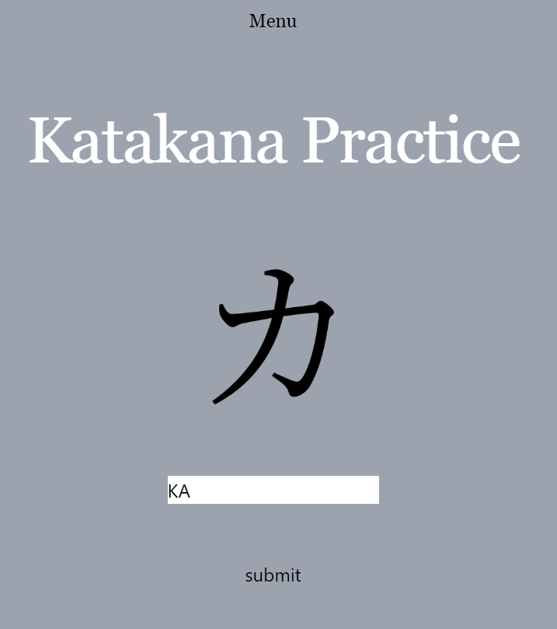

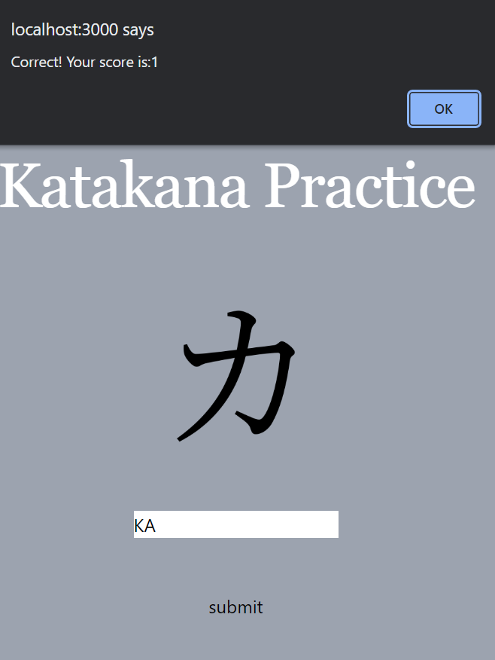

**Test case: ka**

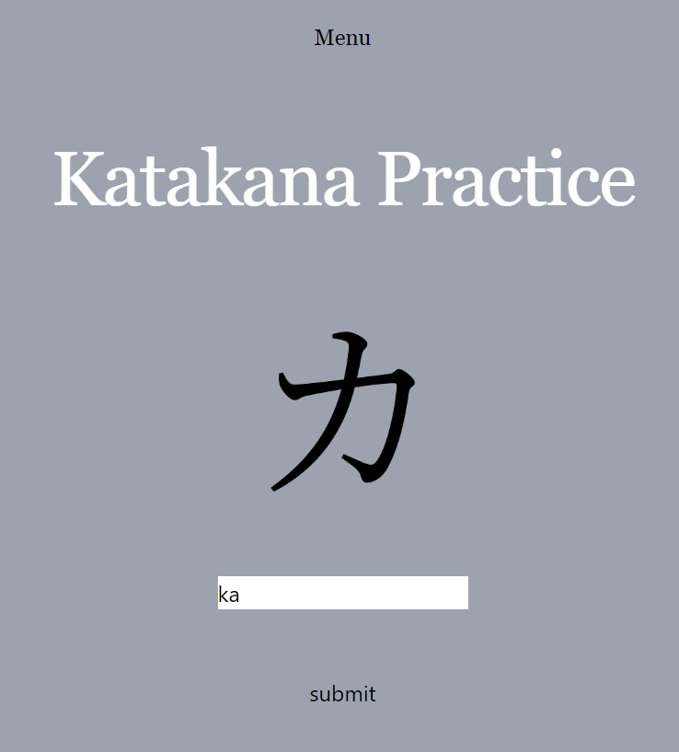

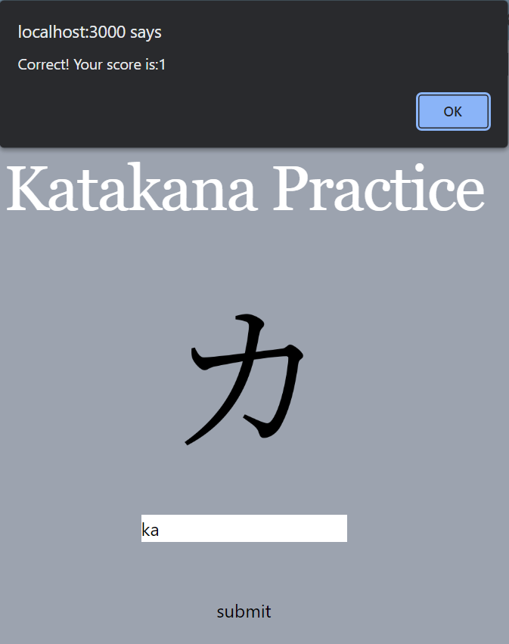

**Test case: kA**

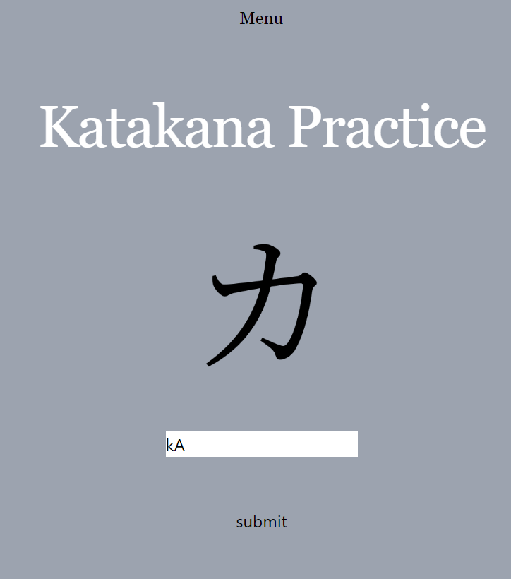

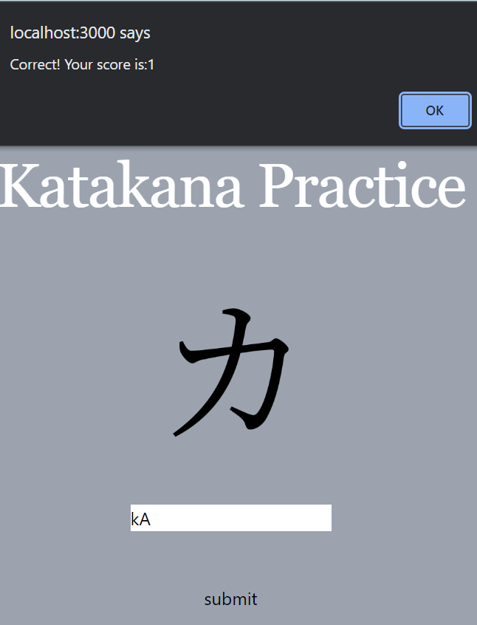

**Test case: Ka**

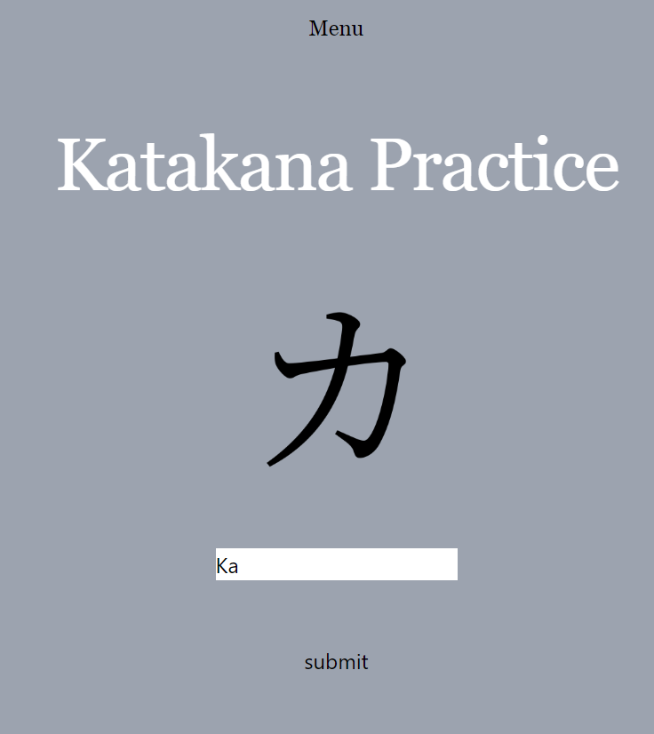

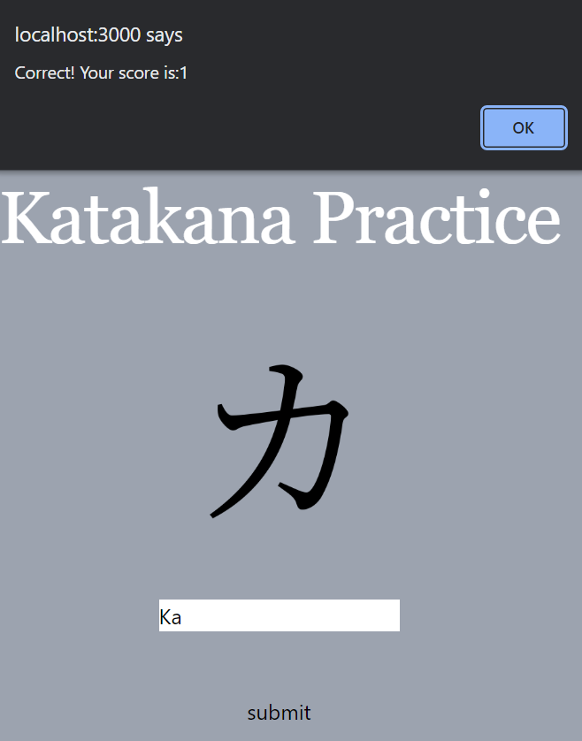

All test cases without the letters ka together did not work as that is not what is held in the database.

**Test case: A**

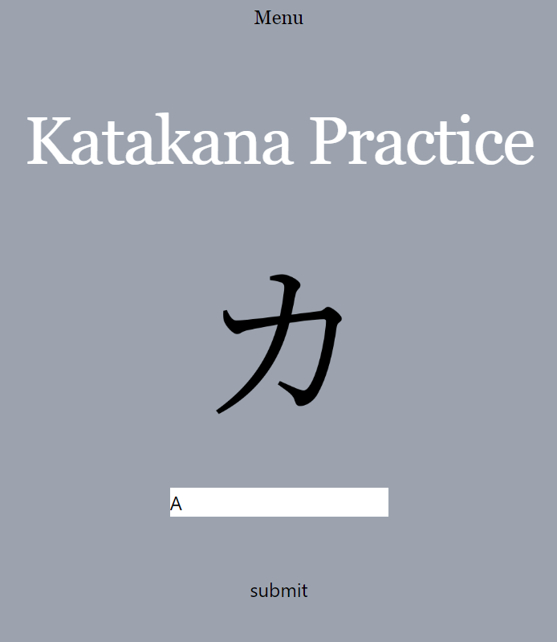

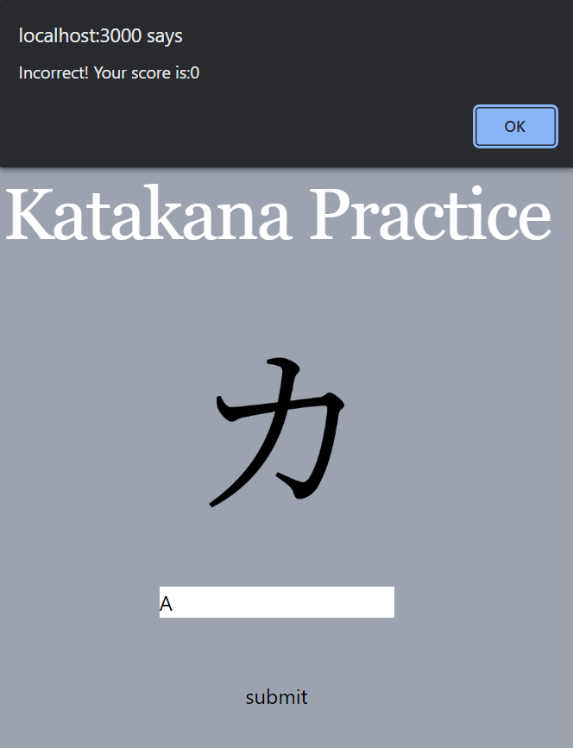

**Test case: a**

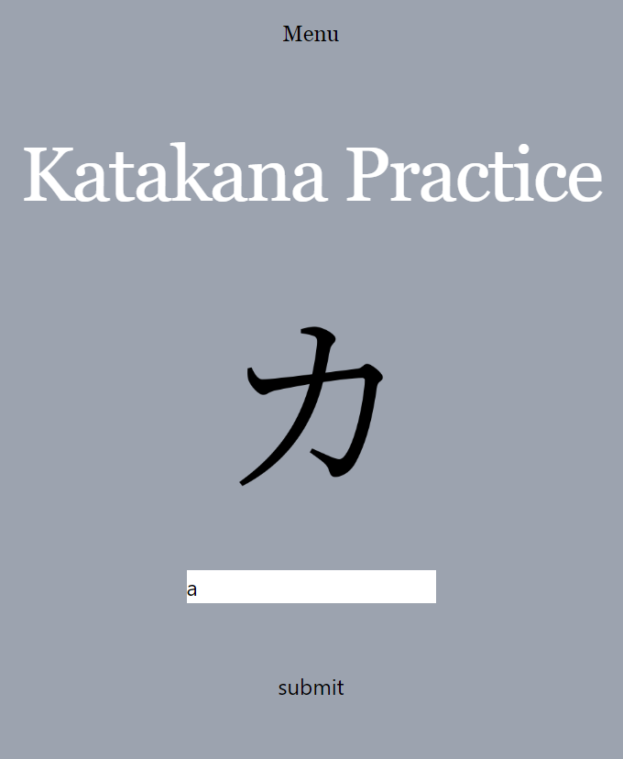

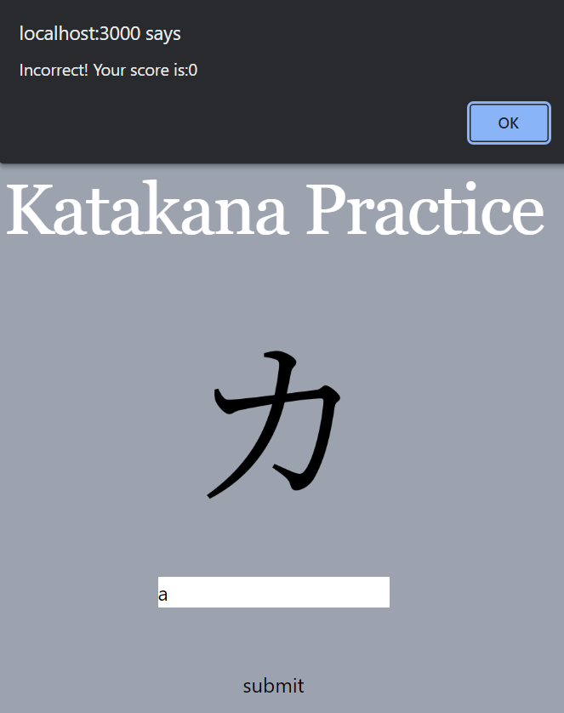

**Test case: 12**

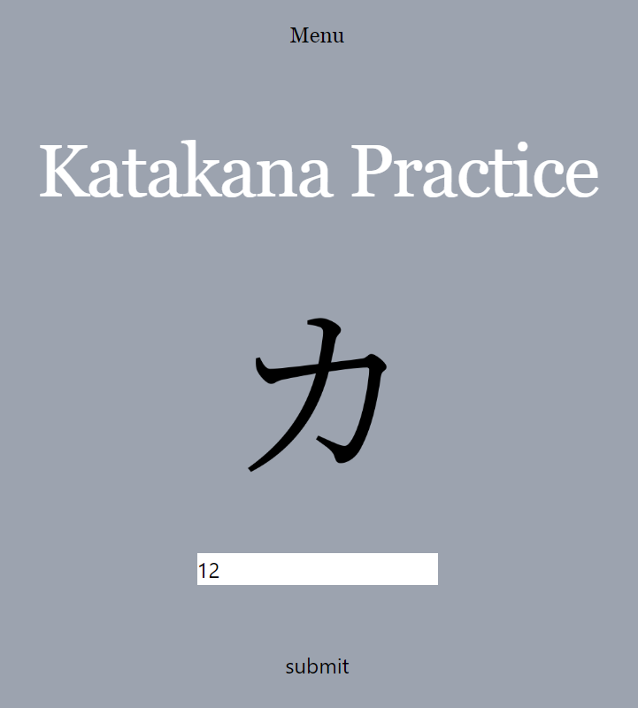

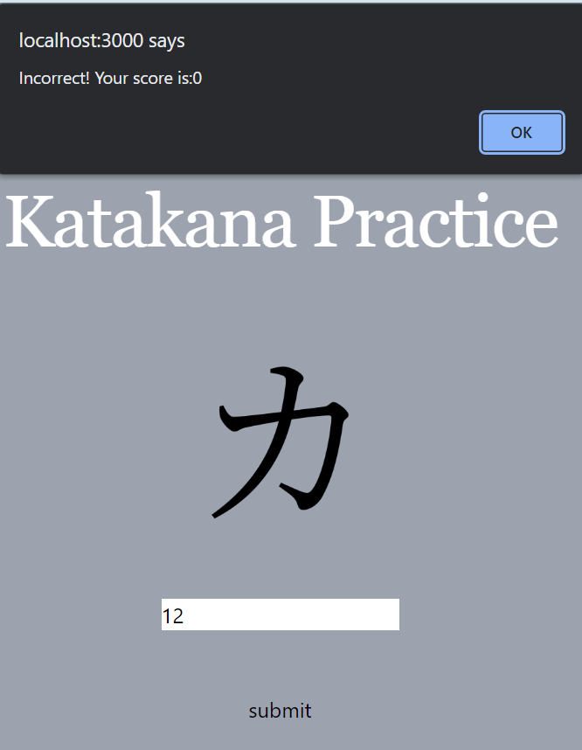

**Test case: !!**

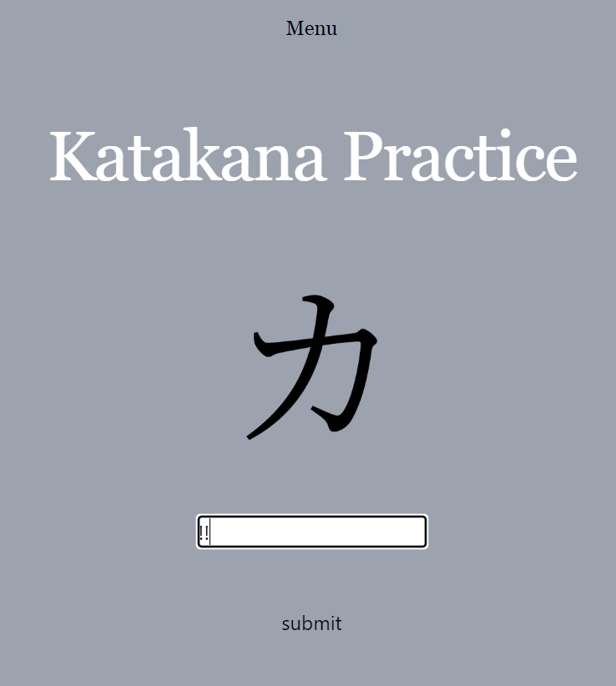

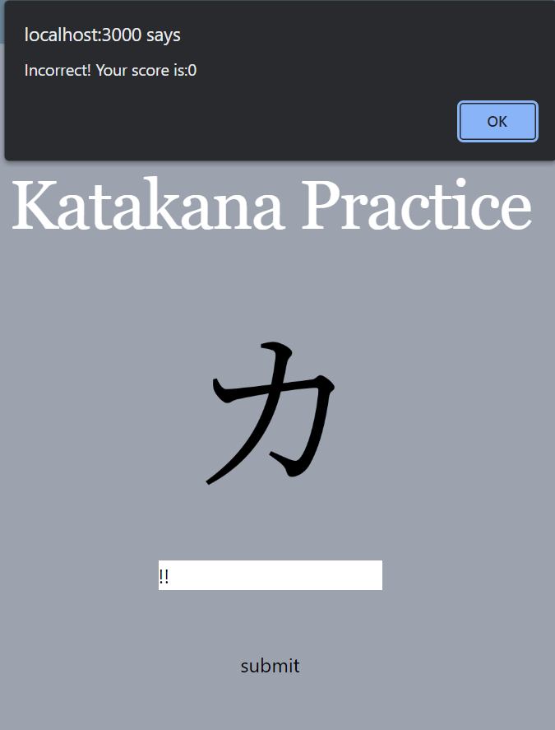

**Test case: %**

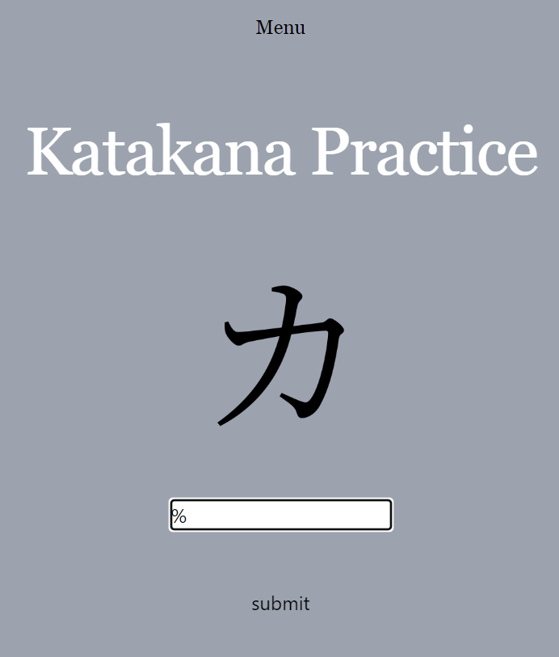

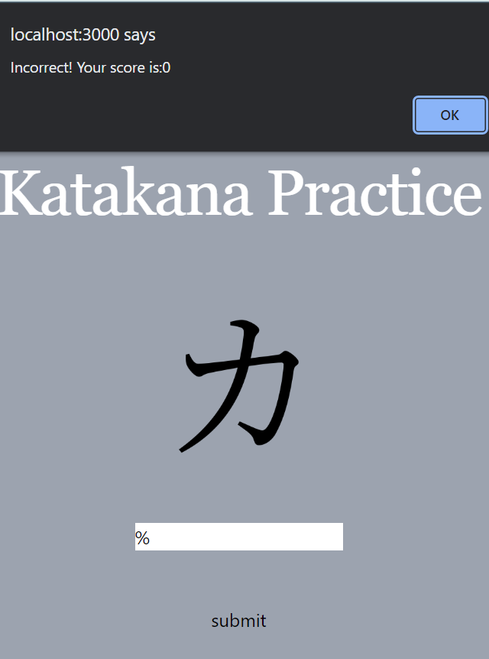

## 4.2 Does the solution match the Success Criteria?

|  |  |  |  |  |
| --- | --- | --- | --- | --- |
| Requirement No. | Requirement | Was Requirement met? | Justification | Stakeholder Evaluation |
| 1. | Log-in Page | Yes | Allows user to save progress | It was very easy to log into the website, with no need to make a password. |
| 2. | Start-Page and Menu-page | Yes | Allows user to choose what they would like to learn, view their levels and progress etc. | This was implemented very well. |
| 3. | Score shown after user completes a task | Yes | User can see what they are excelling and lacking in. | I wanted a good grading system, so I appreciated this feature. |
| 4. | User’s proficiency in each area of the language shown on the start-page | No, If I had time, I would have liked to implement this. This would work by e.g., after the user completes a set of tasks correctly, their rank will increase. | User can see what areas they are excelling and lacking in. | Since I wanted a good grading system, I wished this feature could have been implemented. |
| 5. | Overall proficiency displayed on start-page by taking an average of the proficiencies of each area | Yes | Motivates user to better their proficiency | I was glad this was implemented, and it works very well. |
| 6. | Ten questions per task | Partly, changed to 5 | User can see a set score after completing a task. Allows for easy scoring of the user’s proficiency of the language | Although the number of questions was decreased, it works quite well. However, more questions could have allowed for better language learning. |
| 7. | Animation played after user answers question correctly or incorrectly | No. If I had more time, I would have liked to implement it. | Motivates user, visually appealing | This could have made the language-learning more visually appealing, so it is unfortunate that it was not able to be implemented. |
| 8. | Sound played when user gets a question correct or incorrect | No. If I had more time, I would have liked to implement it. | Motivates user, more interactive | This could have been more interactive for the user, so it is unfortunate it was not implemented. |
| 8. | User has option to practice mistakes after a task | No. If I had more time, I would have liked to implement. I would have created a table within my database which holds the questions the user got incorrect. | Allows user to practice what they need help in | This would have been great for the user as they could improve quickly. It is unfortunate it was not implemented. |
| 9. | Minimalistic Monochrome Interface | Yes | Allows user to navigate website more easily. | This made the website easy to navigate and was visually pleasing. |
| 10. | Question Format split into: Identifying hiragana and katakana characters, vocabulary, and grammar | Partly, Implemented questions hiragana and katakana characters. If I had more time, I would have implemented the rest through creating extra tables of questions in the database. | Allows range of ways to learn the language. | The hiragana and katakana task questions work very well. It would have been nice to see questions for Vocabulary and grammar. |
| 11. | Progress Bar within each task indicating how far user is along task. | Partly, changed to a number. | User can see how long is left of a task. | This works well. |

**Sections that were implemented well:**

* The log-in and sign-up pages were implemented well as the user can easily create an account with their email and sign in through a link sent to it.
* The start-up page was easy to navigate due to the minimalistic interface and the user can easily view their overall rank in the language.
* The score within a task updates as the user makes their way through questions. This allowed for the user to know exactly what questions they are excelling in and vice versa.
* The questions where the user identifies Hiragana and Katakana characters were implemented well. After the user identifies a character correctly it quickly switches to the next character.

**Sections which need improving:**

* The grading system: While I was able to add a score for each task, I intended to display the user’s rank within each area of the language (hiragana, katakana) but I was not able to do this. Furthermore, since I only had one set of questions for Hiragana and Katakana, the user would not be able to practice “harder” questions to increase their rank.
* The questions: Unfortunately, the way I formatted the questions implied that the user should already know what the characters I displayed are. I should have added an option to “learn” the characters first before practicing them.

## 4.3 Maintenance

If I was to distribute this website for many other users, I would probably need to implement more maintenance features which currently the website does not have. For example, having a page where users can report problems within the website such as bugs, inconsistencies within the language-learning, etc. This would allow me to update the website accordingly.

### 4.3.1 Limitations

|  |  |
| --- | --- |
| Limitation/Desired change | Justification |
| Levels of difficulty | This would allow the user to continuously improve and practice even harder questions. |

Currently the user can only practice a few sets of questions. If I were to extend my project, I would classify certain questions as easy, medium and hard. As the user learns more, they will be introduced to harder/newer topics.

|  |  |
| --- | --- |
| Limitation/Desired change | Justification |
| Classroom learning | This would allow a teacher to view how their student is fairing within their practice of Japanese |

Currently the user can only view their own progress. If I were to extend my project, I would allow for students’ teachers to view their progress. The teacher will be able to adequately help the user as they are aware of what they are lacking in. This is because my stakeholder is my Japanese teacher and I feel like using this app would be very useful in her future lessons. However, this is only possible for users who are also being taught Japanese outside the app.

|  |  |
| --- | --- |
| Limitation/Desired change | Justification |
| Leader board | This would add a competitive feel to the website-learning and motivate the user. |

Currently the user can only view their own progress and not others. If I were to extend my project, I would add a leader board so users can compete against each other possibly within the classroom and outside.

# 5. Project Appendixes

## 5.1 Complete Code Listing

**Log-in Page/Sign-up Page/Start-Page**

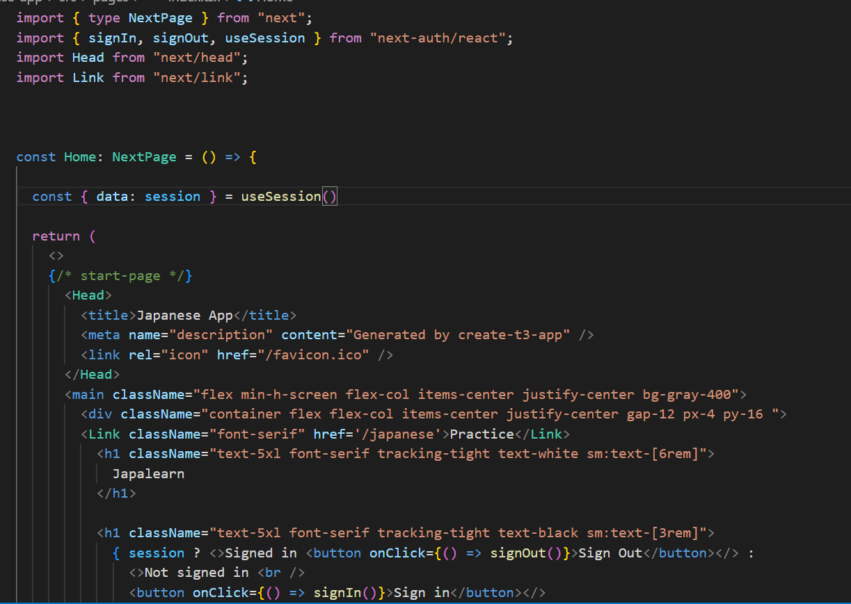

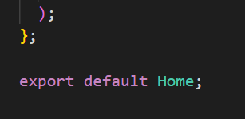

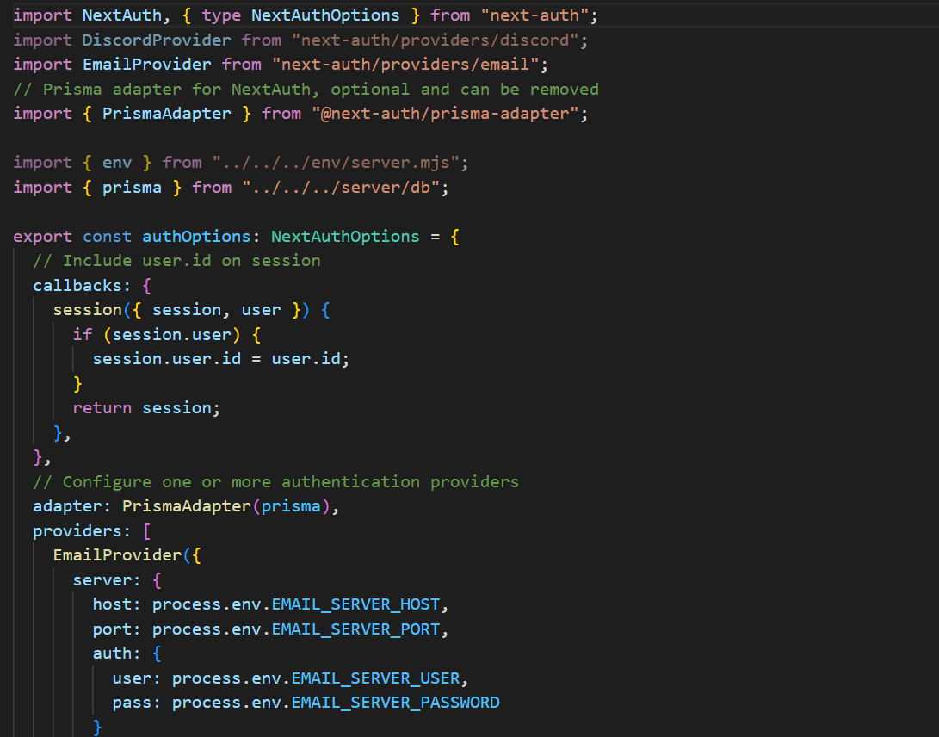

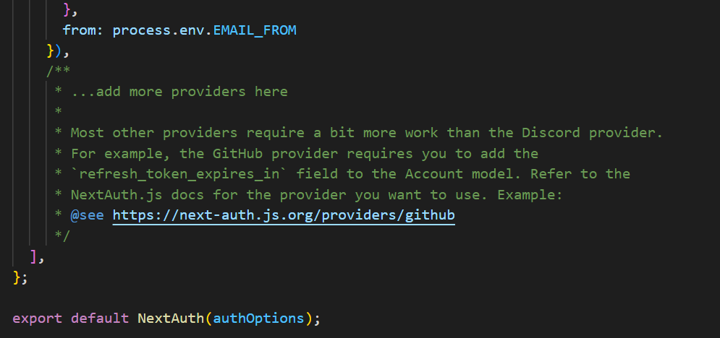

**Menu-Page**

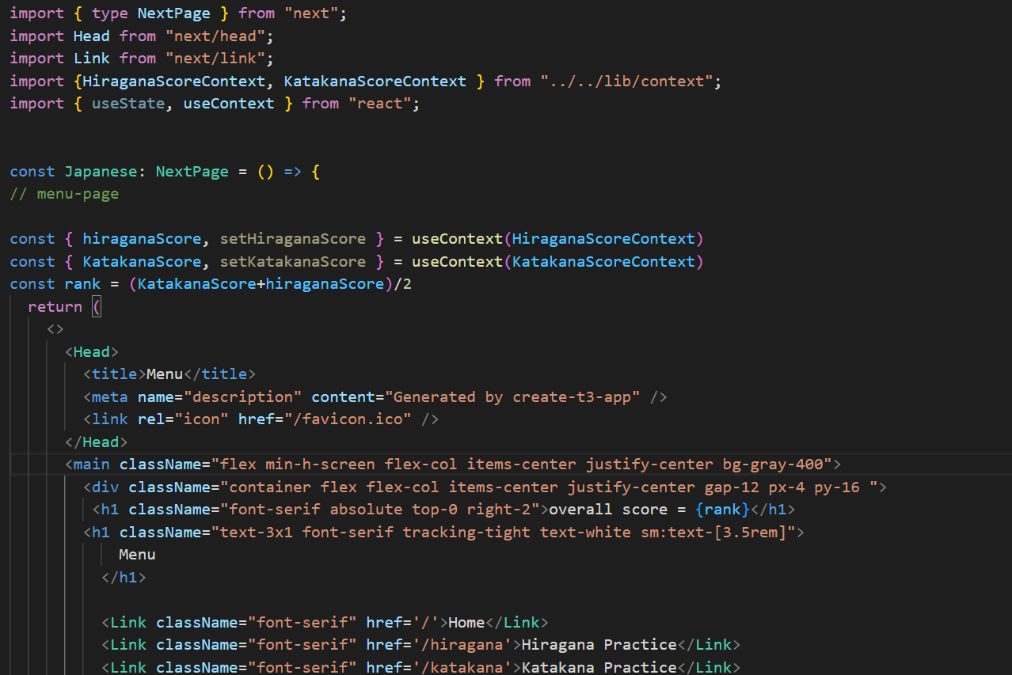

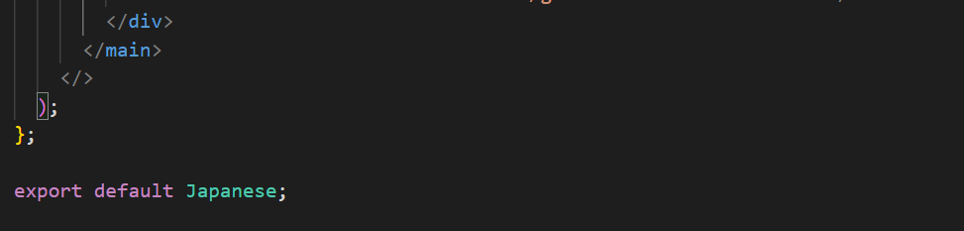

**Hiragana-Task Page**

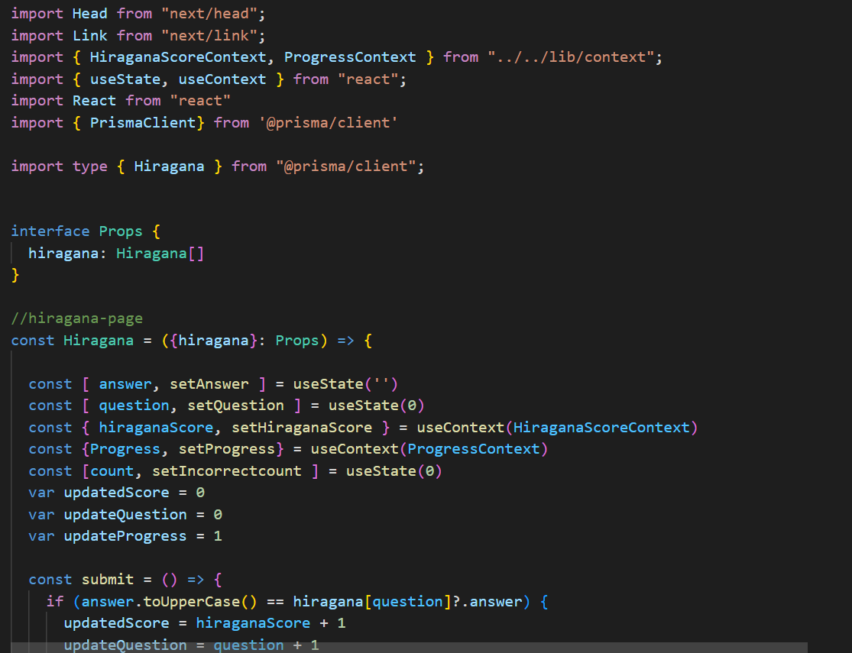

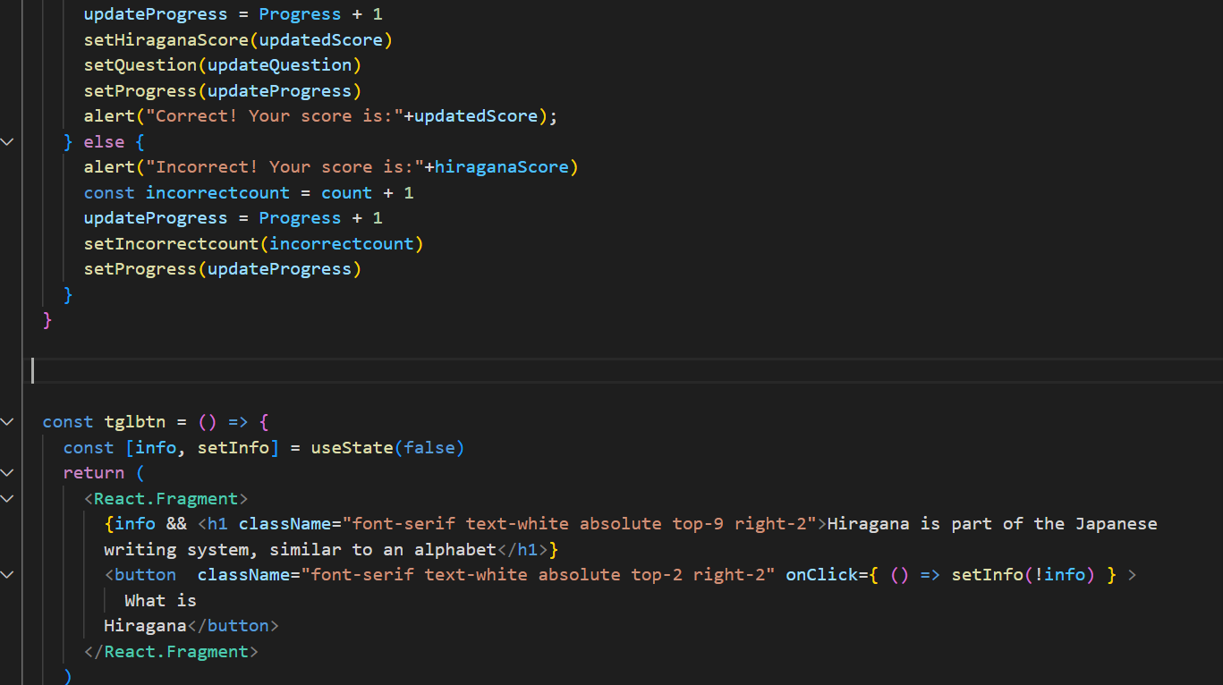

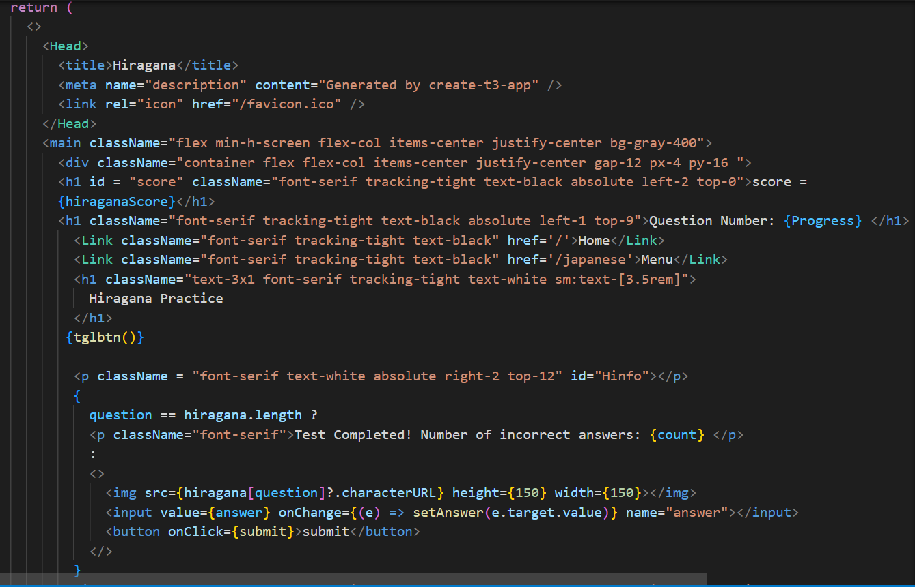

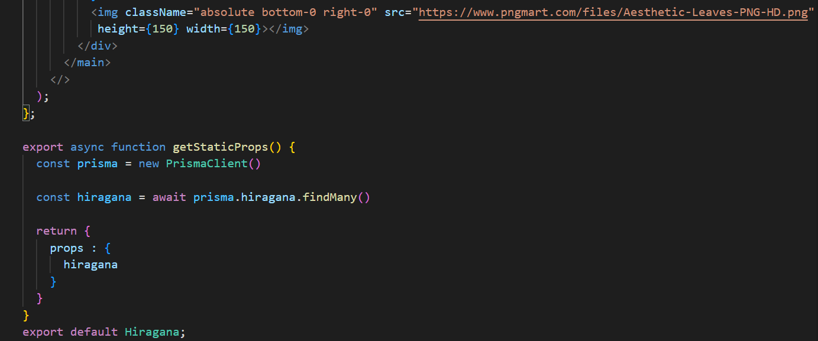

**Katakana-Task Page:**

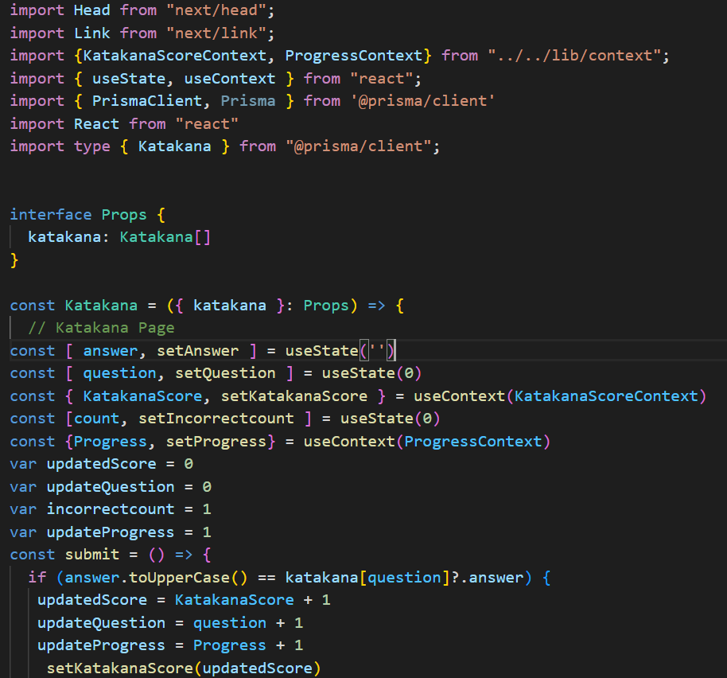

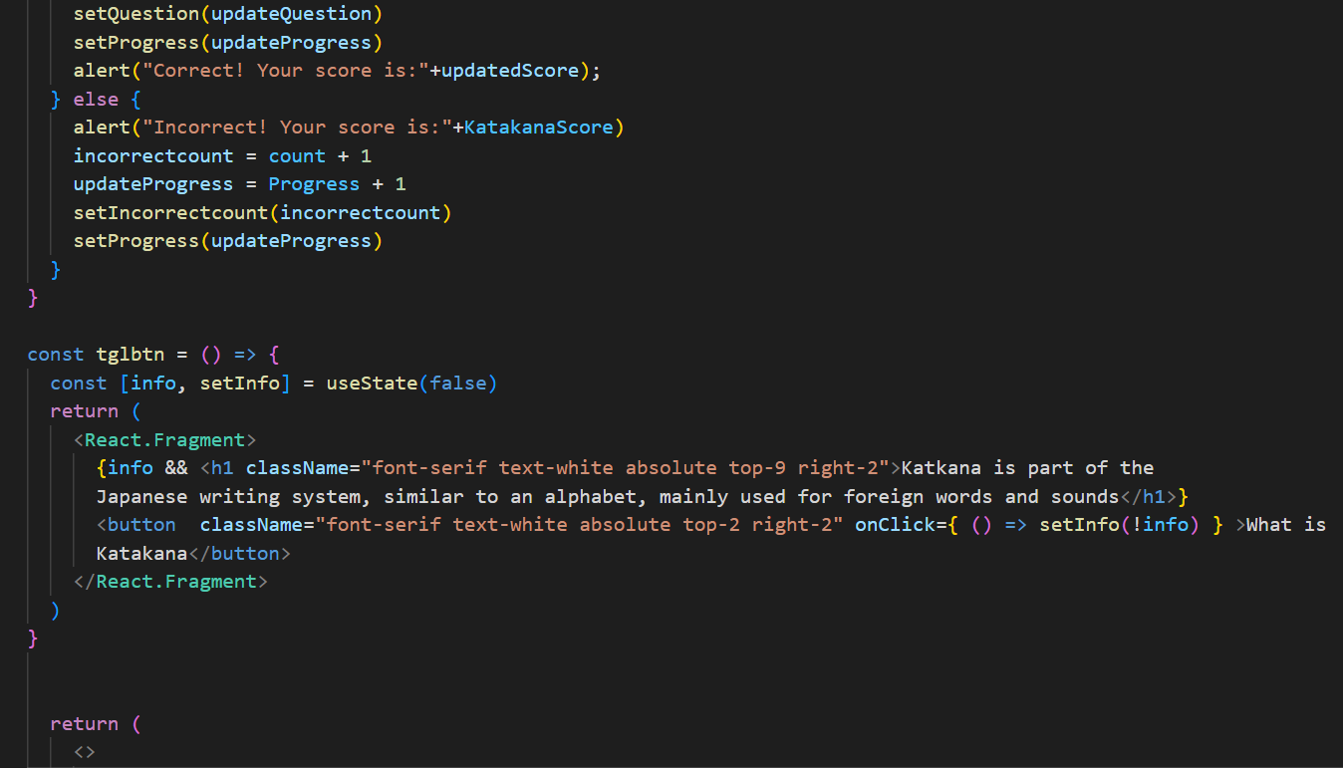

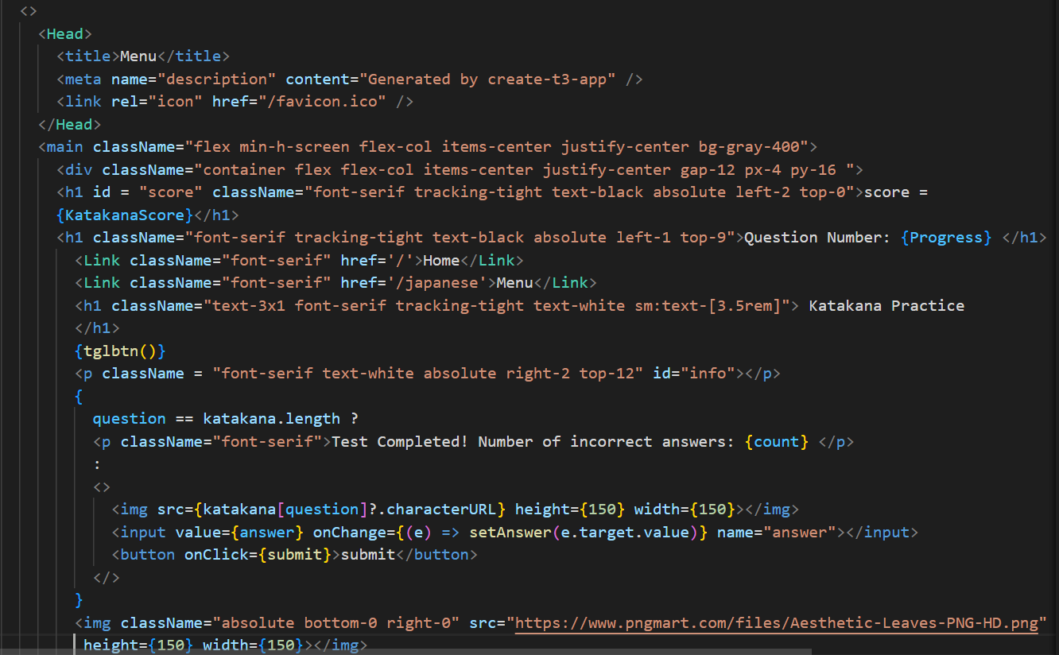

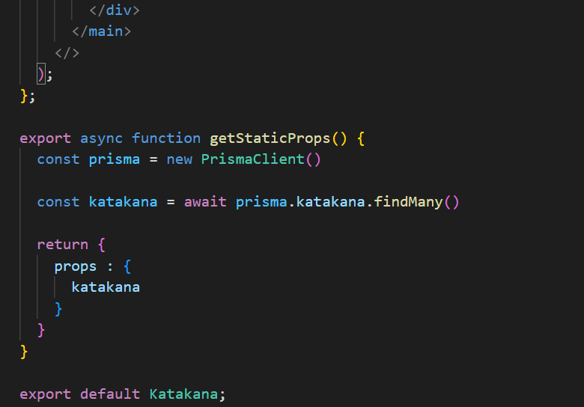

**Contexts**

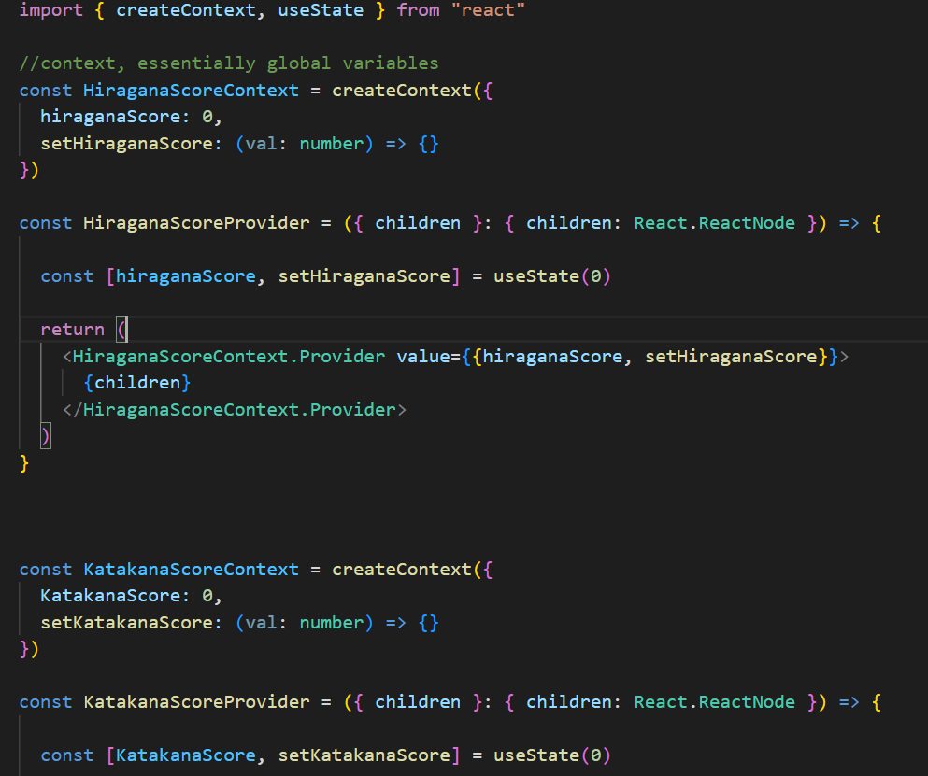

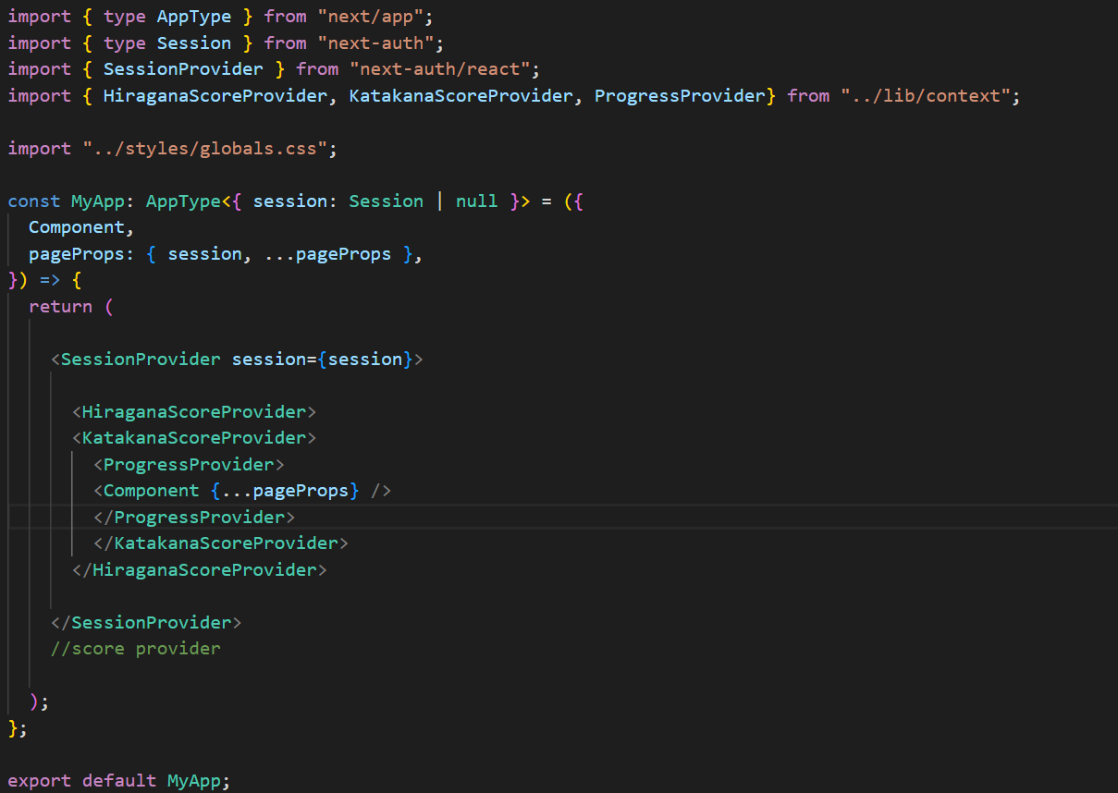

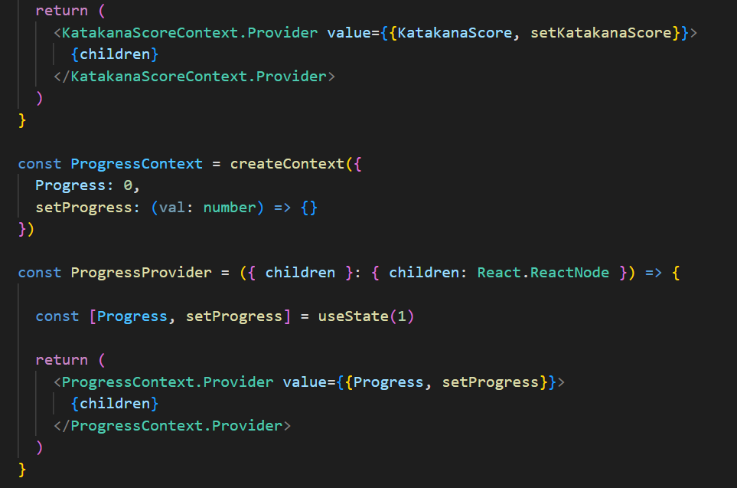



**Database:**

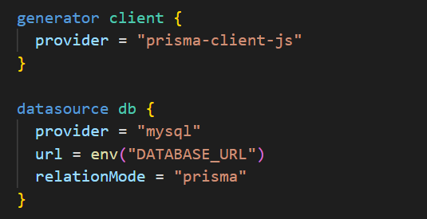





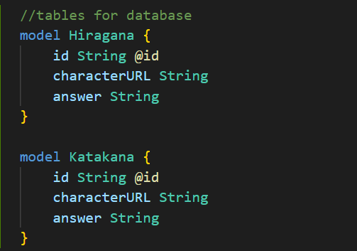

# 6. Bibliography

bobbyhadz.com <https://bobbyhadz.com/blog/react-onclick-redirect>

legacy.reactjs.org <https://legacy.reactjs.org/docs/handling-events.html>

next-auth.js.org <https://next-auth.js.org/getting-started/example>

next-auth.js.org <https://next-auth.js.org/providers/email>

prisma.io <https://www.prisma.io/docs/concepts/components/prisma-client/crud>

react.dev <https://react.dev/learn/state-a-components-memory>

stackoverflow.com <https://stackoverflow.com/questions/67483097/toggle-text-within-a-variable-type-function-in-react-js>

w3Schools <https://www.w3schools.com/howto/howto_css_signup_form.asp>

Youtube.com [Build A Next.js App with Prisma and PlanetScale](https://www.youtube.com/watch?v=JtqdAn_wYzY)

Youtube.com [Context API Tutorial For Beginners - Using React Hooks](https://www.youtube.com/watch?v=sP7ANcTpJr8)

1. w3schools.com <https://www.w3schools.com/howto/howto_css_signup_form.asp>
2. Youtube.com [React JS + Python Django + SQLite | full-stack app tutorial](https://www.youtube.com/watch?v=WsBYK5Nv2V8)
3. bobbyhadz.com <https://bobbyhadz.com/blog/react-onclick-redirect>
4. Youtube.com [Build A Next.js App with Prisma and PlanetScale](https://www.youtube.com/watch?v=JtqdAn_wYzY)

   Next-auth.js.org <https://next-auth.js.org/getting-started/example>
5. next-auth.js.org <https://next-auth.js.org/providers/email>
6. legacy.reactjs.org <https://legacy.reactjs.org/docs/handling-events.html>
7. [Context API Tutorial For Beginners - Using React Hooks](https://www.youtube.com/watch?v=sP7ANcTpJr8)
8. <https://react.dev/learn/state-a-components-memory>
9. <https://www.prisma.io/docs/concepts/components/prisma-client/crud>
10. <https://stackoverflow.com/questions/67483097/toggle-text-within-a-variable-type-function-in-react-js>